Formal languages and compiler design

!!! IMPORTANT: README: for images use [FLCD Notes](https://docs.google.com/document/d/1w5dVGgyhk2__FfmHxxjtNRsmQWbXAmhERrdbYBq3sm8/edit?usp=drive_link) instead. because this one cuts images due to the page width of the .docx format

# BOF

EOF -> [FLCD Notes](https://docs.google.com/document/d/1w5dVGgyhk2__FfmHxxjtNRsmQWbXAmhERrdbYBq3sm8/edit#heading=h.46baig9dr31c)

!!! Where to find administrative stuff:

1. beginning of 1st lecture
   1. moodle
2. <https://motogna.wordpress.com/labs/>
3. references: [fisa disciplinei](https://www.cs.ubbcluj.ro/files/curricula/2020/syllabus/IE_sem5_MLE5023_en_motogna_2020_5077.pdf)

# LECTURE W1

"idk about other subjects, but this course is important"

## administrative stuff

1. everything on moodle
2. why 6 for the lab? because simulations
3. extra time allowed for lab delivery
4. labs depend on each other
5. slides on moodle after each course
6. books
   1. no strings attached to her book
   2. lot of internet resources: warning about the trustworthiness of it
      1. regular expressions, regular expression, regular automata. they construct very simple solution which are not complete.

## what is a compiler

object file

## history

1st compiler in the '50 for fortran

1st interpreter in the '50 for lisp

Backus, the name behind Fortran, will be heard again

McCarthy - 1st gargabe collector in sixty-two for Lisp

Ritchie intended at first to build the unix system, then realized they created a language

Java and the new perspective: class loader

## structure of a compiler

∀ phase is a equivalent

1st phase: analysis

2nd phasE: synthesis

### Scanning

detect & classify & codify

lexical items = tokens

ST = symbol table - stores the identifiers

### Parsing

it also respects the syntactic rules

### Semantic

ex: type mismatch for operands of an operation

Intermediary code optimization will be reasoned about later.

components

1. Error handling
2. Symbol Table management

Detect

tokens = words, punctuations

Remarks

1. separators: spaces delimit tokens and we also ignore them. delimiter: . , ; ( )
2. Look ahead. for some symbols like (=,+,-,<,>) look ahead at next symbol to see if it forms a token

Boian senior: the computer is the perfect asshole. it does exactly what you tell it to do

reserved keyword vs keyword

reserved keywords

separator

identifiers

operators

constant

can't classify => lexical error

reserved words, operators, separators: check if it is the list

rule for Id

'_' or letter

followed by '_'/letter/digit

identifiers length restriction

## codification

## 

0 = identifiers

1 = constants

ST construction: search & insert

Algorithm scanning

examples slide

antlr.org - very useful, you might not realize its potential

# SEMINAR W1 - PROGRAMMING LANGUAGES SPECIFICATION

administrative stuff

* answers for bonus points
* homeworks on moodle
* attendance
* ivu6kqi
  + <https://ubbcluj.sharepoint.com/sites/FLCDSeminar2022-2023/Class%20Materials/Forms/AllItems.aspx>

lab target: develop a scanner and a parser for your own defined mini language. write a specification for it.

today will discuss about notation, formal language specification

I BNF (Backus-Naur Form)

Language elements

1. meta-linguistic variables (nonterminals) - written between <>
2. language primitives (terminals) - written w/o any special delimiters
3. meta-linguistic connectors
   1. ::= (is defined as)
   2. | (alternatives, OR)

**<nonterminals> ::= expr1 | expr2 | … | exprn**

ex. 1: all nonempty sequences of letters - BNF

<LETTER> :: a | … | z | A | … | Z

<NON-EMPTY SEQUENCE> ::= <LETTER> | <LETTER> <NON-EMPTY SEQUENCE>

ex. 2: all (signed & unsigned) integers, with 2 constraints

1. 0 is always unsigned
2. no s of at least 2 digits should not start with 0

integers numbers, both signed and unsigned, 0 as unsigned, numbers of at least 2 digits should not start with 0

pay attention, you have to replicate this def in your language specification

<non-zero digit> = 1 | … | 9

<digit> ::= 0 | <non-zero digit>

<sign> ::= + | -

<integer> ::= 0 | <no> | <sign> <no>

<no> ::= <non-zero digit> | <non-zero digit> <digit seq>

<digit seq> ::= <digit> | <digit> <digit seq>

the 2nd case for <no> can be: <no> <digit>

II. EBNF (Extended BNF)

Wirth's dialect

at the lab you're free to use any, but keep consistency

Language elements

1. nonterminals are written w/o <>
2. terminals are written between ""
3. ::= -> =
4. | - the same
5. {} - 0 or more
6. [] - 0 or 1 (optional)
7. () - grouping
8. (* *) - comments
9. rules end with .

ex. 3: rewrite ex. 2 in EBNF

<sign> = "+" | "-"

<non-zero digit> = "1" | … | "9"

<digit> = "0" | <non-zero digit>

<integer> ::= 0 | [<sign>] <non-zero digit> {<digit>}

avoid EBNF combined with recursivity, because the point of EBNF is to avoid recursivity

no need to come up with very complex language

2 simple data types and a user-defined type

4 cat. of statements: input, output, assignment operator, conditional, loop

specify 3 things: alphabet, lexic and syntax

alphabet = ∀ character that is legal in that language

operators, sparators, reserved keywords vs identifiers, constant

beware of constants - they are literals

write the natural language, then the formal language below

it's better to use EBNF for the lexical part, BNF for the syntactic part

identifier = letter {letter|digit}

next seminar: continue with constants

# LAB W1

advice: go to the lecture

if you go and you pay attention, you shouldn't have problems

<https://motogna.wordpress.com/labs/>

work during lab + work after lab

contact: teams or email for any problems

tema code review

are laburi doar luni si miercuri cu IE

dar si joi cu mate info, dar doar in cazuri exceptionale

<https://moodle.cs.ubbcluj.ro/course/view.php?id=91>

conditional, for while, assignment

lexical error: 1a,

next lab: we'll define the formal language

atm: no scope, no classes, no recursivity, strongly-typed, no user-defined functions

have read, write, assignment

100% vor fi cazuri in care nu putem termina in timpul laboratorului

# LECTURE W2

the scanner skips comments and spaces

## symbol table (ST)

index | name | location | type | value

at laboratory we'll construct the symbol table

no point in using BST if it's not balanced. ex: variables a, b, c

Hash tables were invented as a data structure for symbol tables

### hash table

best results when m is a prime number - statistically proven

val(a) = asci code of a

toy hash function to use at the lab: sum of ascii code of chars

hash table solutions: open & closed bucket

for the scanner some will have to do the hash functions, other the bst

## visibility domain / scope

scopes stored in a tree

## 

most cited book in compiler construction, red dragon book: Compilers Principles, Techniques and Tools by Alfred V. Aho, Ravi Sethi

## formal languages

it has 2 parts: grammar, automaton

red dragon problem was a finite automaton

FA = Finite Automaton / Automata = (ro) automat finit

PDA = Push-Down Automaton

formal language = a mathematical view of a programming/natural language

a language is a set

languages may be infinite => write a mathematical formula

a boy has a dog.

S → A V S = Sentence

A → B N

B → a | the

N → boy | dog

V → has A

a dog has a dog

the dog has a boy

A → α = rule

S, P, V, N, Q, C, B= nonterminal symbols

a, boy, dog, has = terminal symbols

sentence = word, sequence (contains only terminal symbols); denoted w

### Grammar

A* = transitive & reflexive

A+

A, AA, AAA, …

A0 empty word

|w| = 0, w = ε

or w = λ

### binary relations defined on (N ∩ Σ)*

### language generated

remember very well: L(G) = { w ∈ Σ* | S =>* w } - language generated by a grammar G=(N, Σ, P, S)

the compiler solved the problem if the language can be generated

L1 = { a, b, c }

L2 = { 0, 1}

L1L2 = { a0, b0, c0, a1, b1, c1 }

L complement = Σ \ L

### Chomsky hierarchy

cfg = context free grammar = gramatica independenta de context = gic

### notations

# SEMINAR W2

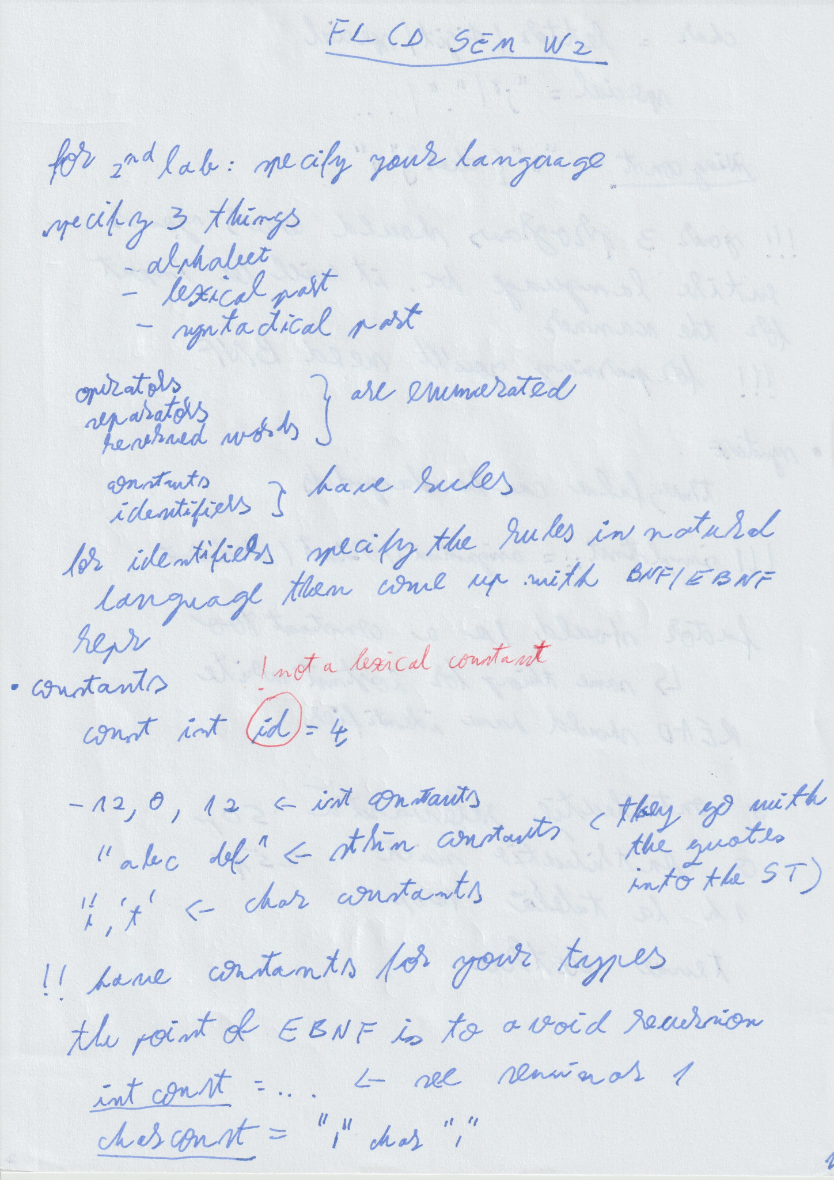

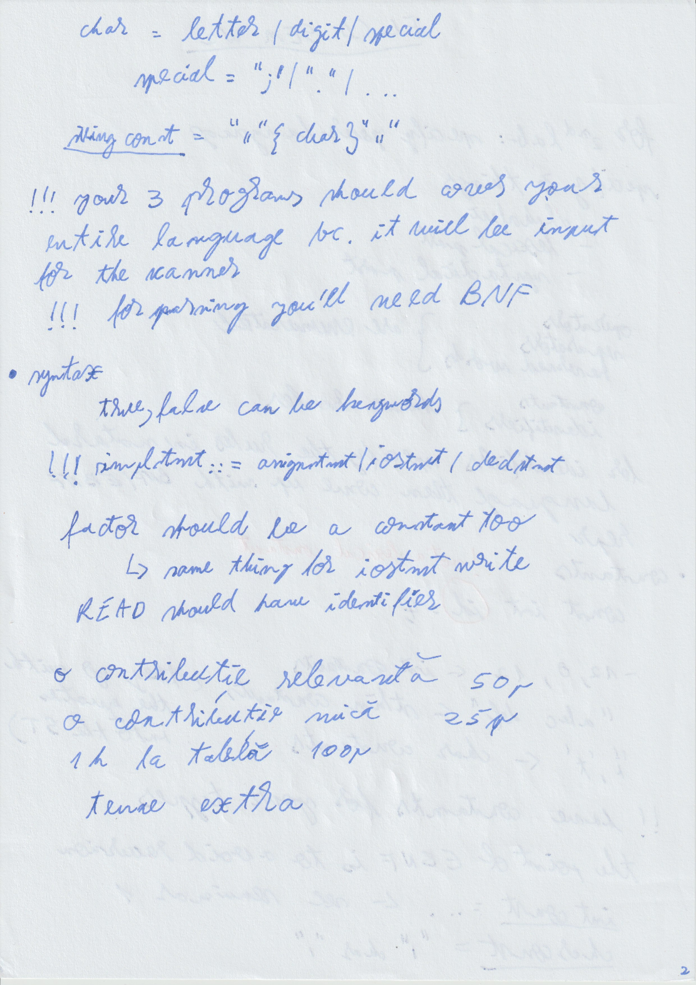

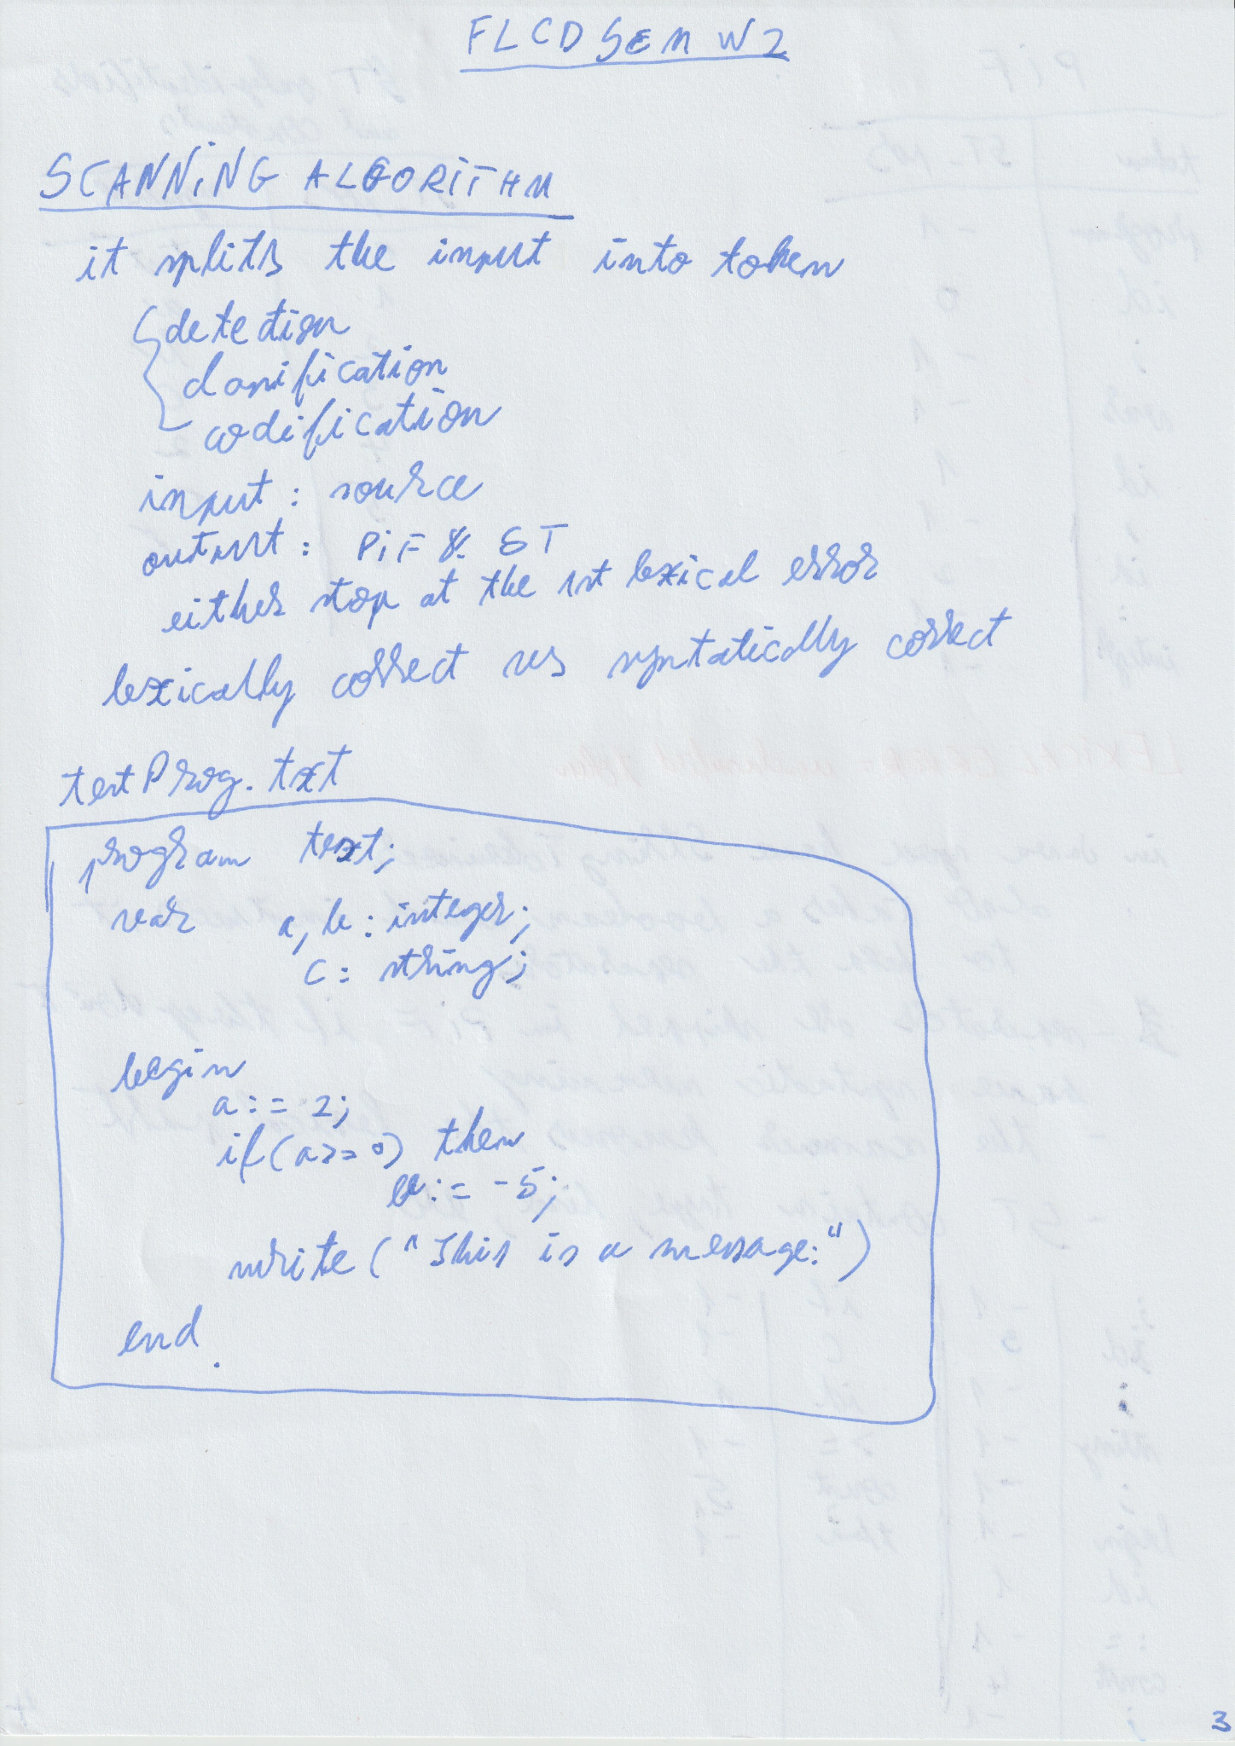

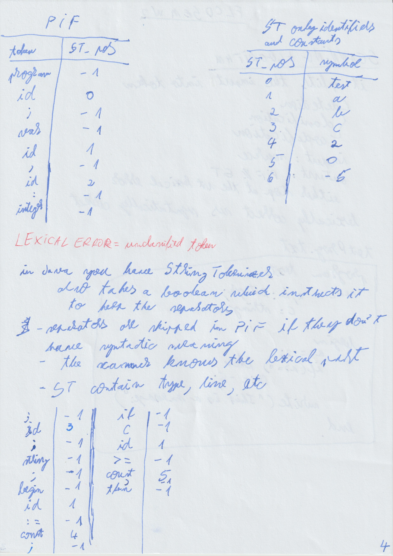

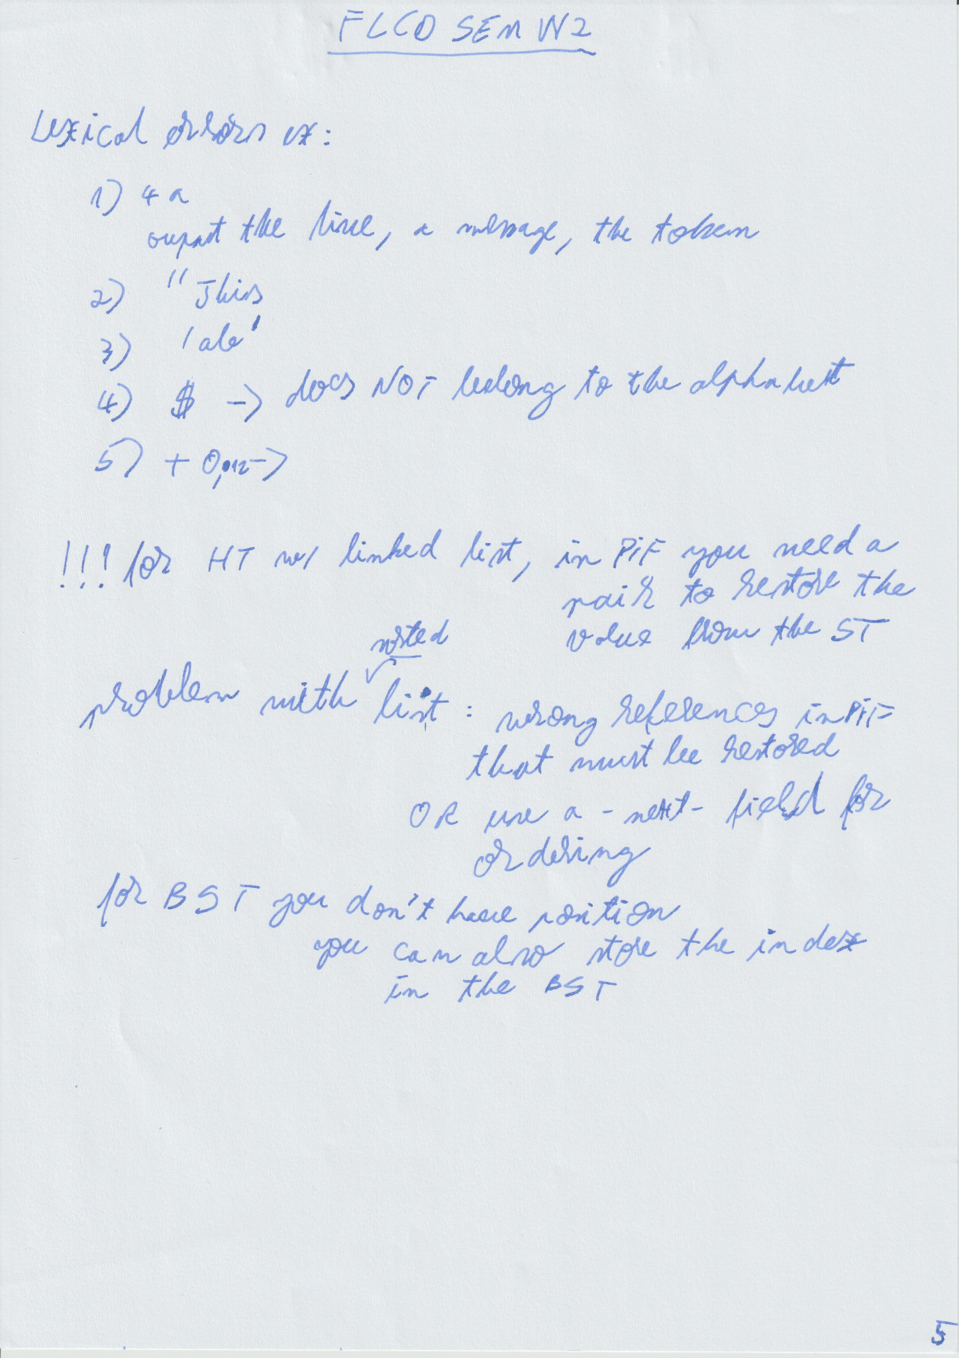

# LAB W2

task 2:

repo pe git

upload last lab on git

upload this lab on git

pull request on github

review pt altcineva pt labul urmator

grade 10 unless specified

statement: assignment, conditional, io, loop,

EBNF

{} - 0 or more time

[] - 0 or 1 times

parentheses - grouping

::= becomes =

BNF

<id> = <letter> | <id><letter>

i can't reuse character for string const

iostream=(Read|Write)"("id")"

choose either BNF or EBNF

pt lab 2 prima linie in pdf este link-ul catre git

# LECTURE W3 - 4h

???? 1st 10 minutes

finite automata ⇔ regular grammar ⇔ regular expression ⇔ …

## Finite Automata

minimizing finite automata - algorithmic problem

eliminate redundant states

merge states that have the same behavior

the first state in Q is considered initial

simplifying multiple sequences diagram

ε not allowed as an input for an edge

exercise - checking if a formula W ∈ L of M

incomplete states

showing that: finite automata ⇔ regular grammar

regular grammar => finite automata

when an automata accepts ε? when the initial state = the final state

F = {K} U { S | S -> ε ∈ P}

only 2 types of algorithms in FLCD: saturation & ??

finite automata => regular grammar

P: delta of p, q = then p -> a ∈ P

AND if q ∈ F then p -> a ∈ P

if q0 ∈ F then S -> ε ∈ P

at exam i'm going to ask this ??? part

example of grammar construction

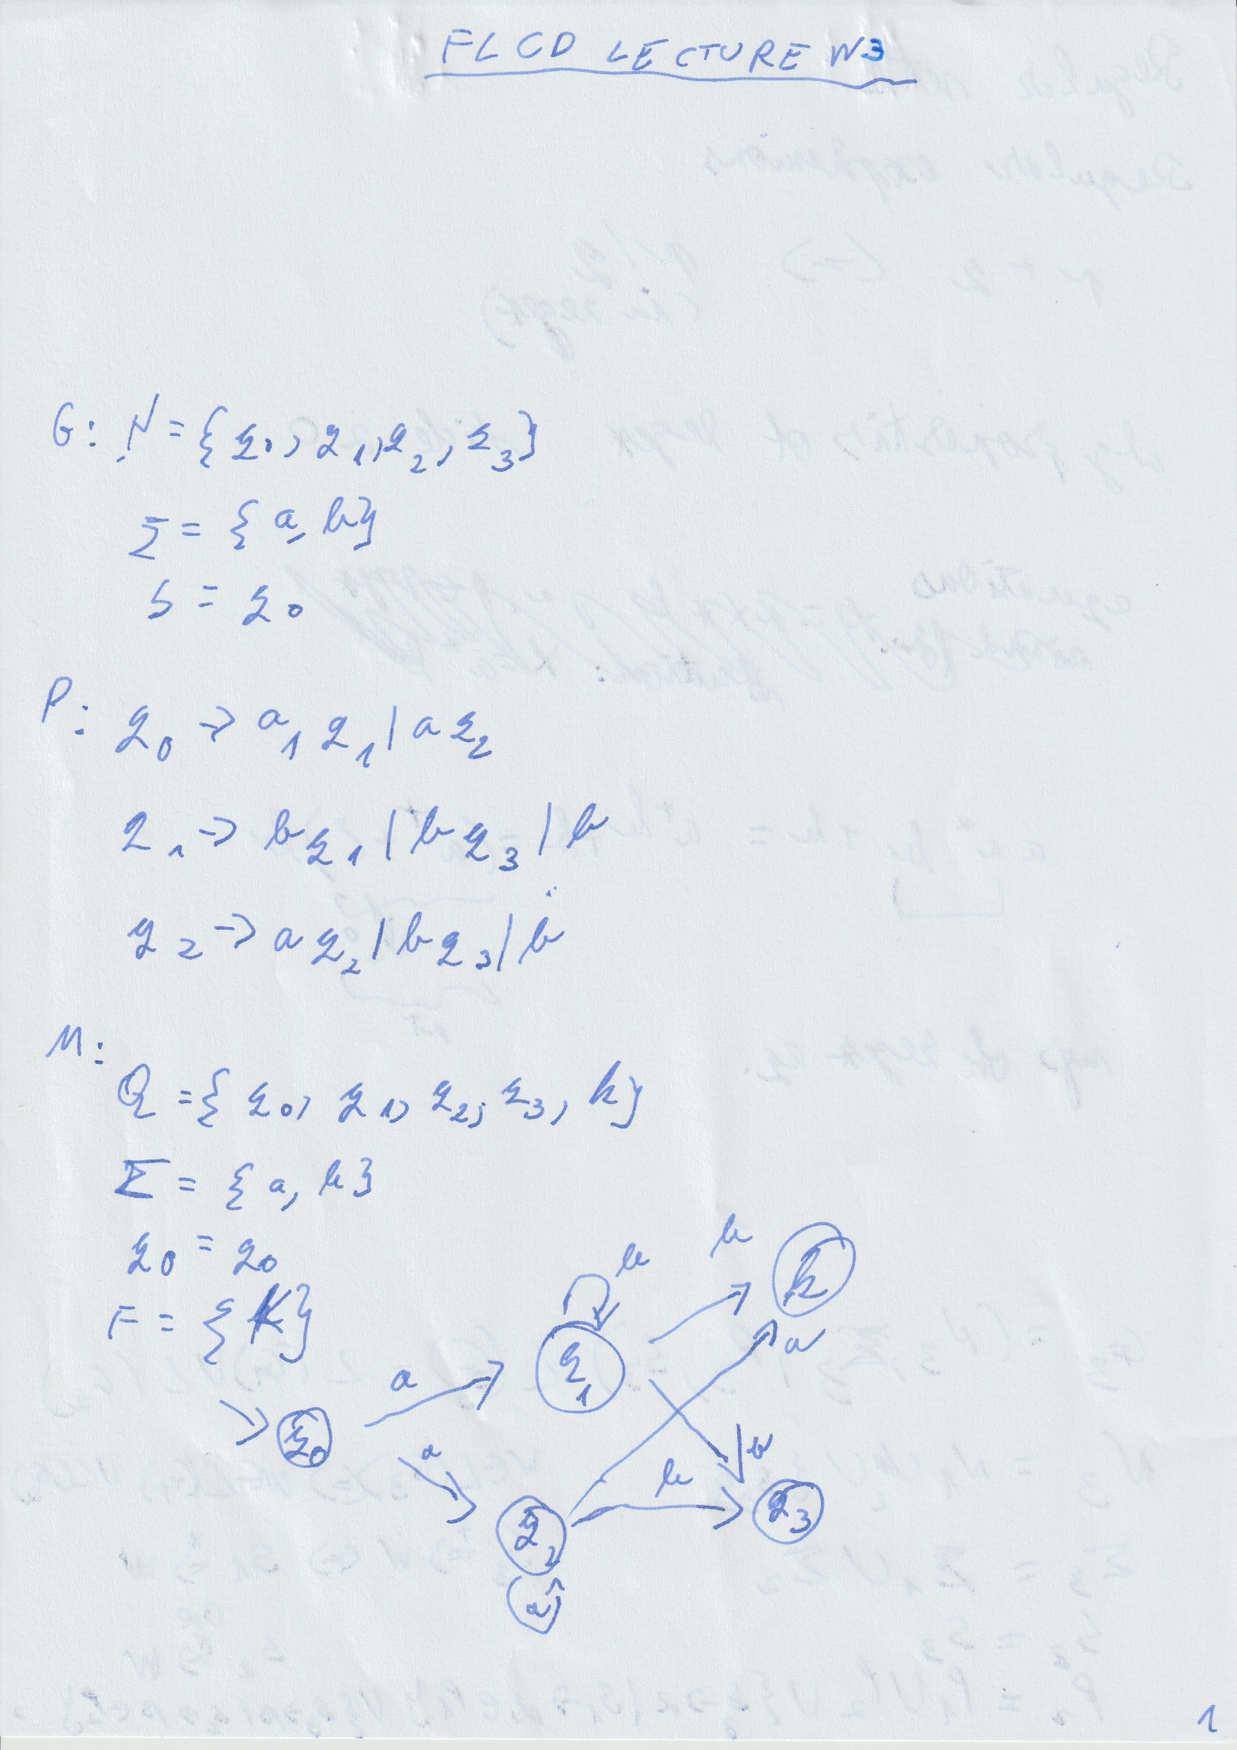

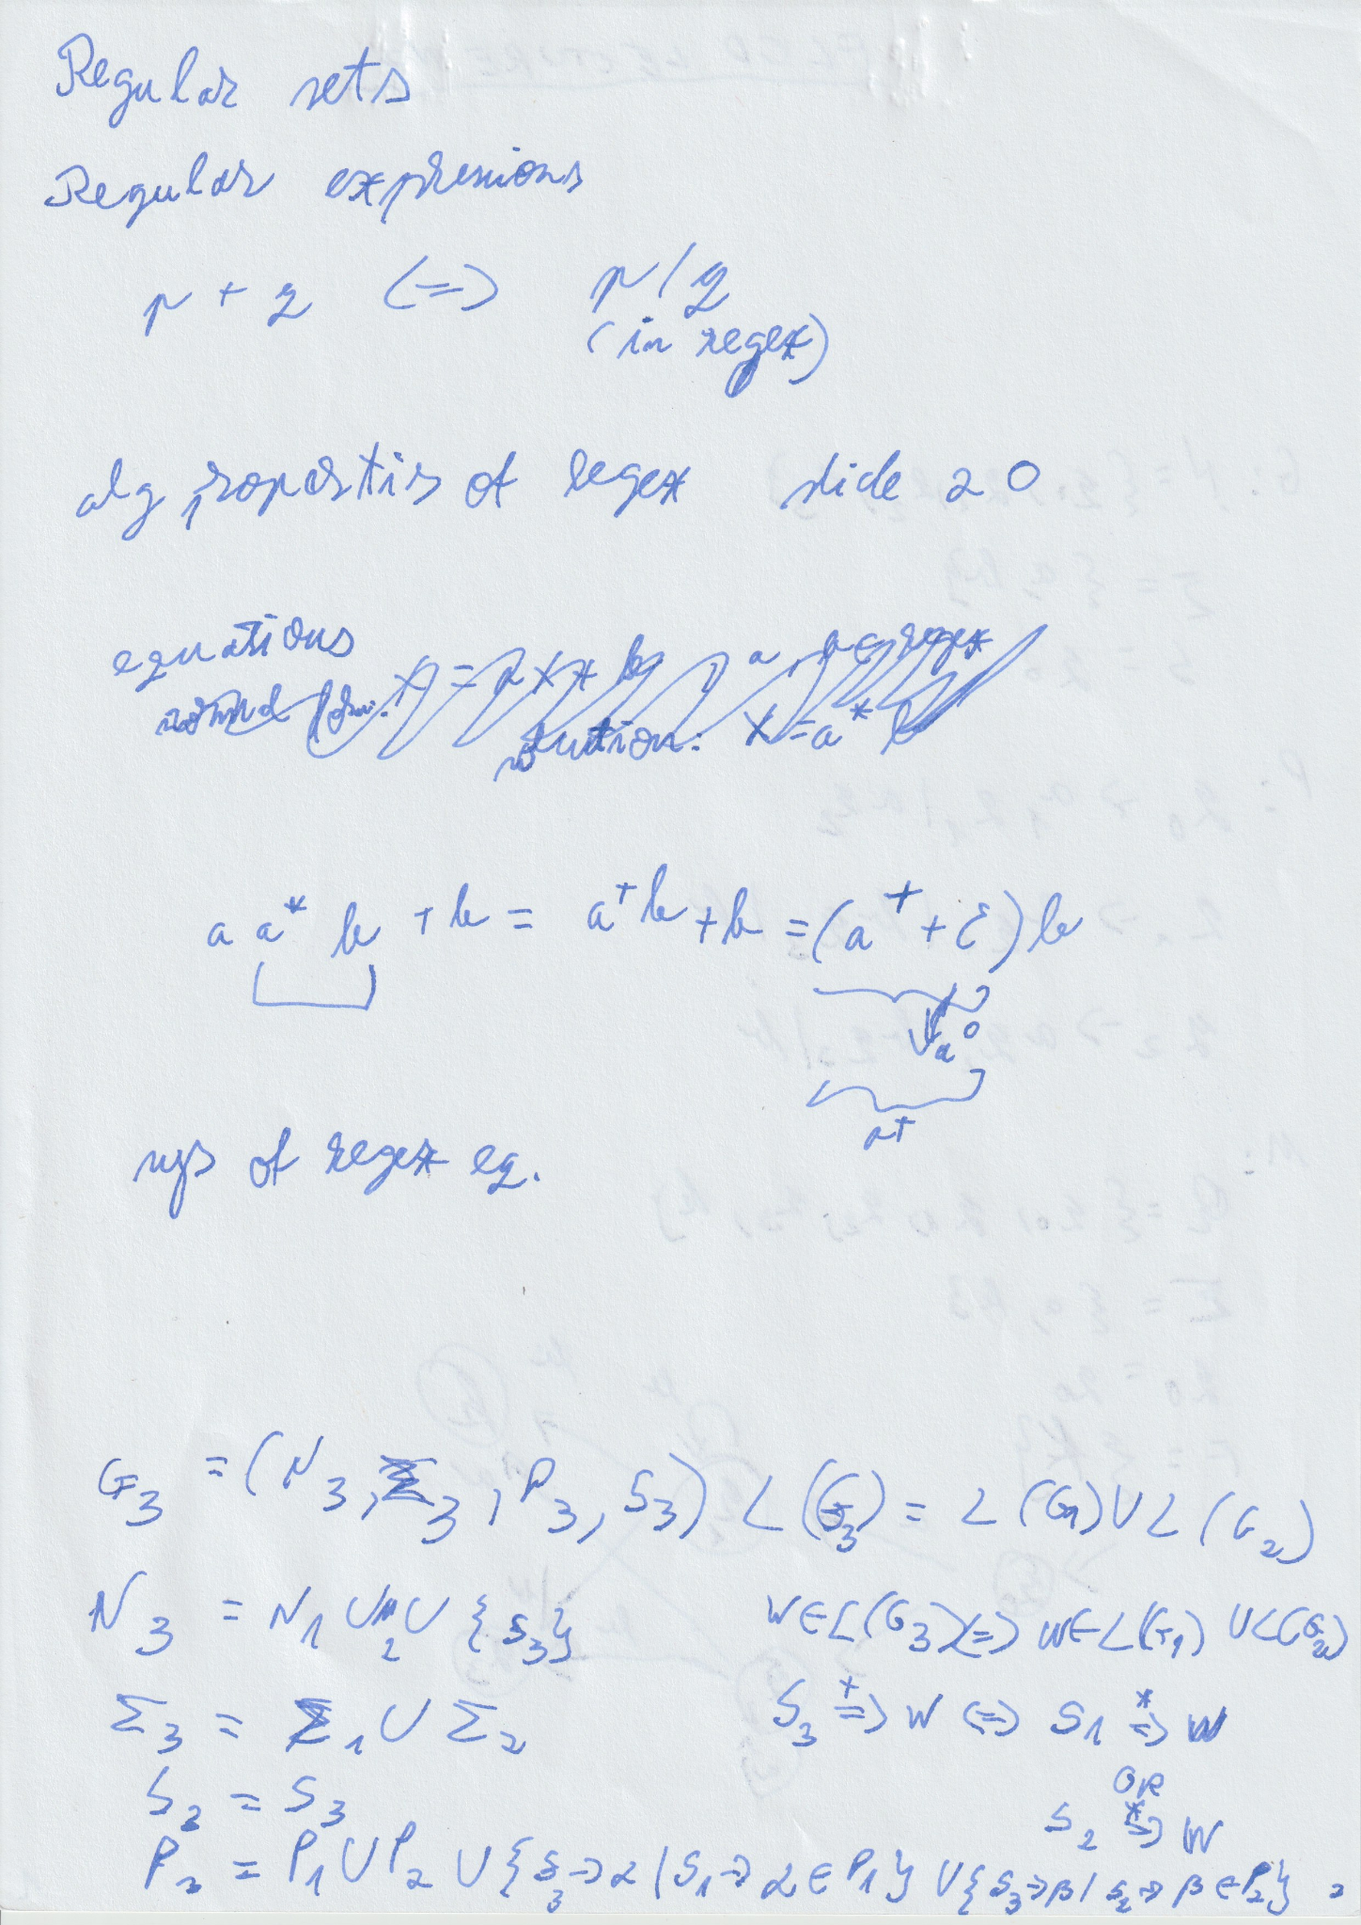

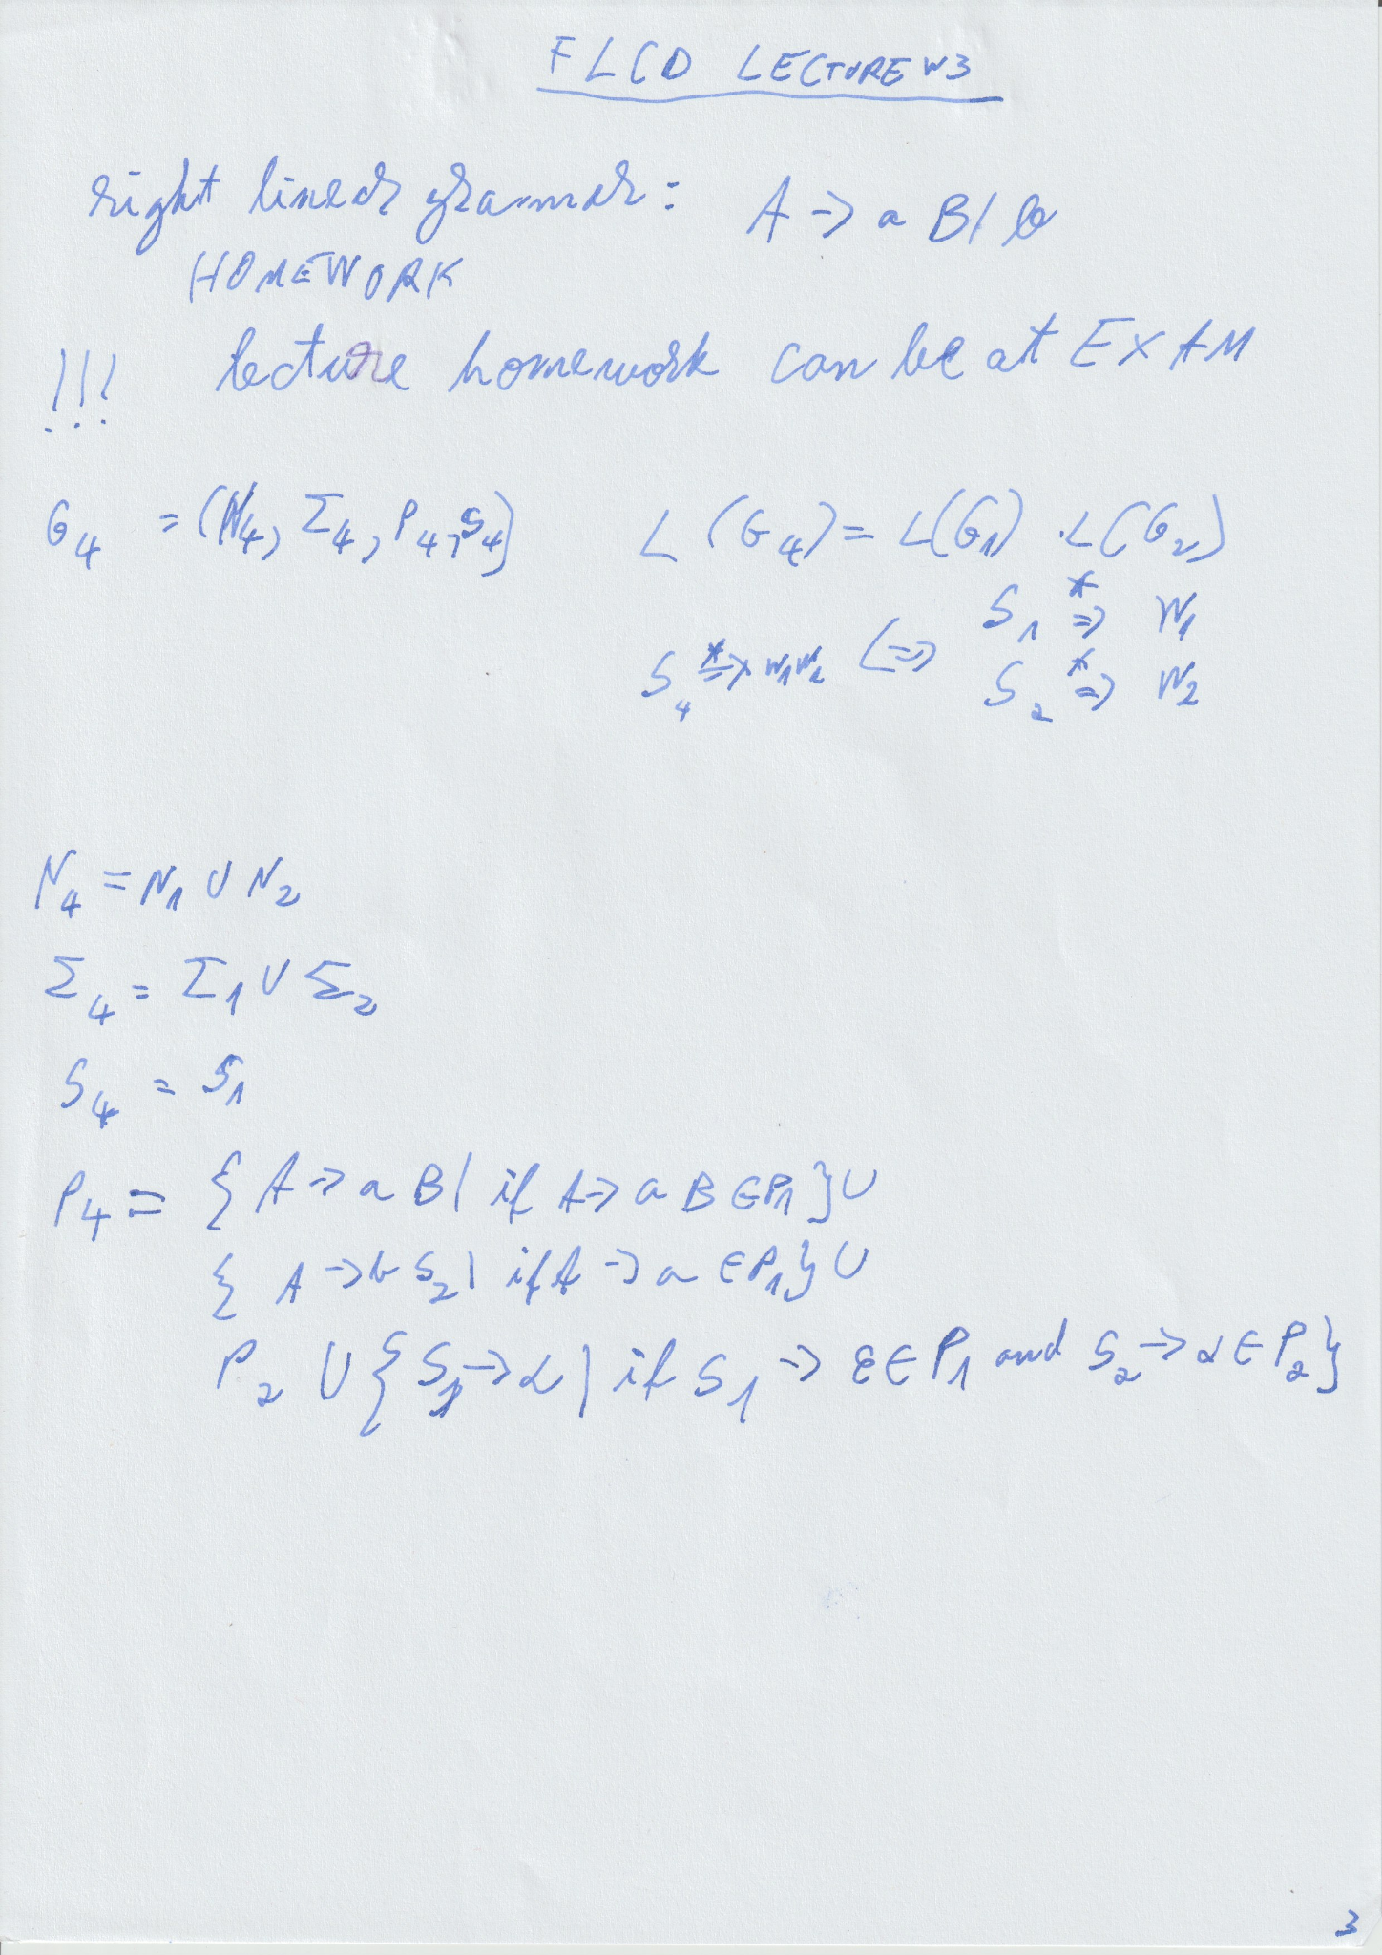

poza de la Deac:

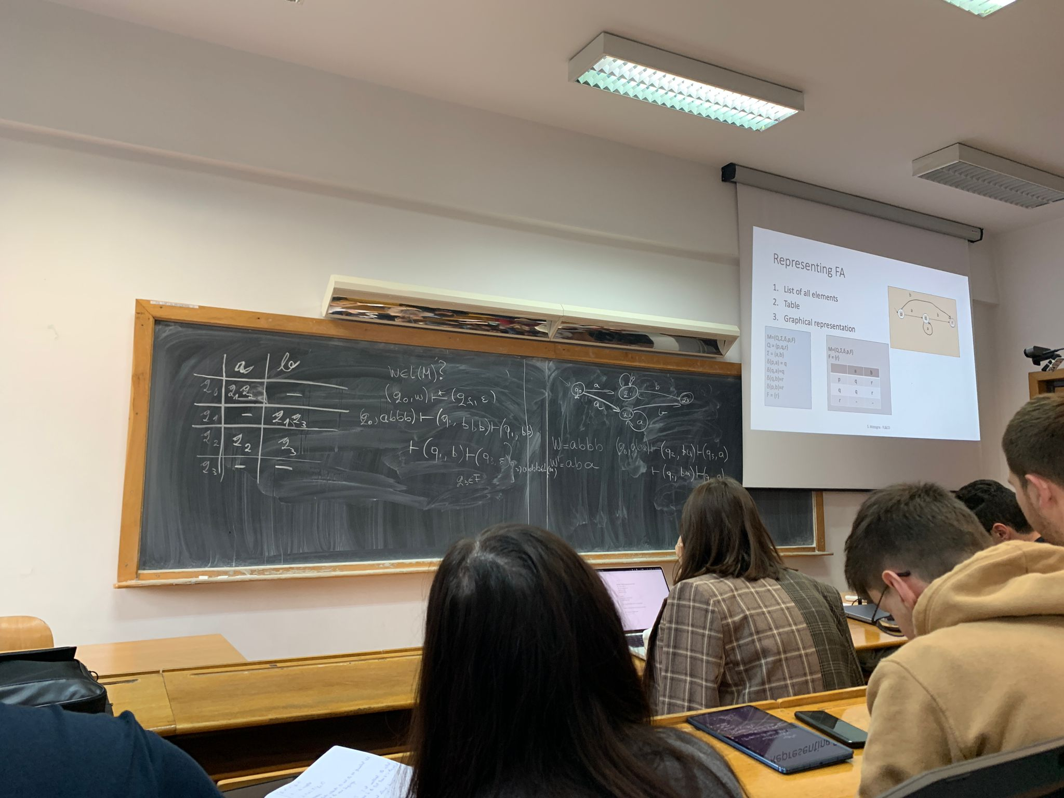

# SEMINAR W3 - Grammars

pdf pe wapp/935 in 24 oct la mesaje marcate

G = (N, Σ, P, S) - grammar

N - nonterminals

Σ - terminals

V = N U Σ - vocabulary

P ⊆ V* N V* X V*

V* - reflexive & transitive closure of V

(α, β) α -> β, α, β ∈ V*

direct derivation:

α => β iff α = α1 γ1 β1 β = α1 γ2 β1 & γ1 -> γ2 ∈ P

α =n> β <- derivation of order n, n ∈ N*

[? in right side of equals is actually above it

? in left side of equals is actually below it]

α =*> β

α =0> β iff α = β

α =+> β

empty sequence: ε

L(G) = { w ∈ Z* | S =*> w }

ex 1

G = (N, Σ, P, S)

N = {S, C}

Σ = {a, b}

P: S -> aCSb | ab

C -> S | bSB

CS -> b

? w = ab(ab2)2 ∈ L(G)

number of productions: | operator simplifies them

(ab2) ≠ a2b2

(ab2) = abab

a2b2 = aabb

P: (1) S -> aCSb

(2)

(3)

(4)

(5)

w = ababbabb

S (1)=> aCSb (4)=> abbSb (2)=4> ababbabb = w => S =4> w ∈ L(G)

ex 2

G = ({S}, {a, b, c}, {S -> a2S (1) | bc (2) }, S)

Assume L = { a2nbc | n ∈ ℕ }

and prove that L = L(G)

I. L ⊆ L(G) (G generates all the seq. of that shape)

II. L(G) ⊆ L (G does not generate anything else but seq. of that shape)

I.

∀ w ∈ L, w ∈ L(G)

∀ n ∈ ℕ, a2nbc ∈ L∈ L(G)

P(n): a2nbc ∈ L(G), n ∈ ℕ

? P(n) is true, ∀ n ∈ ℕ (by math induction)

a. ?P(0) is true

a0bc = bc ∈ L(G) (S (2)=> bc) P(0) is true

phone photo

II. L(G) ⊆ L

S (2)=> bc = a2*0bc ∈ L

(1)=> a2S (2)=> a2bc ∈ L

(1)=> a4S (2)=> a4bc ∈ L

(1)=> a6S (2)=> …

(1)=>

HOMEWORK: teams files section. 25p/problem. 1 week to solve them, then take picture, make pdf and submit on moodle

ex 3

L = { 0n1n2m | n, m ∈ ℕ* }

?G

1. S -> AB (1)
2. A -> 0A1 (2) | 01 (3)
3. B -> 2 (4) | B2 (5)

? L = L(G)

L(G) ⊆ L L ⊆ L(G)

I. ? L ⊆ L(G)

∀ m, n ∈ ℕ*, 0n1n2m ∈ L(G)

let m, n ∈ ℕ*

proven by induction

(i) A =(n)> 0n1n, ∀ n ∈ ℕ

(ii) B =(n)> 2n, ∀ n ∈ ℕ

(i) P(n): A =n> 0n1n, n ∈ ℕ ? P(n) true ∀ n ∈ ℕ

P(k) =?> P(k+1)

P(k): A =k> 0k1k (*)

A (2)=1> 0A1 (*)=k> 00k1k1 = 0k+11k+1 => P(k+1) is true => *P(k) => P(k+1)*

P(1): A (2)=1> 01 (T)

S (1)=> AB (i)=n> 0n1nB (ii)=m> 0n1n2m (m)=(n)> ?????

????

I.

A (3)=> 01

(2)=> 0A1 (3)=> 0212

(2) => 02A12 => …

II.

B (4)=> 2

(4)=> B (4)=> 22

(5)=> B22 => … => B only generates 2m, ∀ m ∈ ℕ*

I + II + S has only one prod. S -> AB

=> G only generates 0n1n2m | n, m ∈ ℕ*

# LAB W3

1a

documentatie: diagrama de clase cu

explicat data structure

# SEMINAR W4 - FA

1 Automaton, 2 automata

1 automat, 2 automate

ex 1

M = (Q, Σ, δ, q0, F)

Q = {q0, q1, q2, q7}

Σ = {1, 2, 3}

F = {q7}

| δ | 1 | 2 | 3 |
| --- | --- | --- | --- |
| q0 | {q0, q1} | {q0, q2} | {q0, q3} |
| q1 | {q1, q7} | {q7} | {q1} |
| q2 | {q2} | {q2, q7} | {q2} |
| q3 | {q3} | {q3} | {q3, q7} |
| q7 | ∅ | ∅ | ∅ |

? w = 12321 ∈ L(M)

δ: Q × Σ → 𝒫 (Q)

(q, x) -> config., x ∈ Σ*

(q0, ?) -> initial config.

(qf, ε) -> final config., qf comes from F

direct transition: (P, ax) |--- (q, x) iff q ∈ δ(p, a), P ∈ Q, a ∈ Σ, x ∈ Σ*

|---n n ∈ ℕ*

|---*

|---+

L(M) = {w ∈ Σ* | (q0, w) |---* (qf, ε), qf ∈ F}

continued on paper

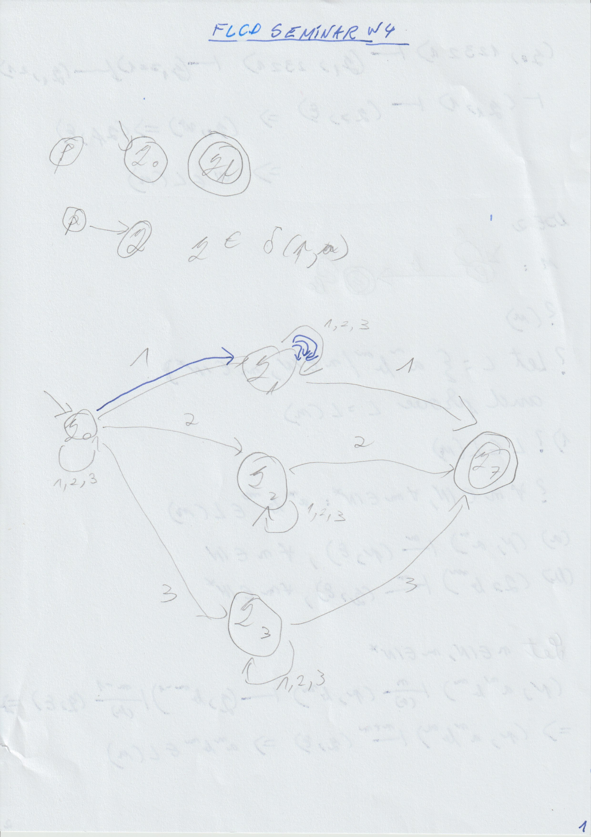

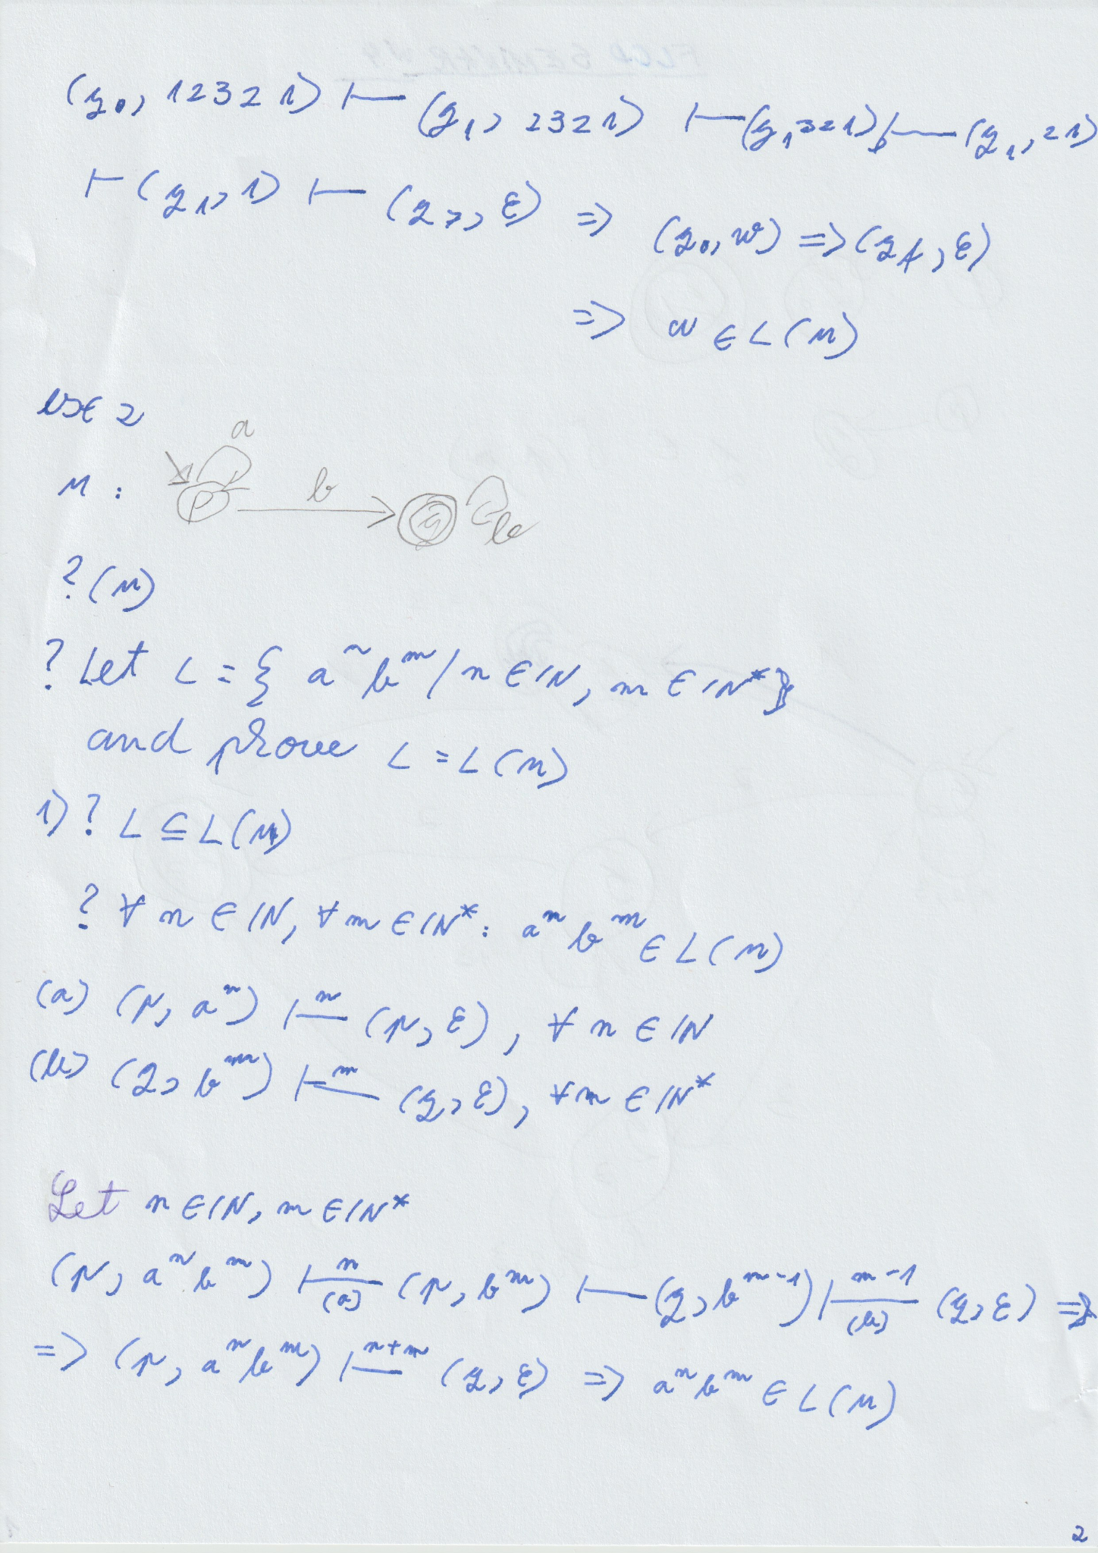

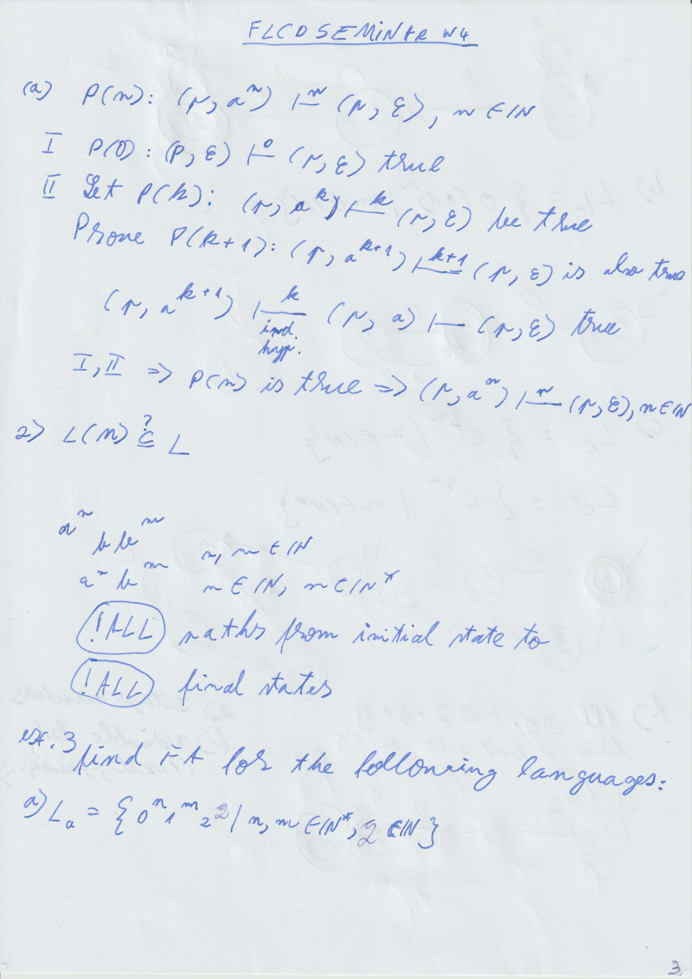

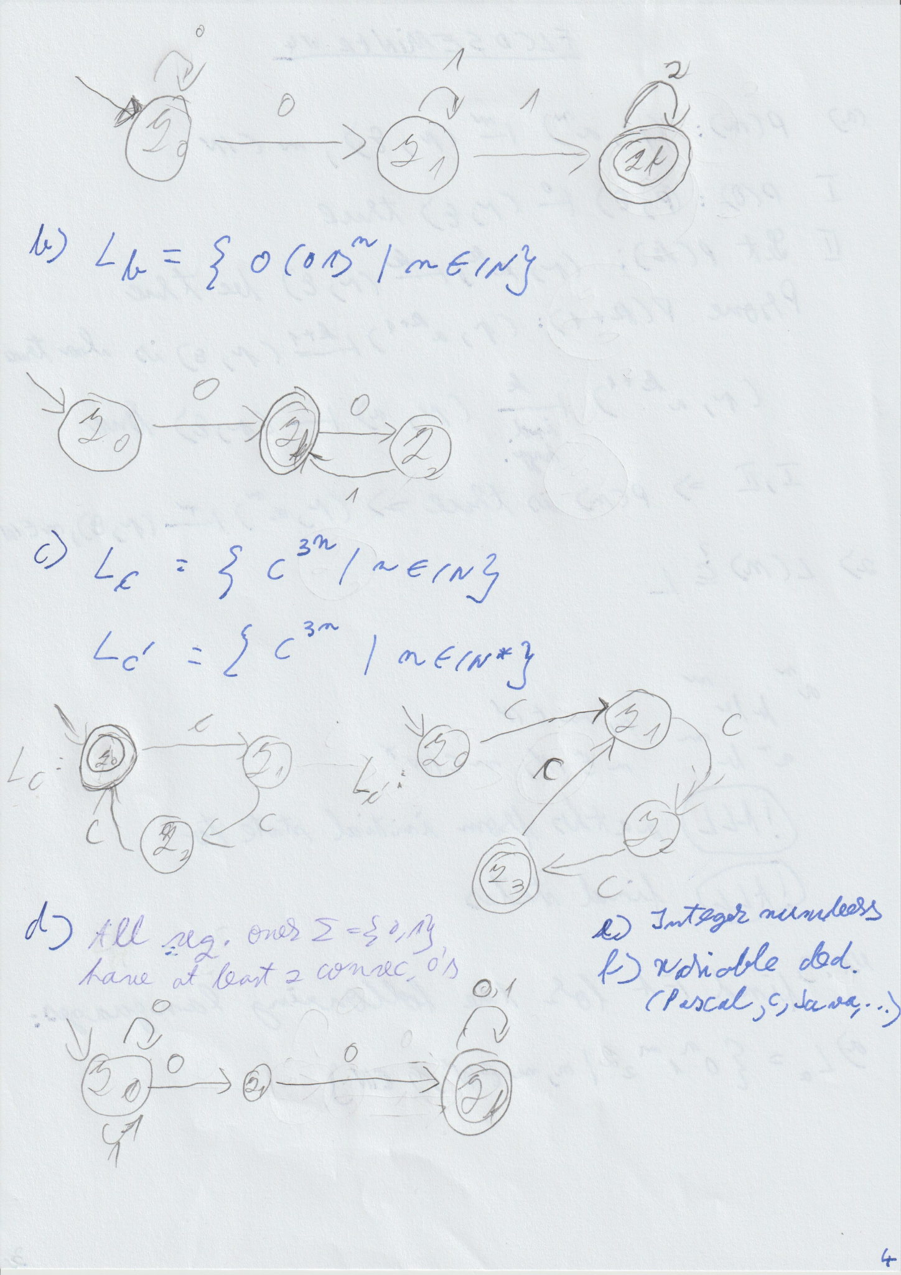

# LAB W4

documentatie:

* explicam structura de data pentru pif
* algoritmul pe scurt
* regex-urile
* diagrama de clase: PIF, scanner, ST

keyword, sep, operators - adaug in PIF cu -1

id, const - adaug in ST once, adaug in PIF de fiecare data cu poz in ST

regex pt fiecare tip, pt identifier

!!! attention to >= - corresponds to 1 PIF entry

# LECTURE W5

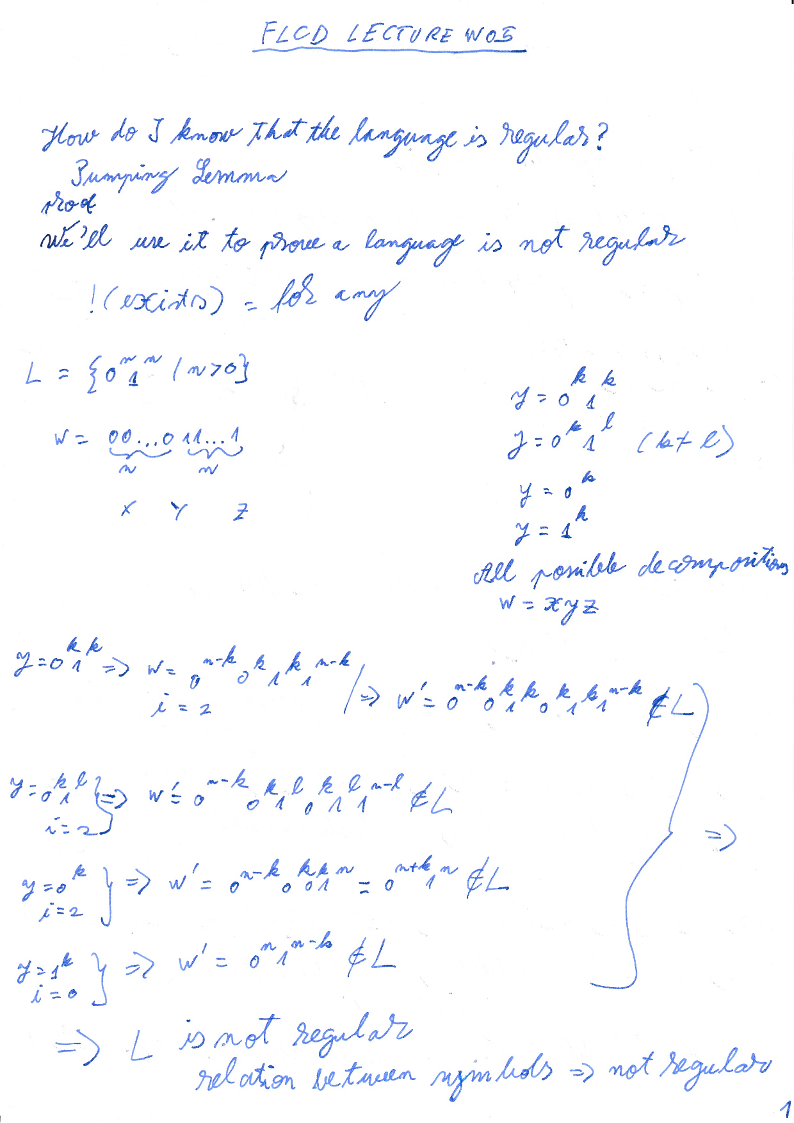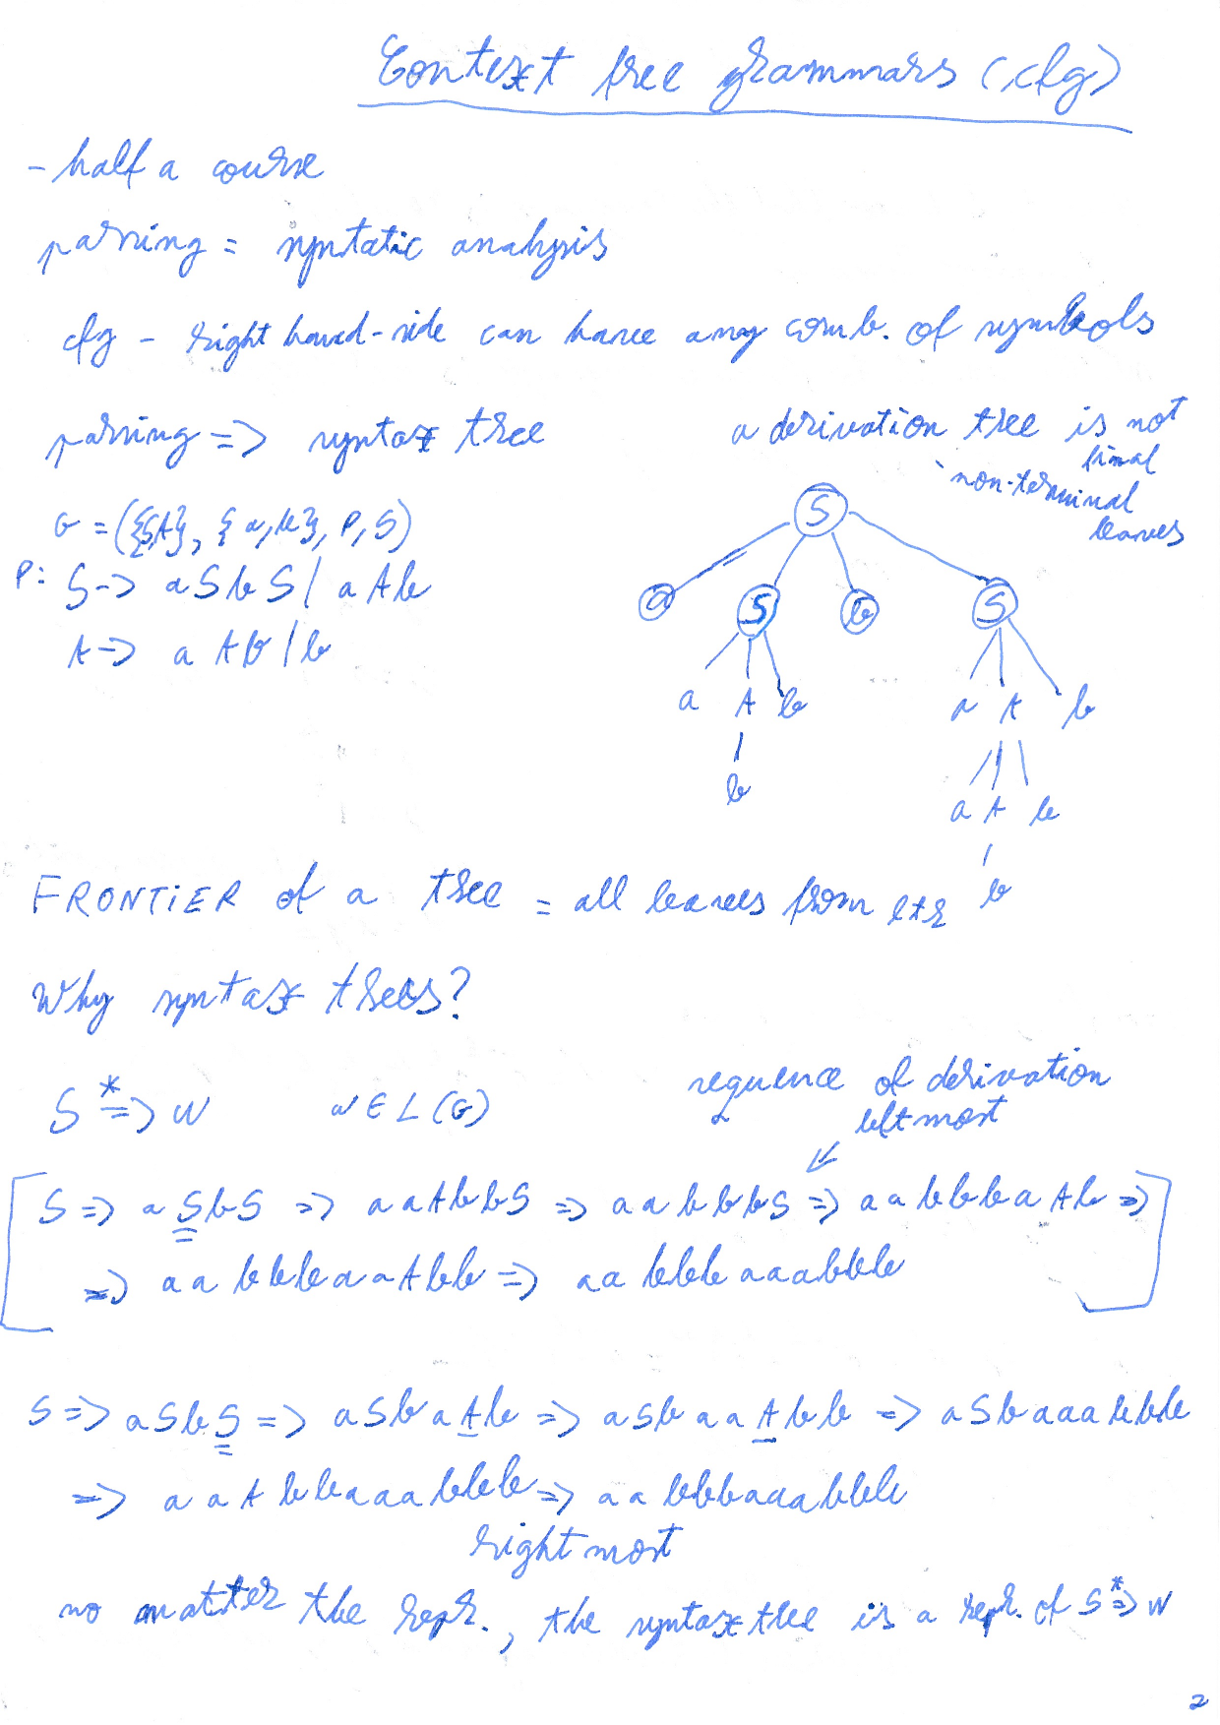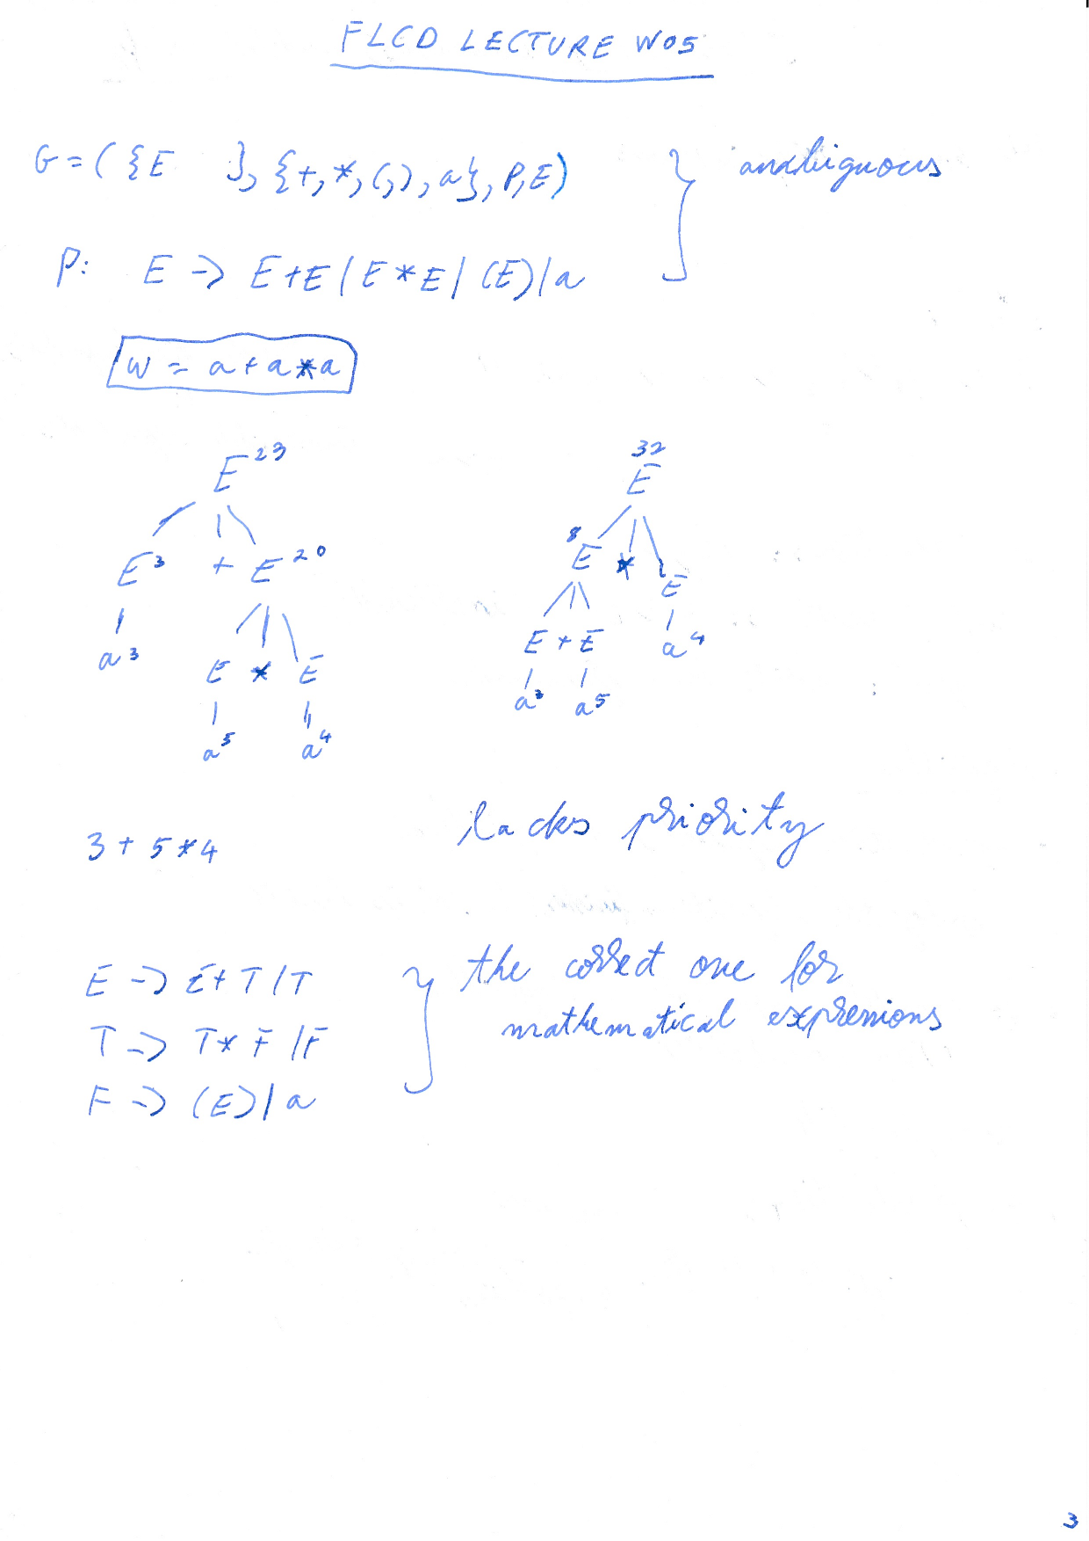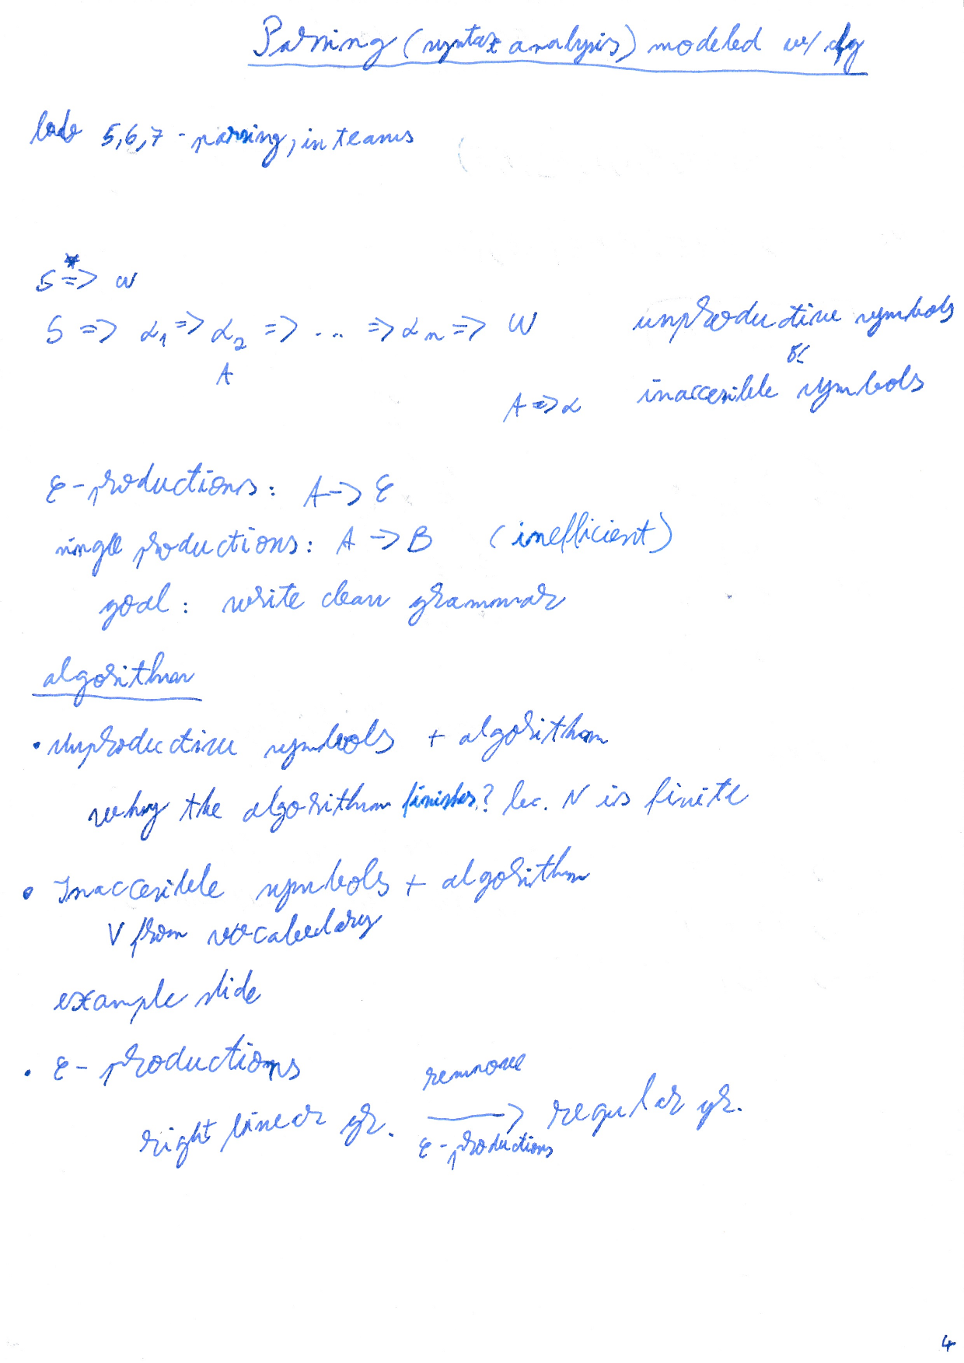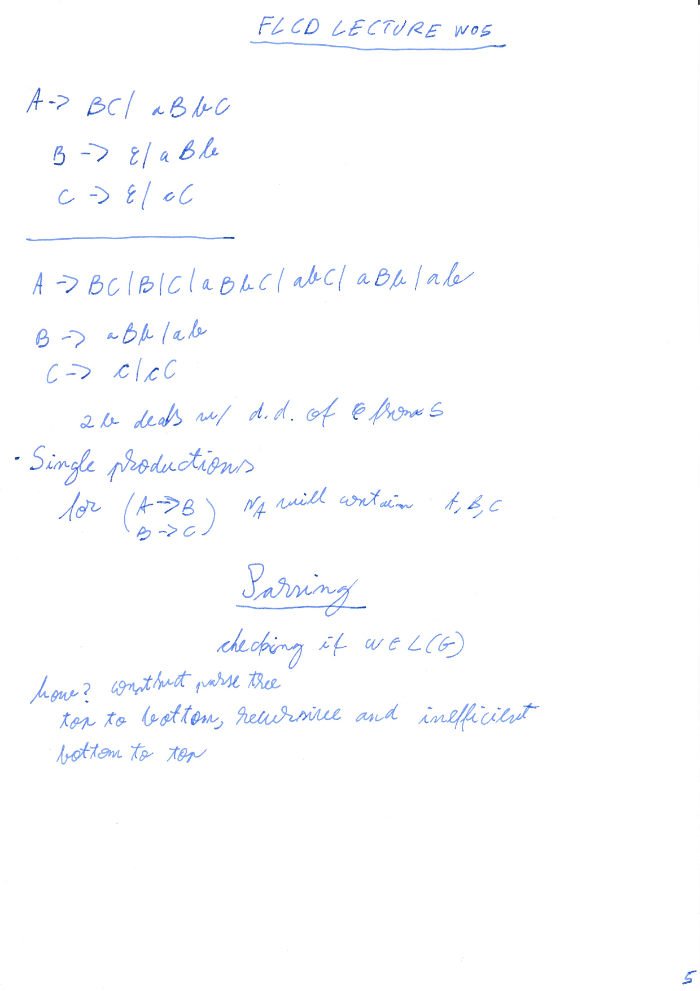

# SEMINAR W5 transformations

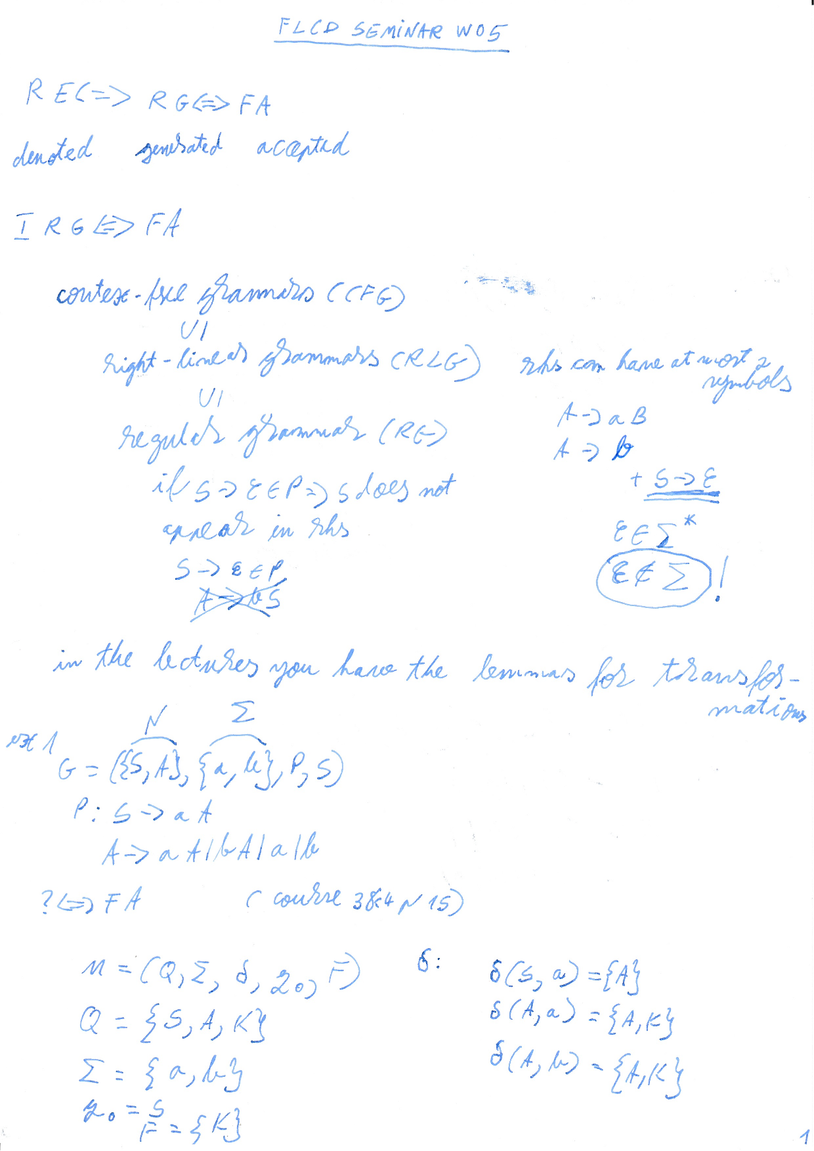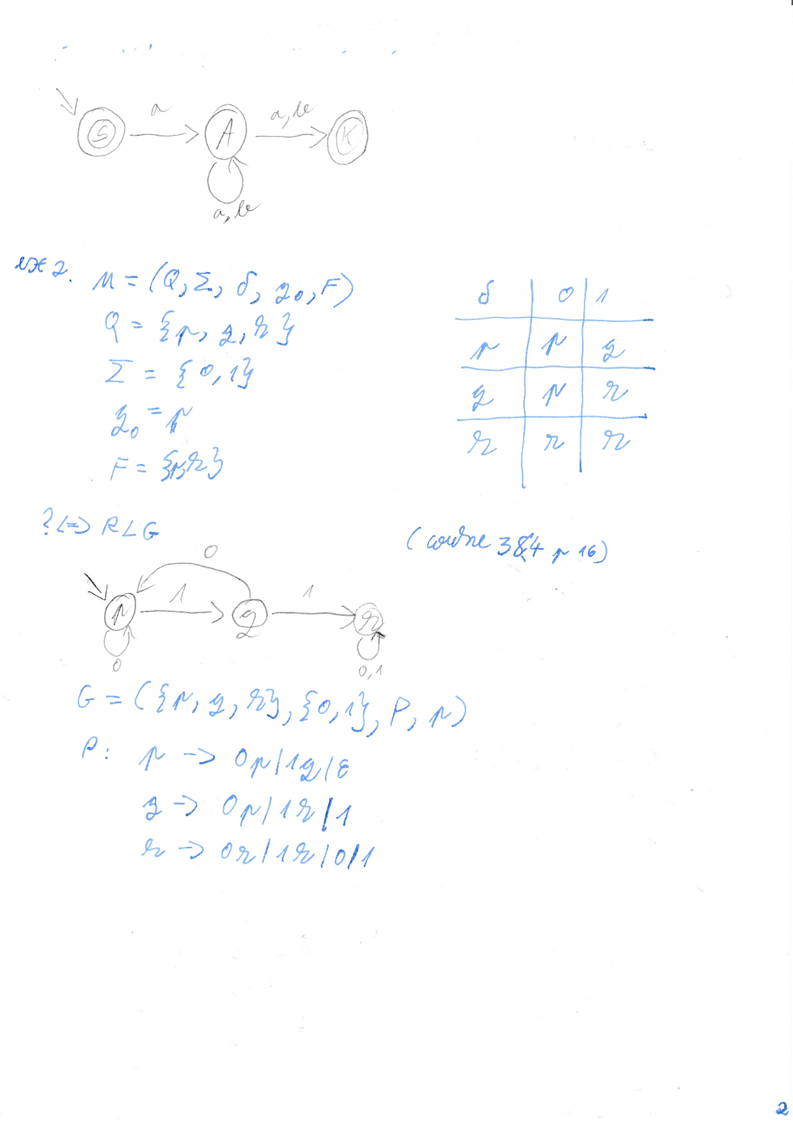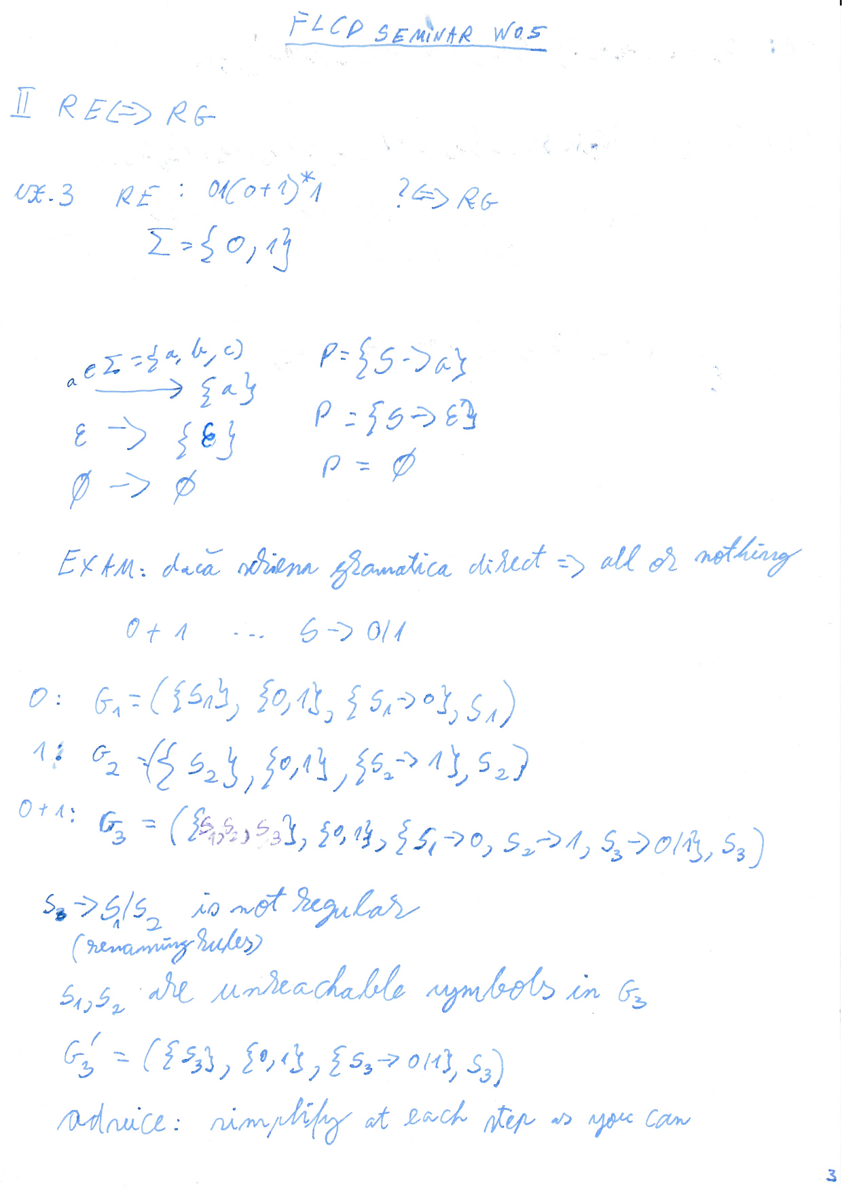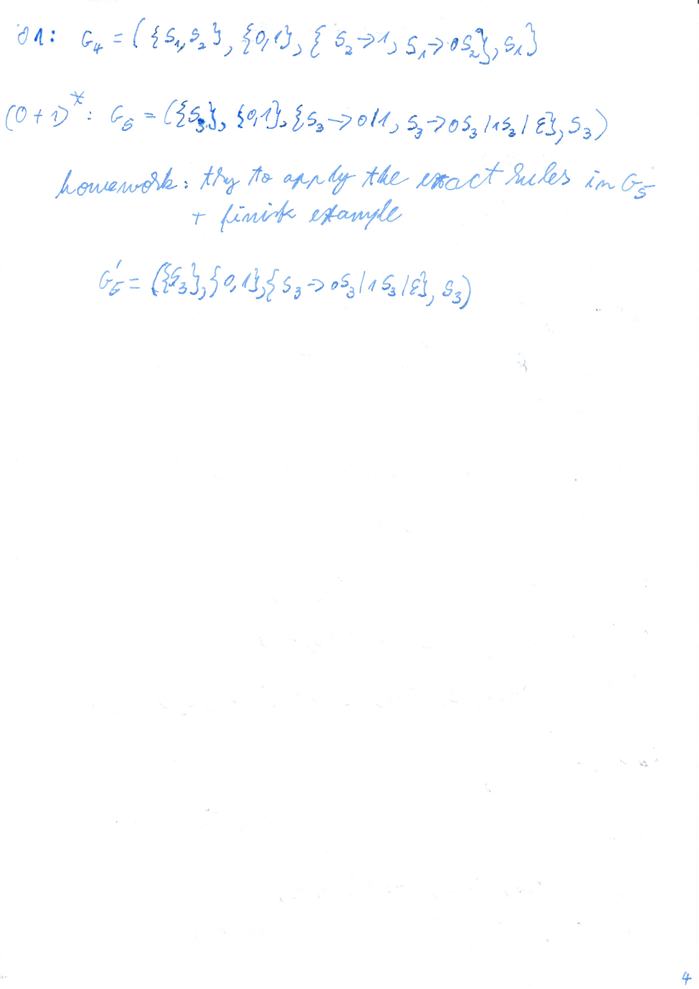

# LAB W5

examen: se cere demonstratia la Pumping Lemma

# LECTURE W6

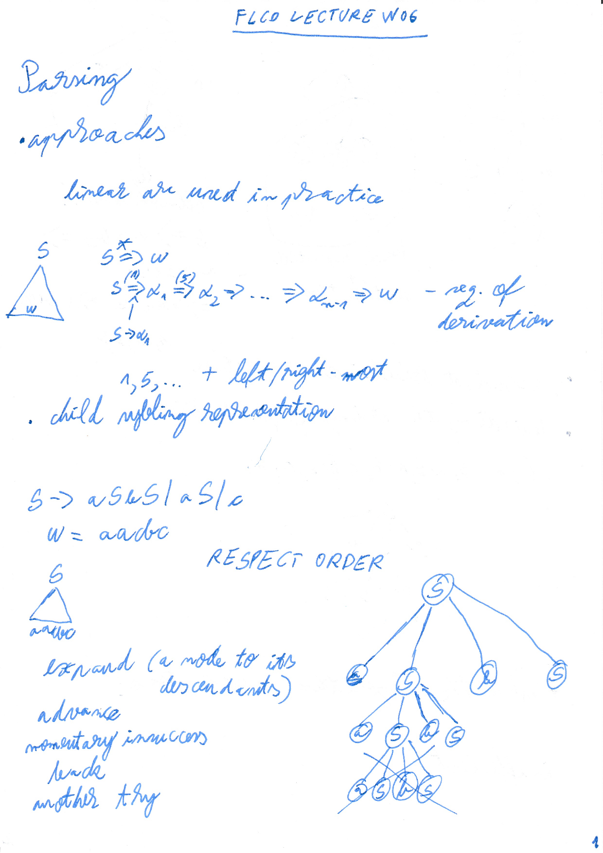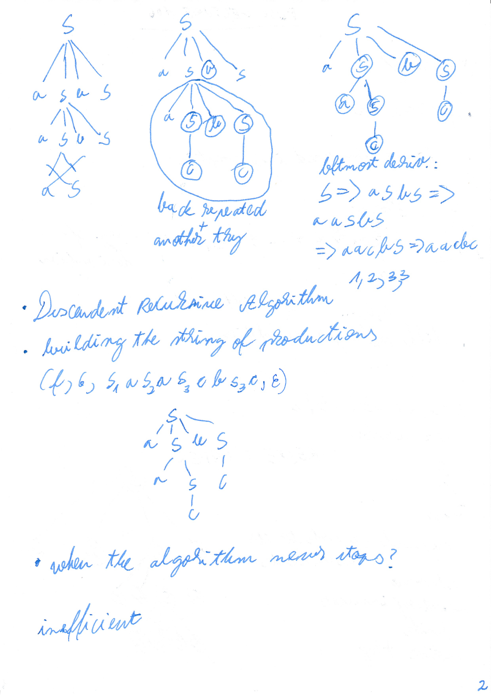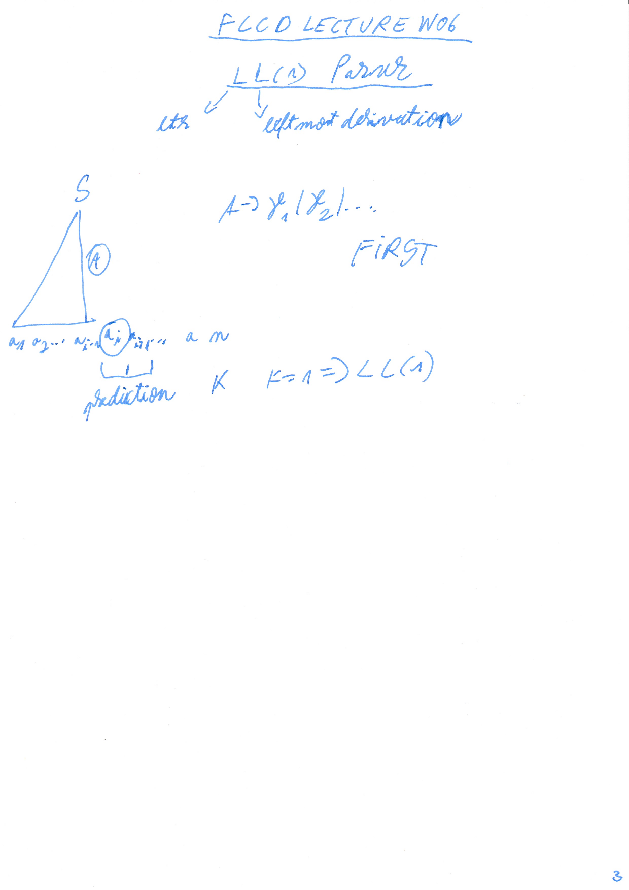

# SEMINAR W6 - transformations

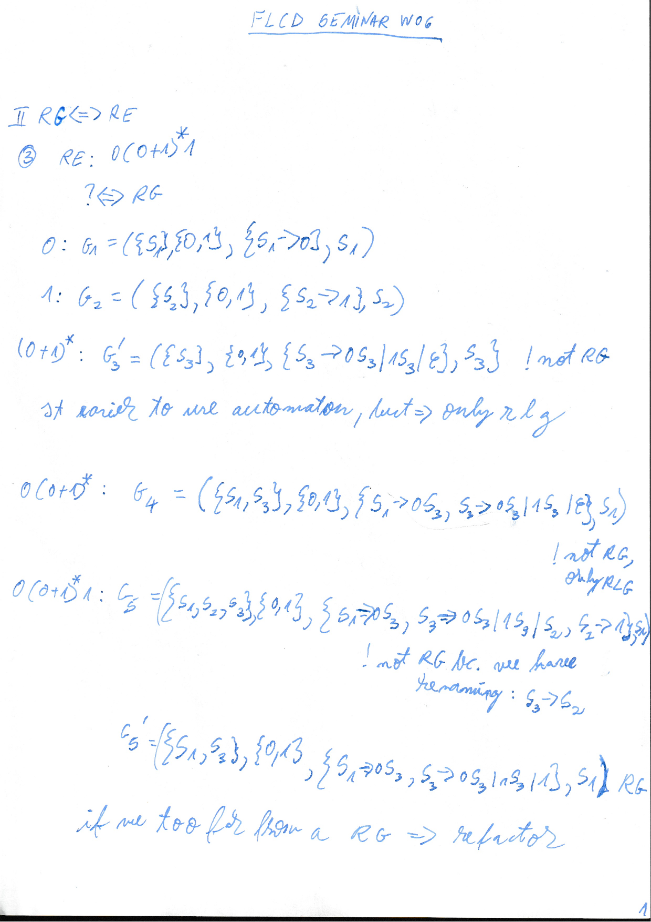

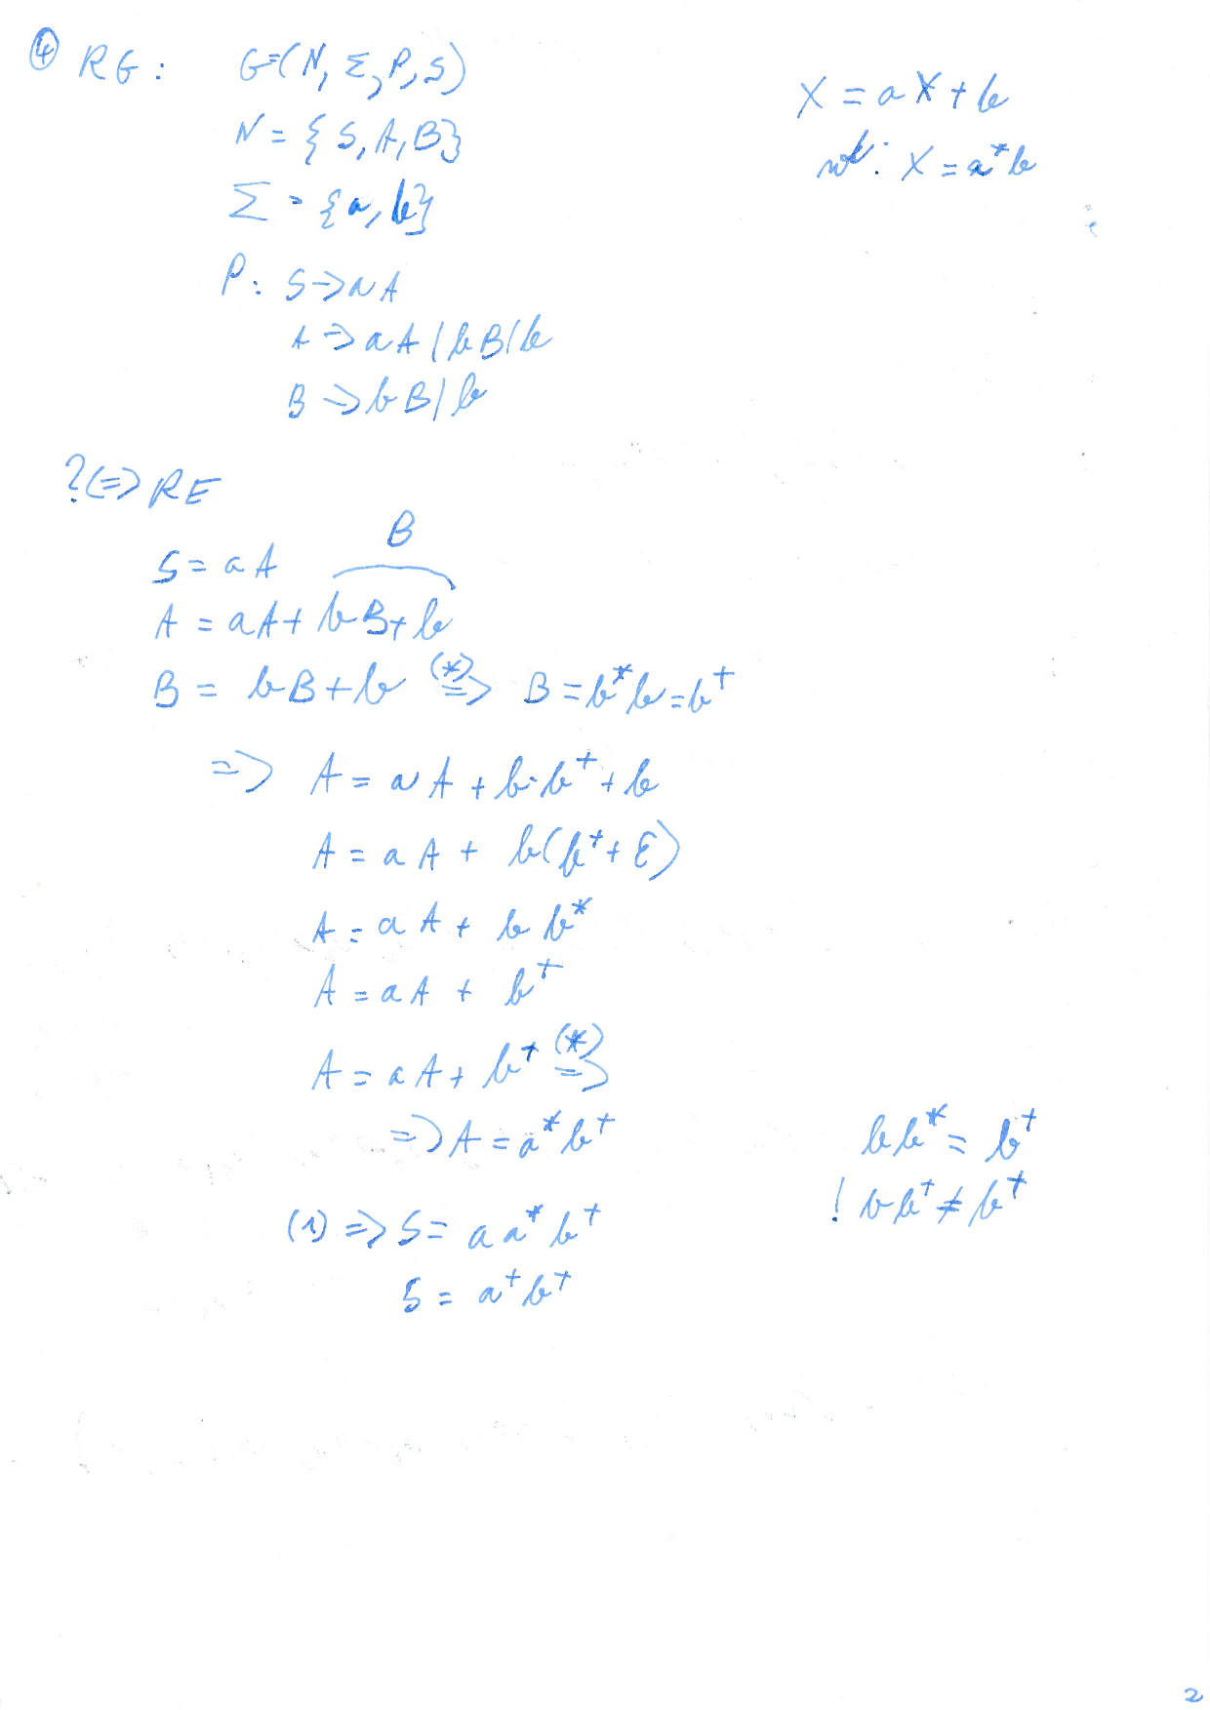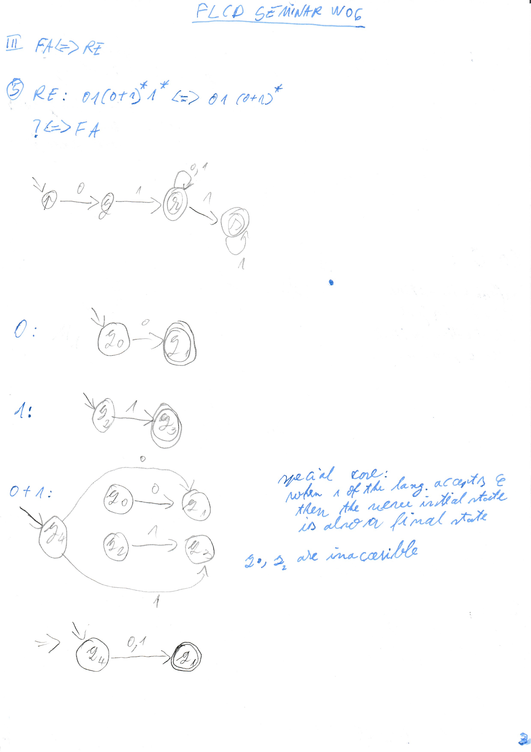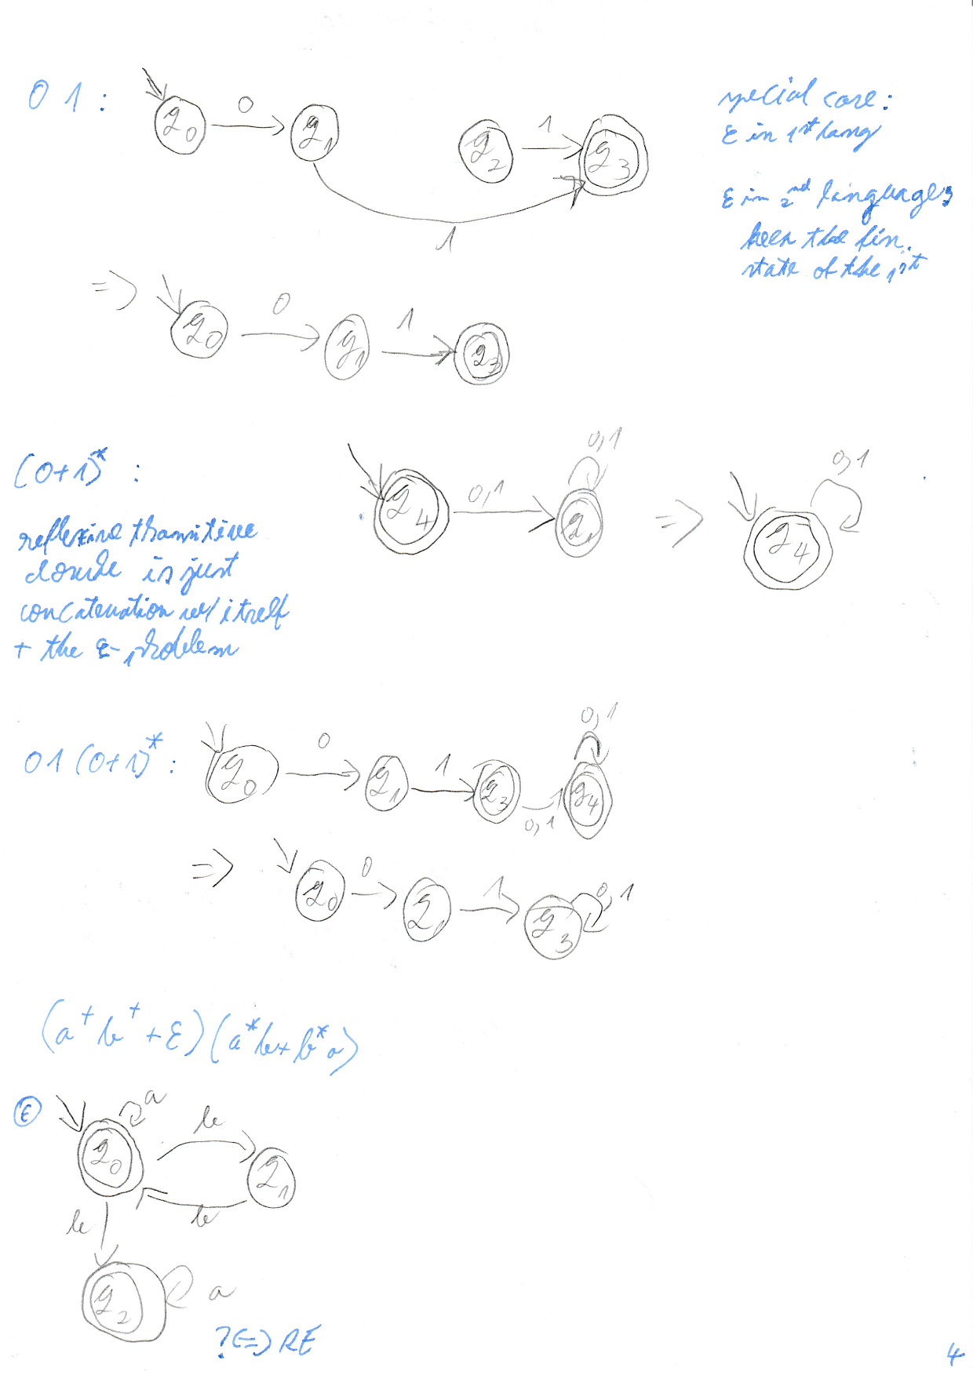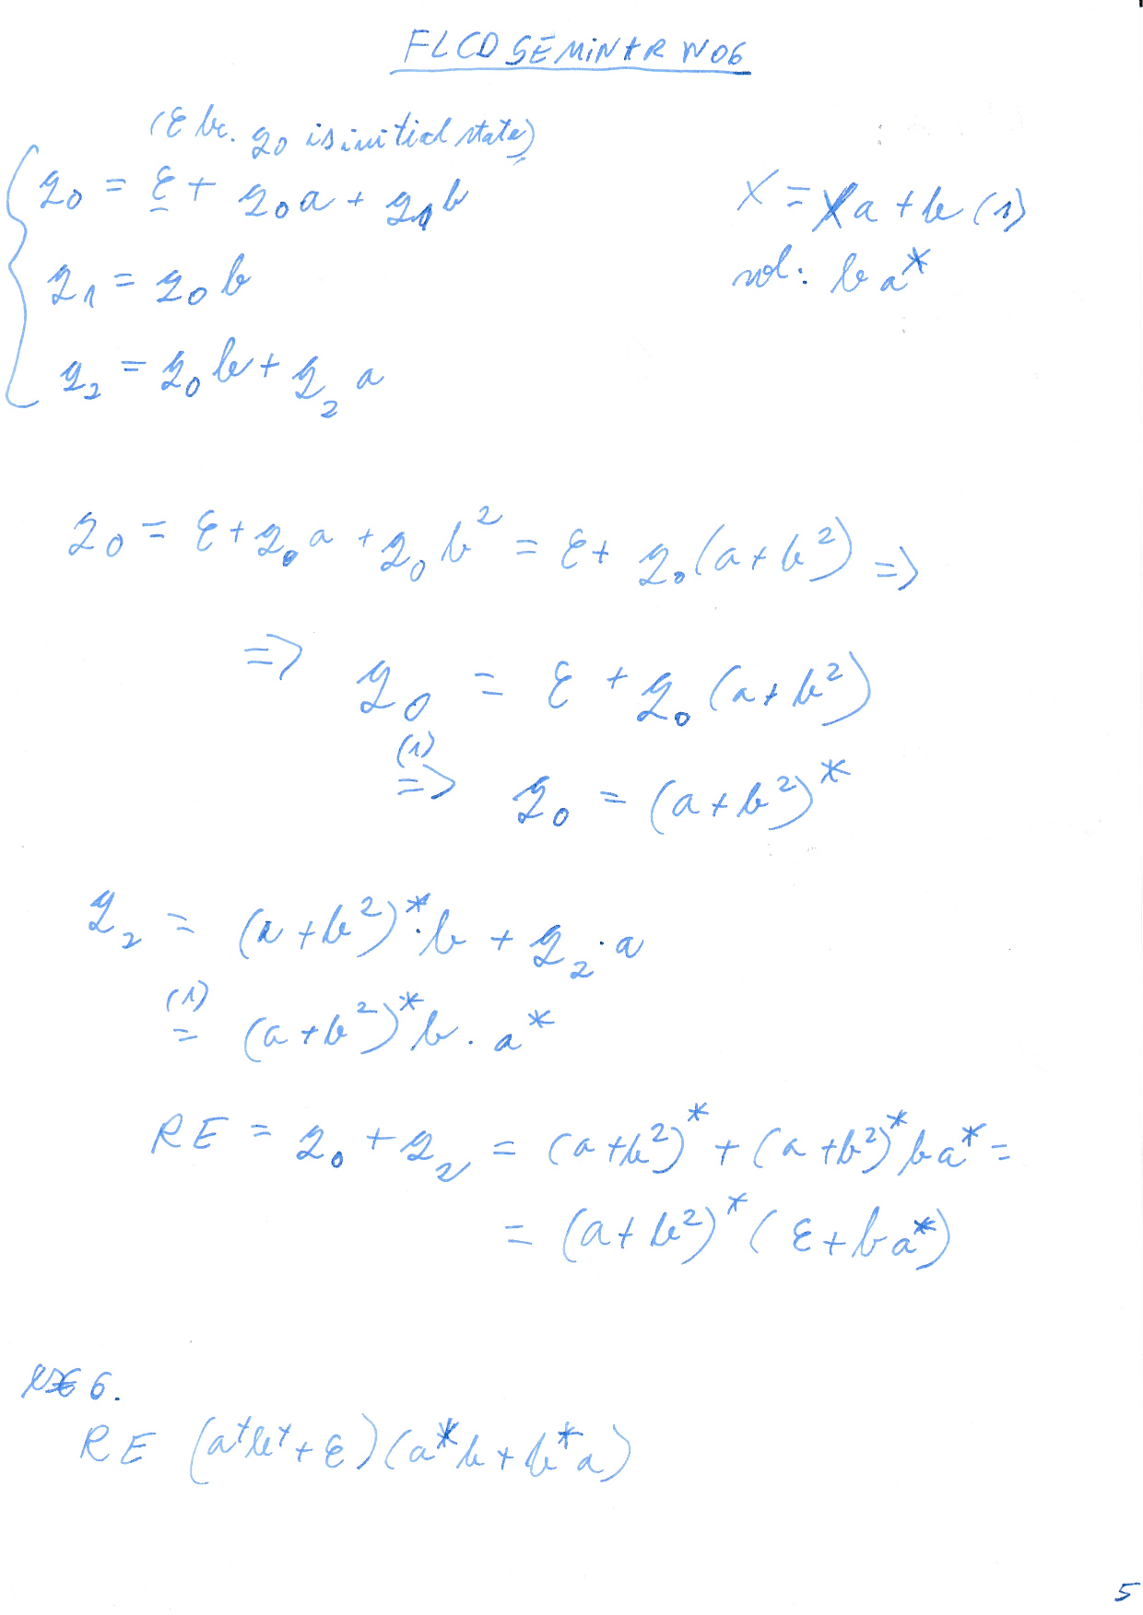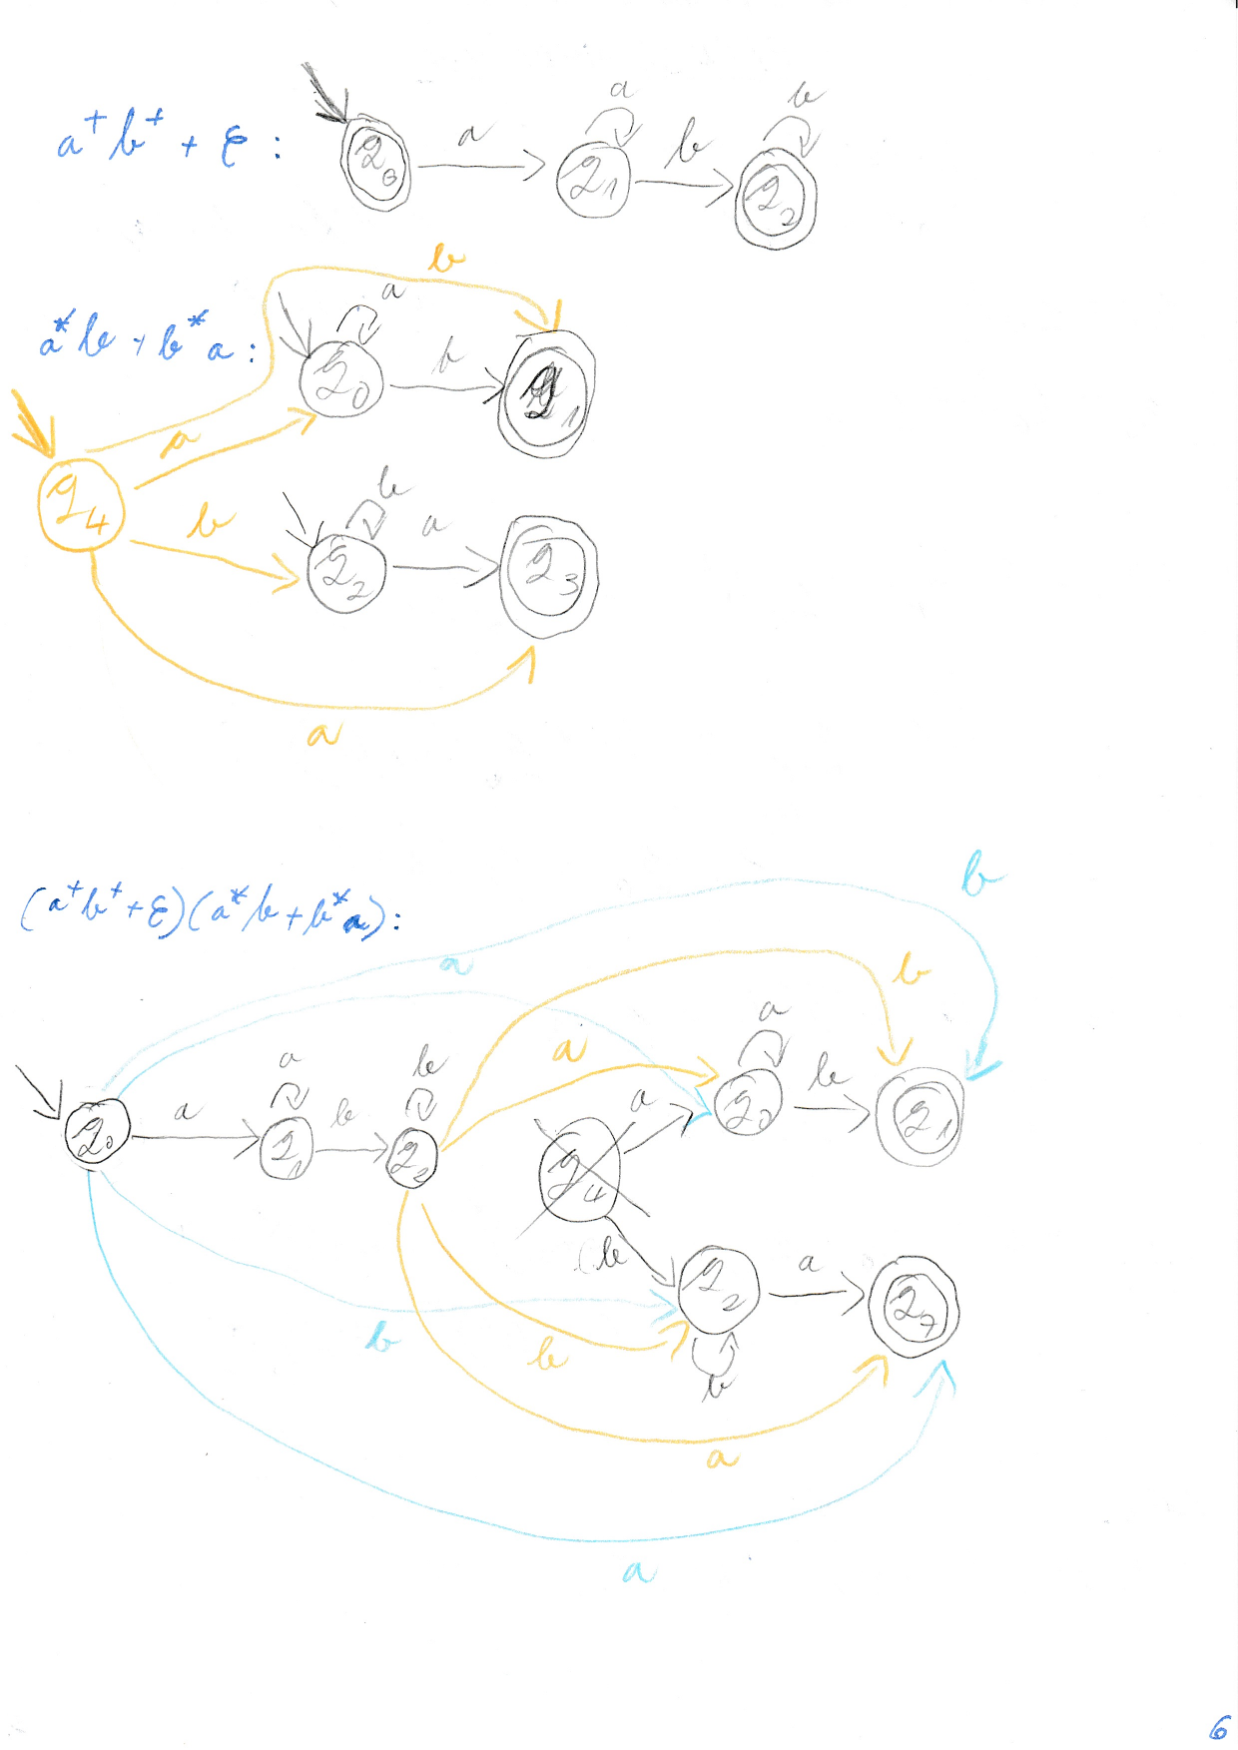

# LAB W6

DFA = deterministic finite automata

pentru a accepta o secventa: parcurg intreaga secventa + starea curenta e finala

would be nice to make a function which checks for DFA

p,q,r

0,1

p,0 - q

p,1 - r

q,1 - q

clasa FA cu 5 elemente, functia de tranzitie

set of states

alphabet

initial state

set of final states

transitions - list of elements of type transition

!!! nu se face laboratorul in saptamana cu 1 dec ca e plecat profu toata saptamana

wifi:

MateInfoMHP

computer

instead of regex to check is identifier, constat, use FA

documentatie: diagrama de clase

file = states alphabet

states = state{, state}

# LECTURE W7 - LL(1) & LL(k)

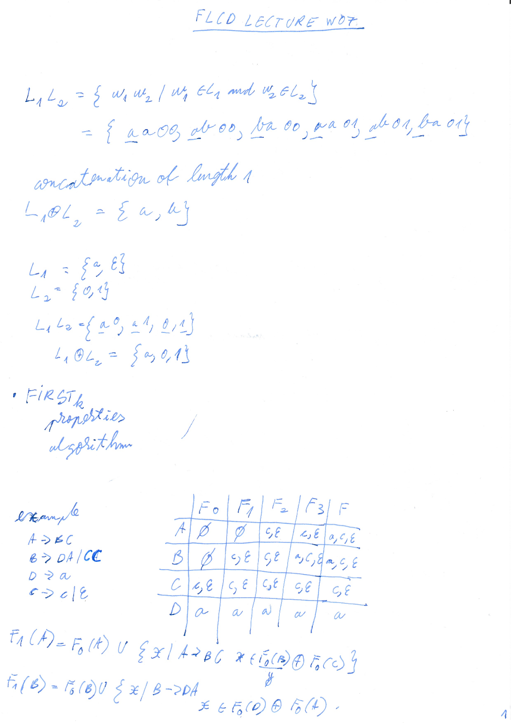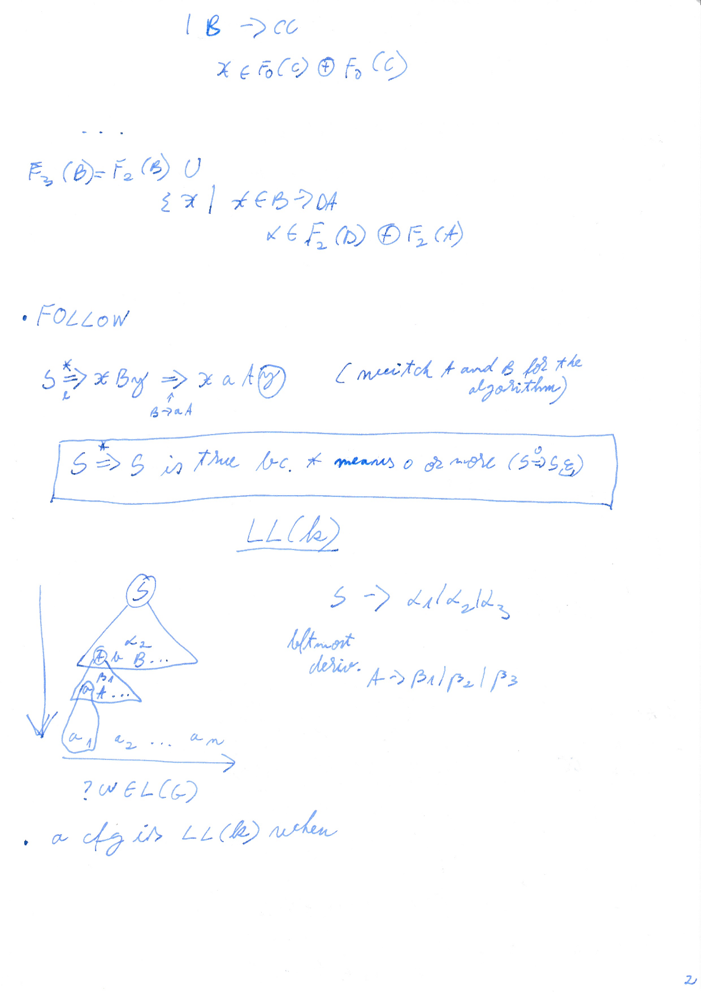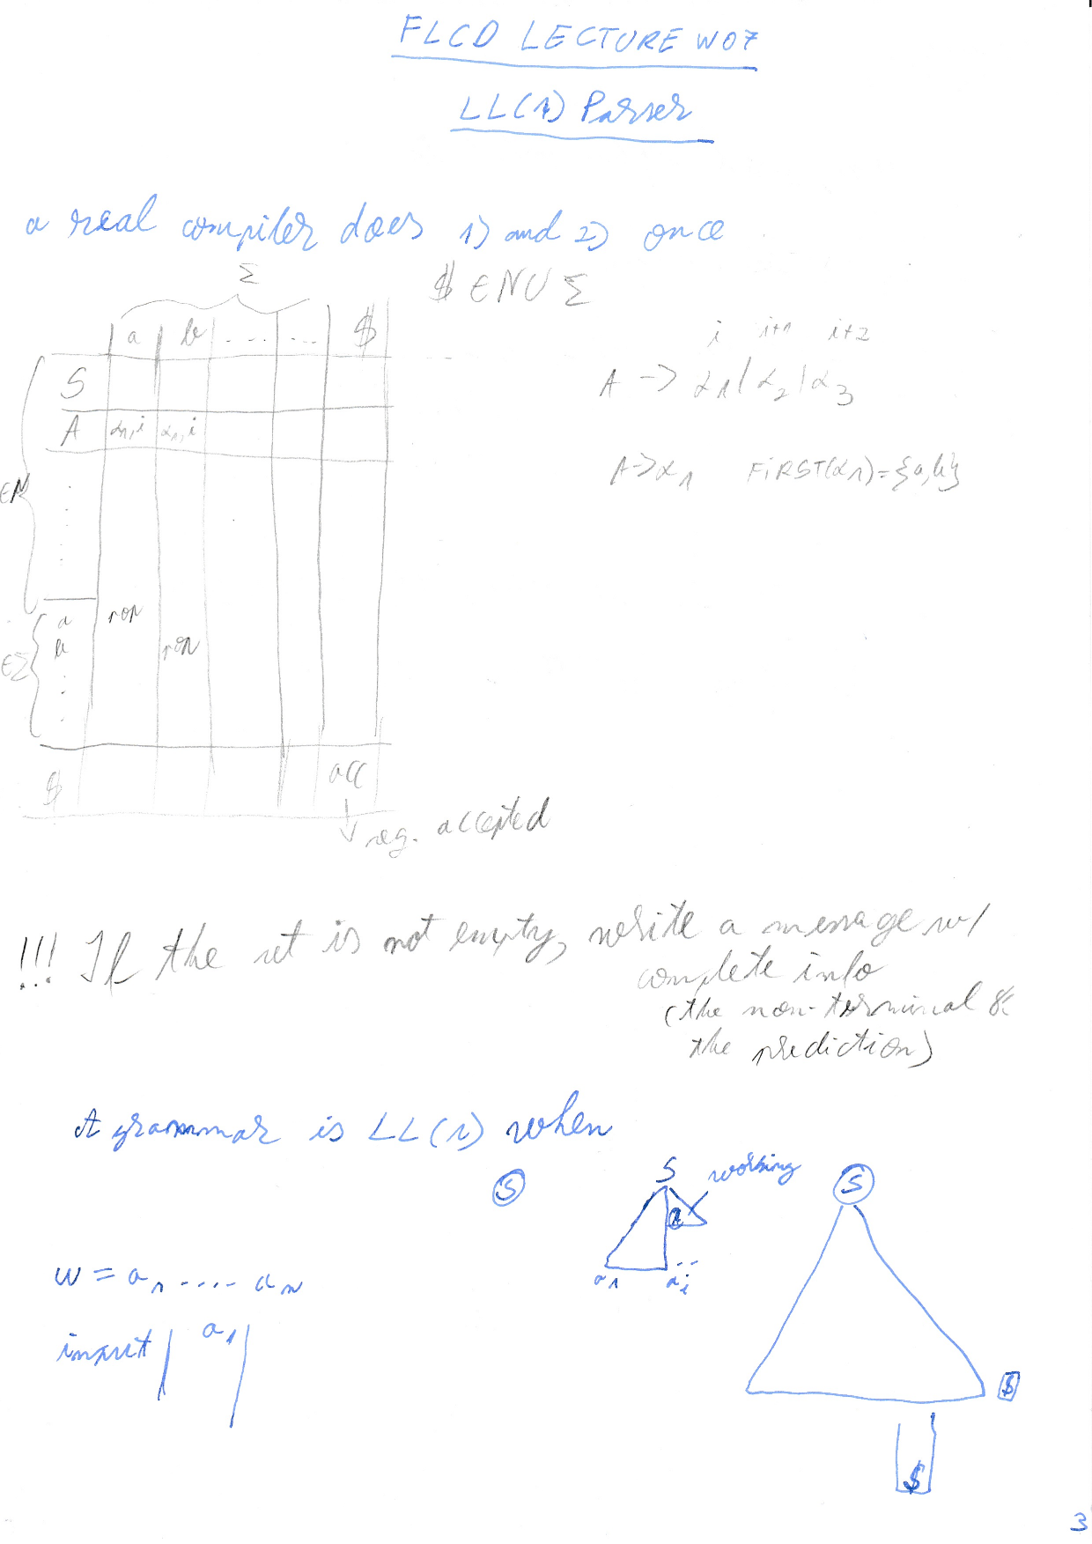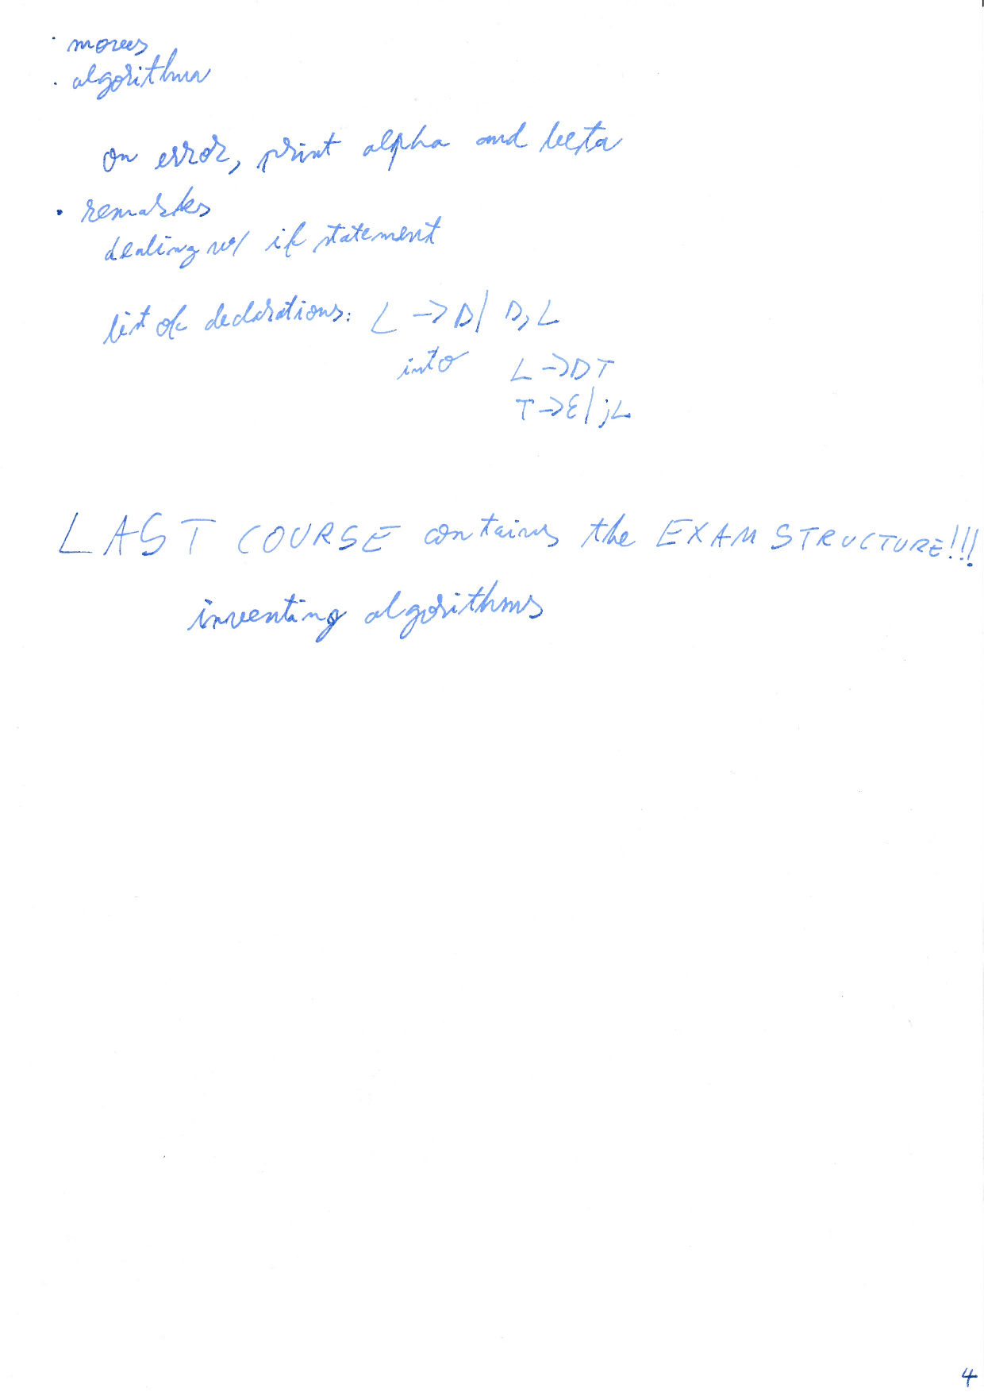

# 

# SEMINAR W7 - CFG, parser, descendant recursive

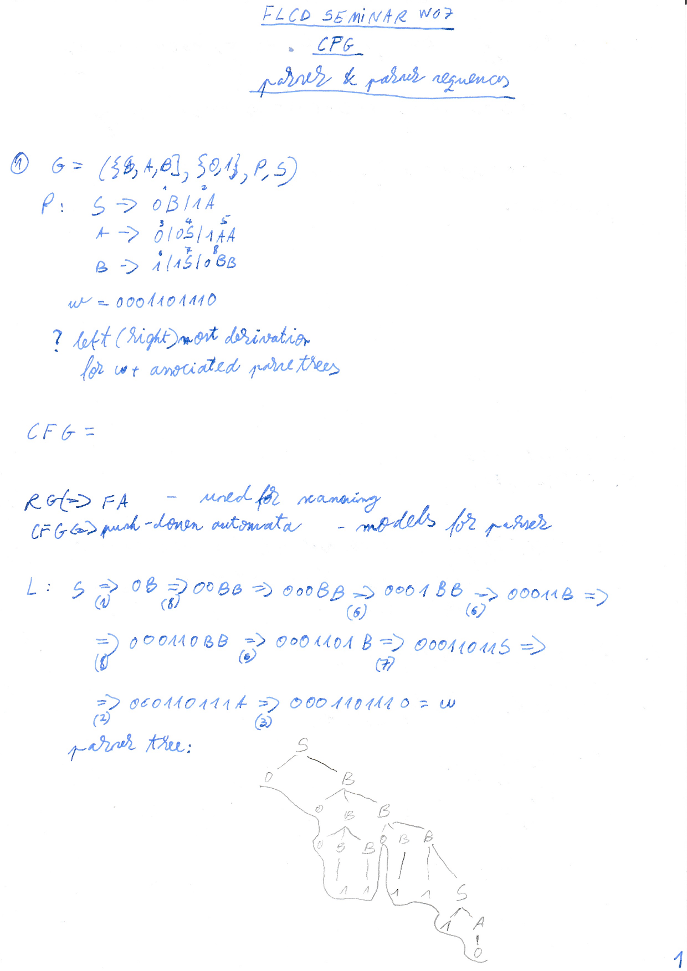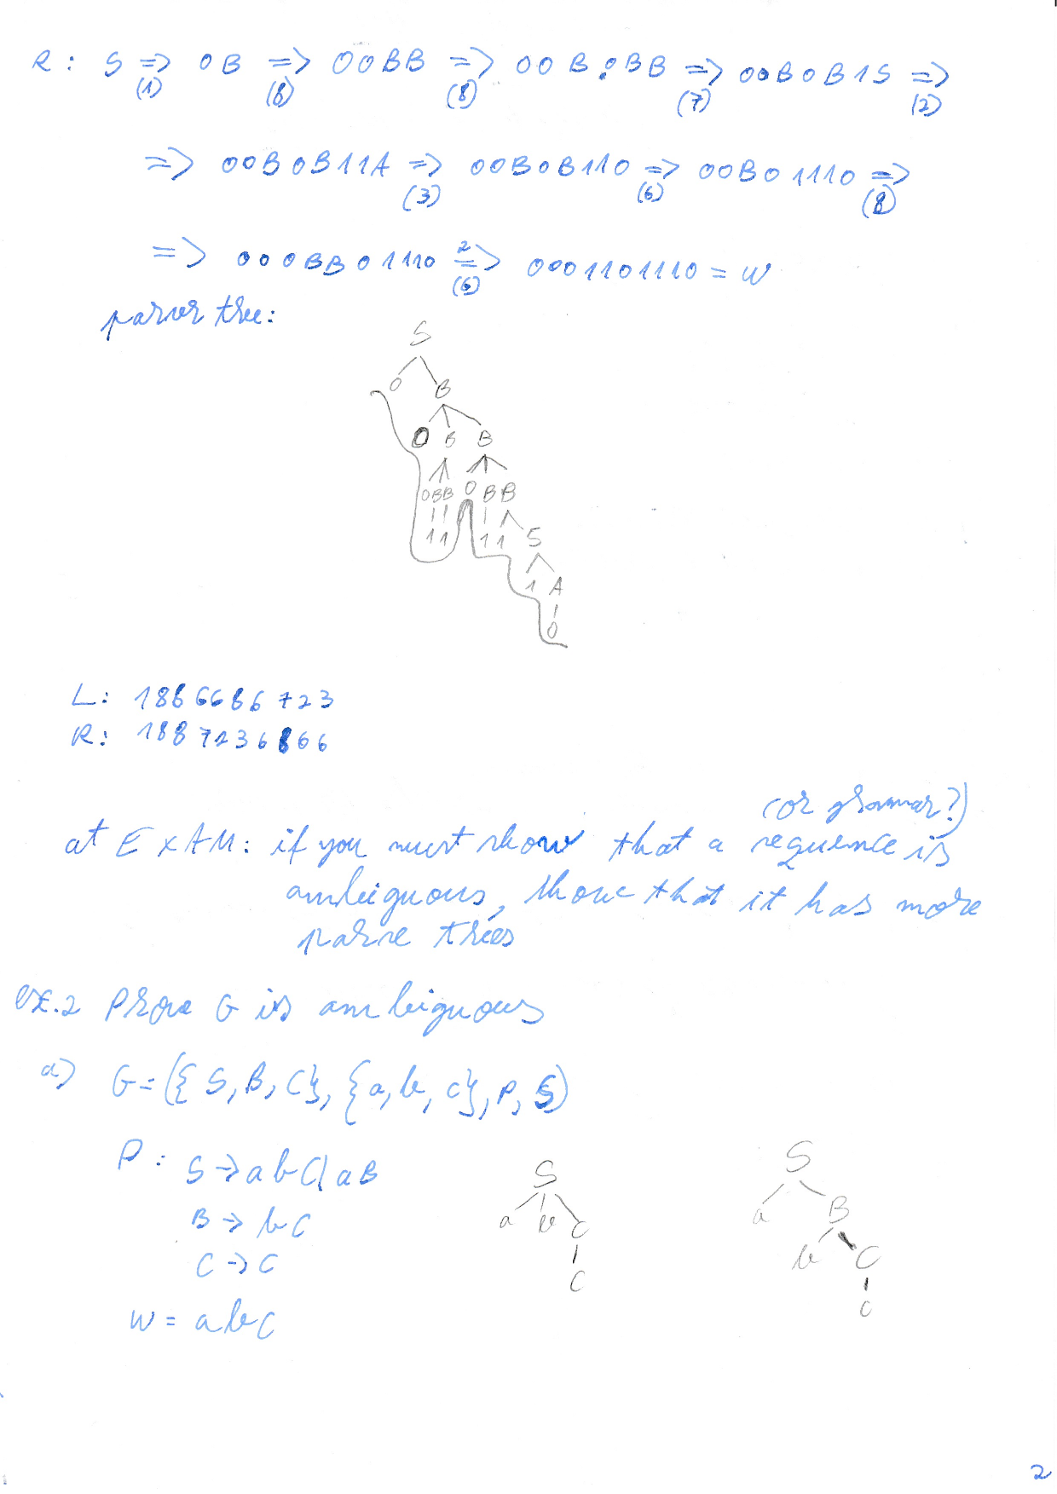p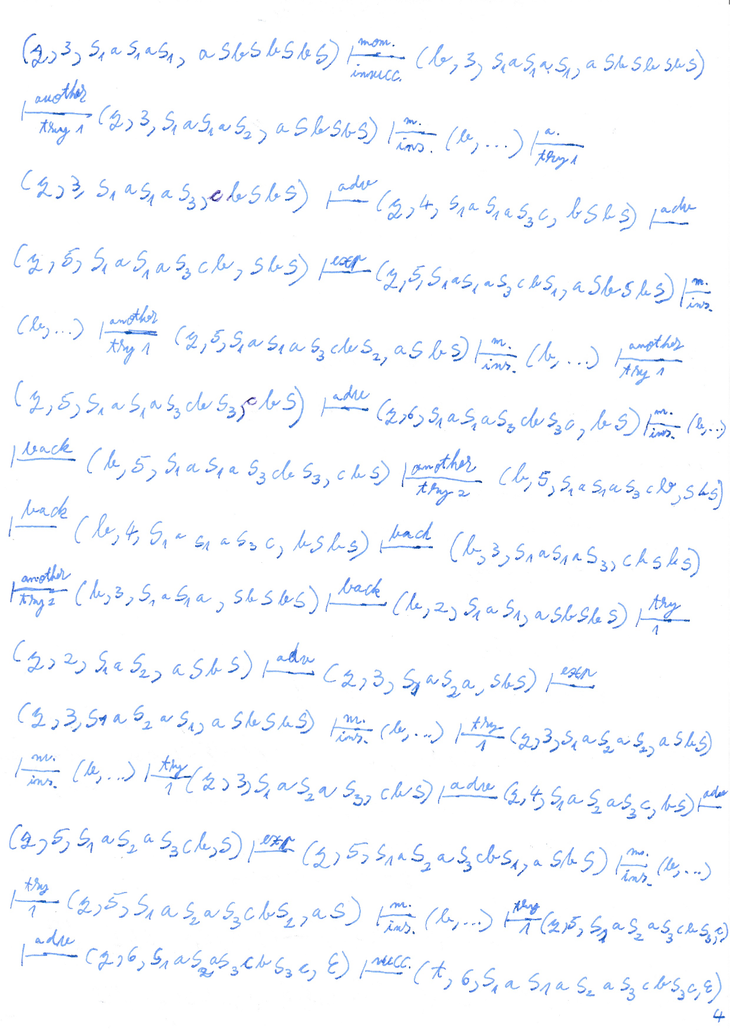

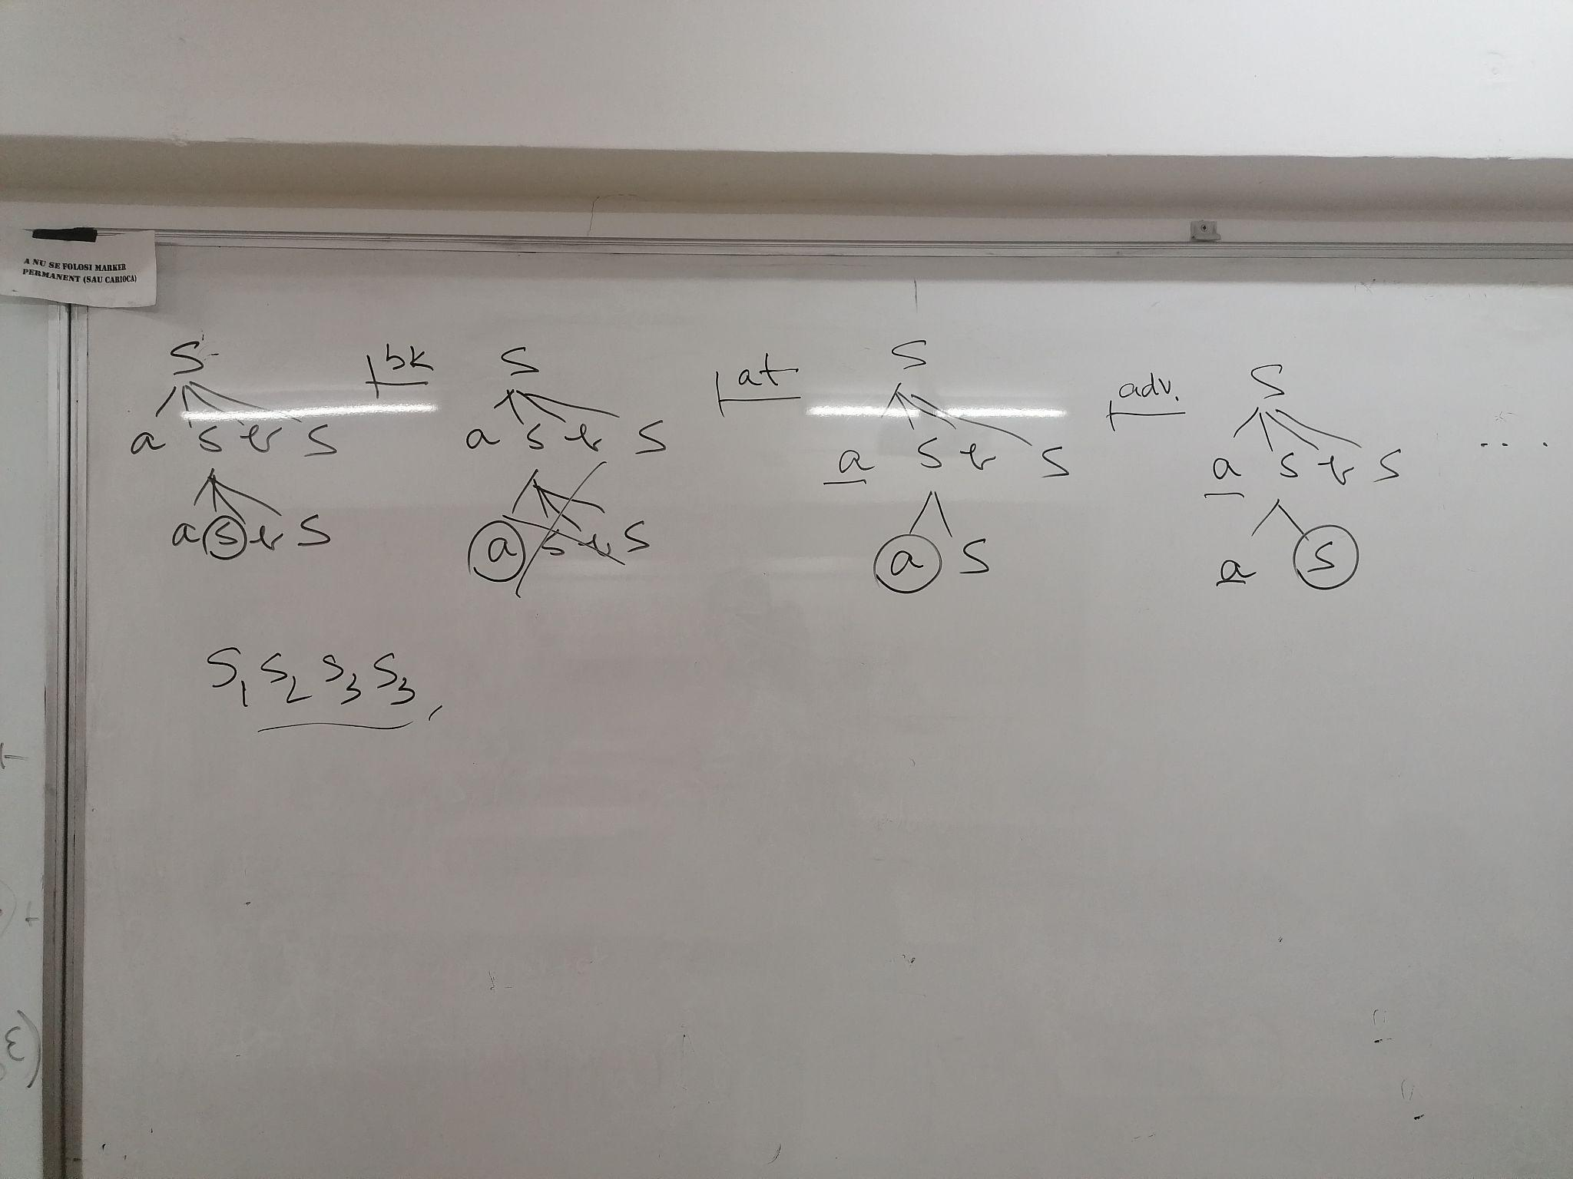

# LECTURE W8

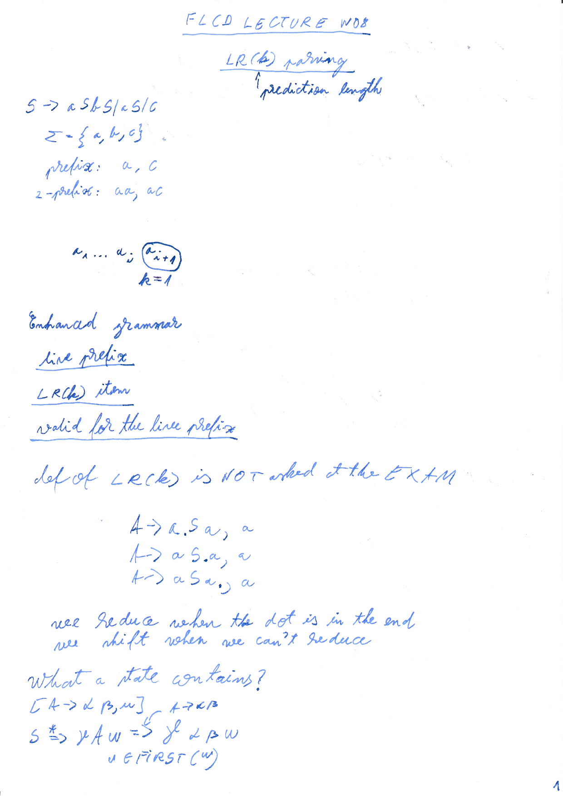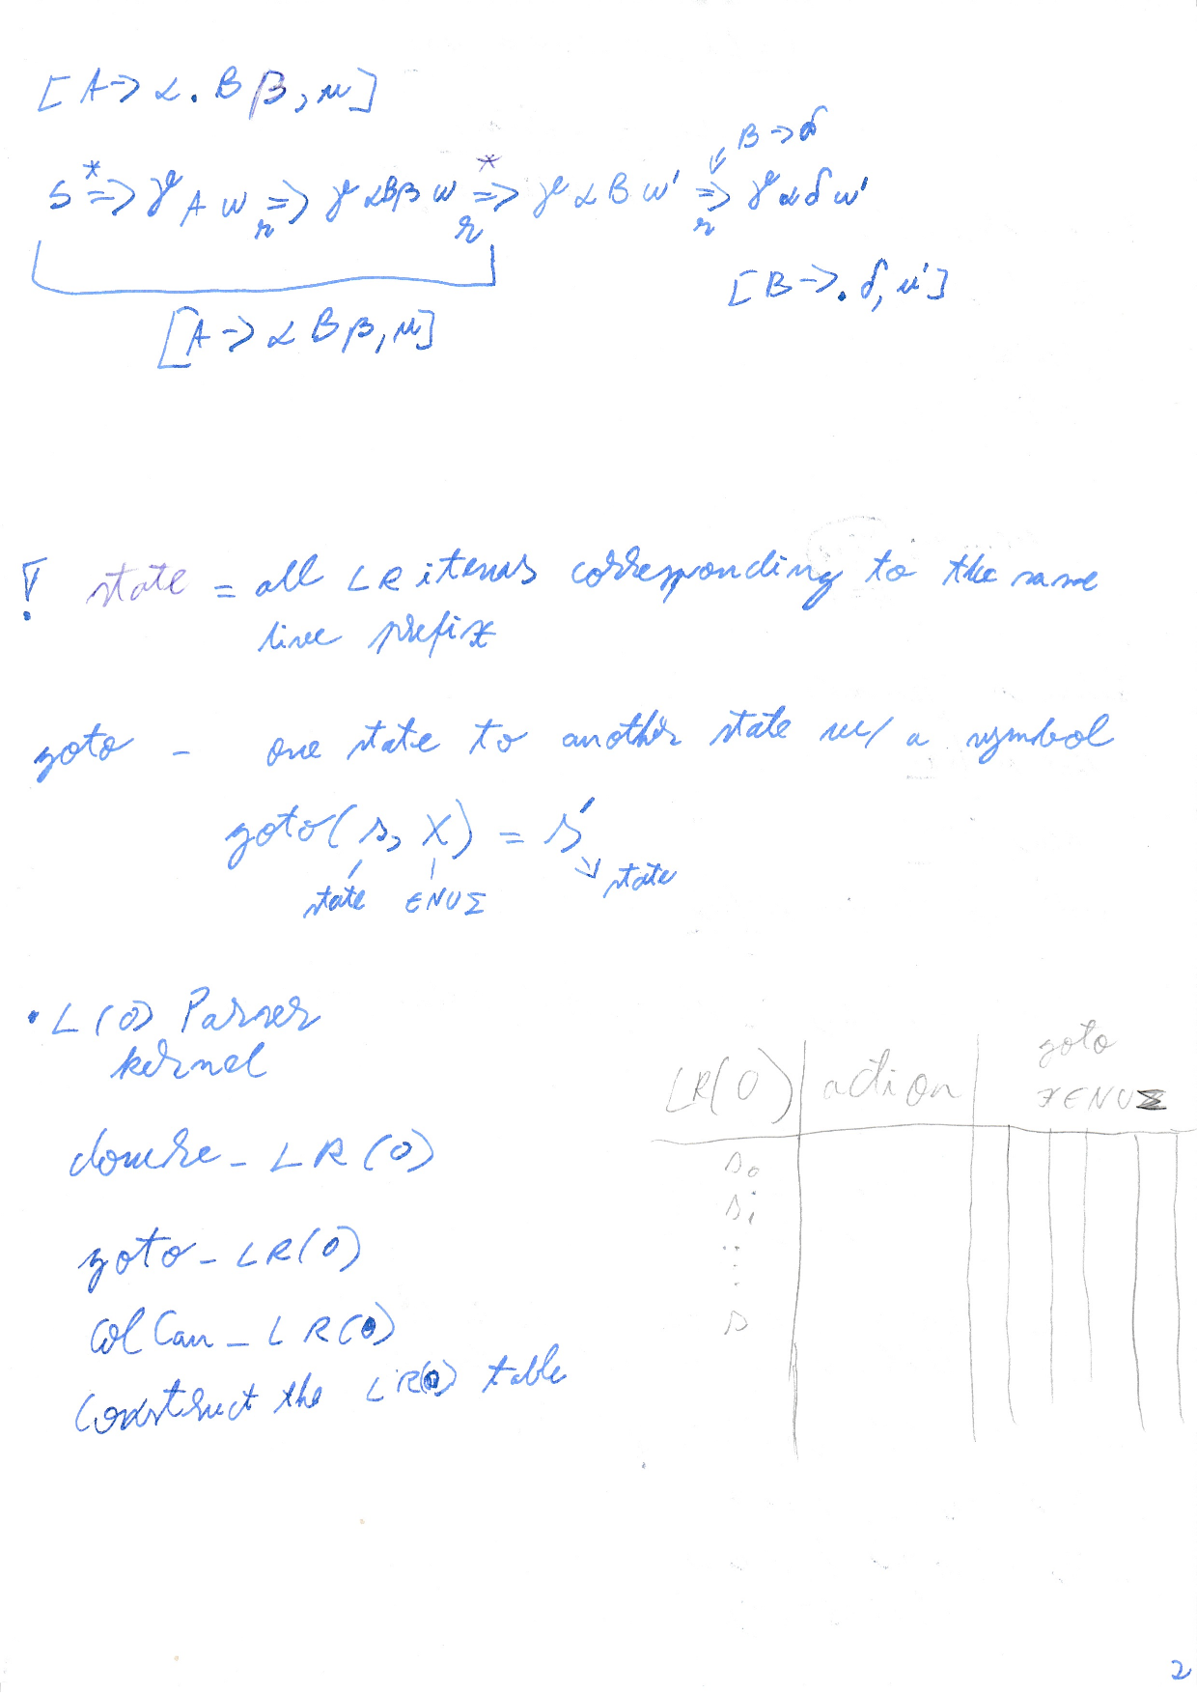

# SEMINAR W8 - LL(1)

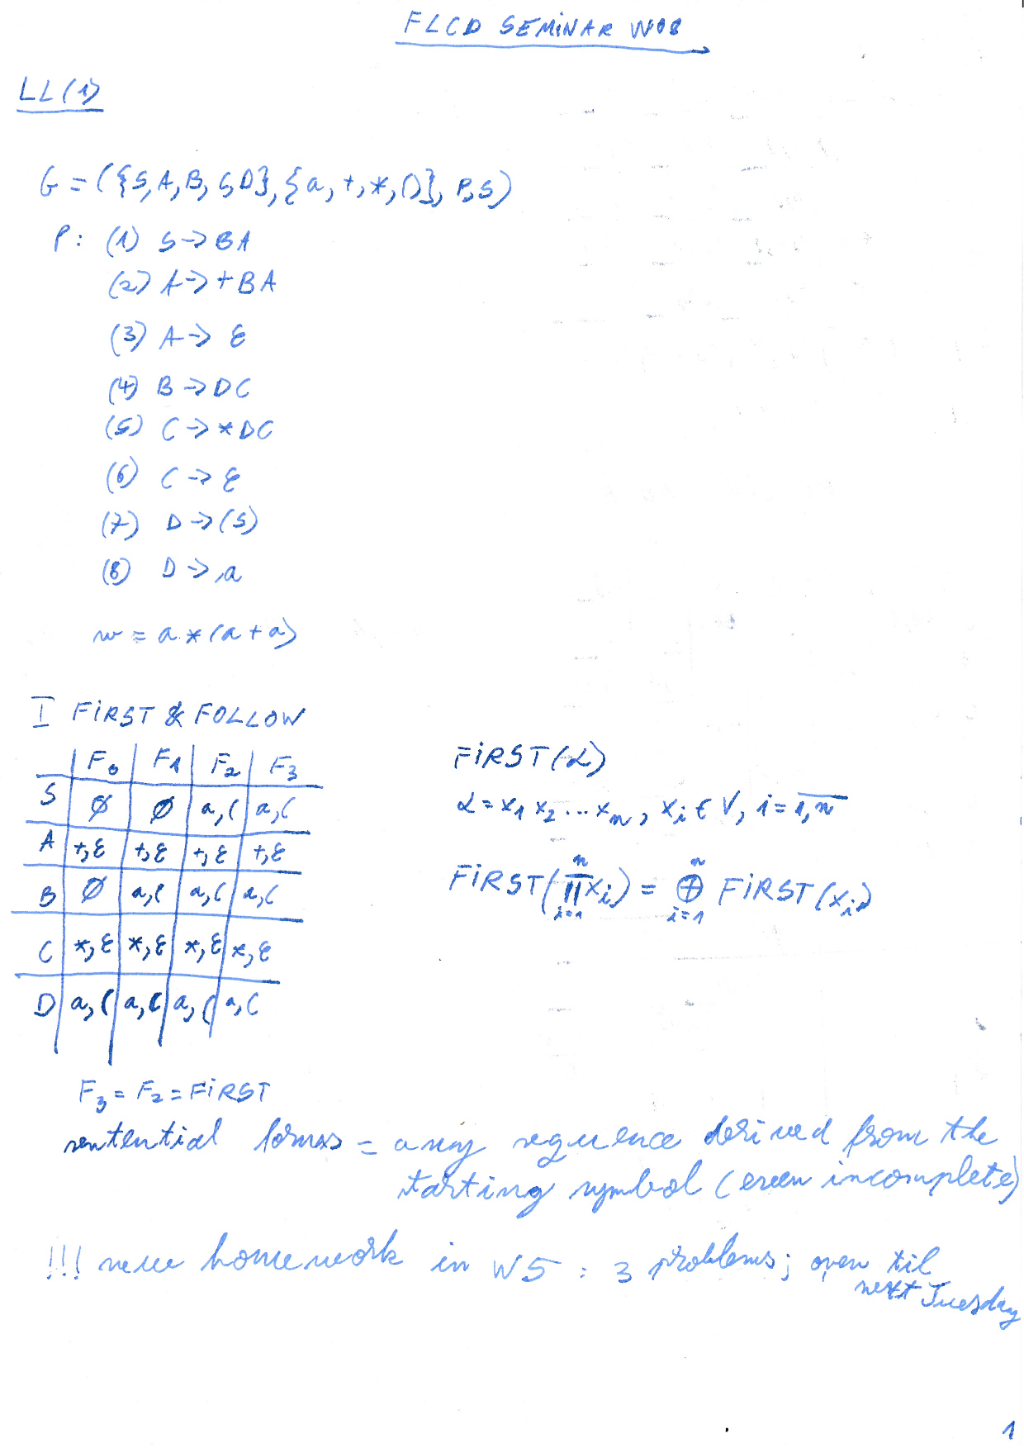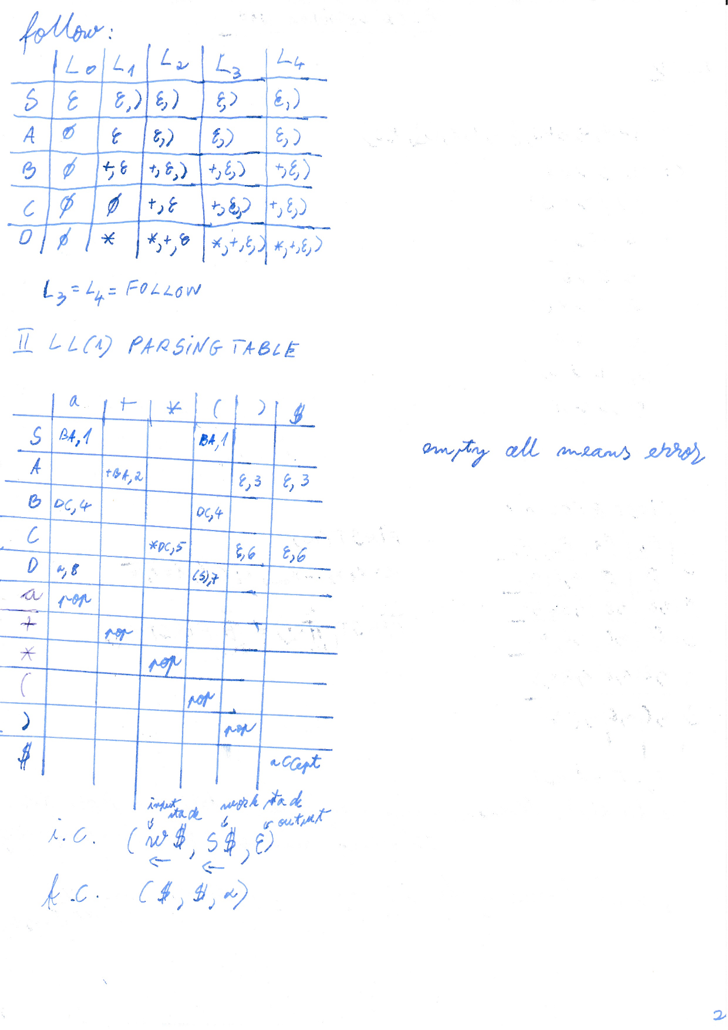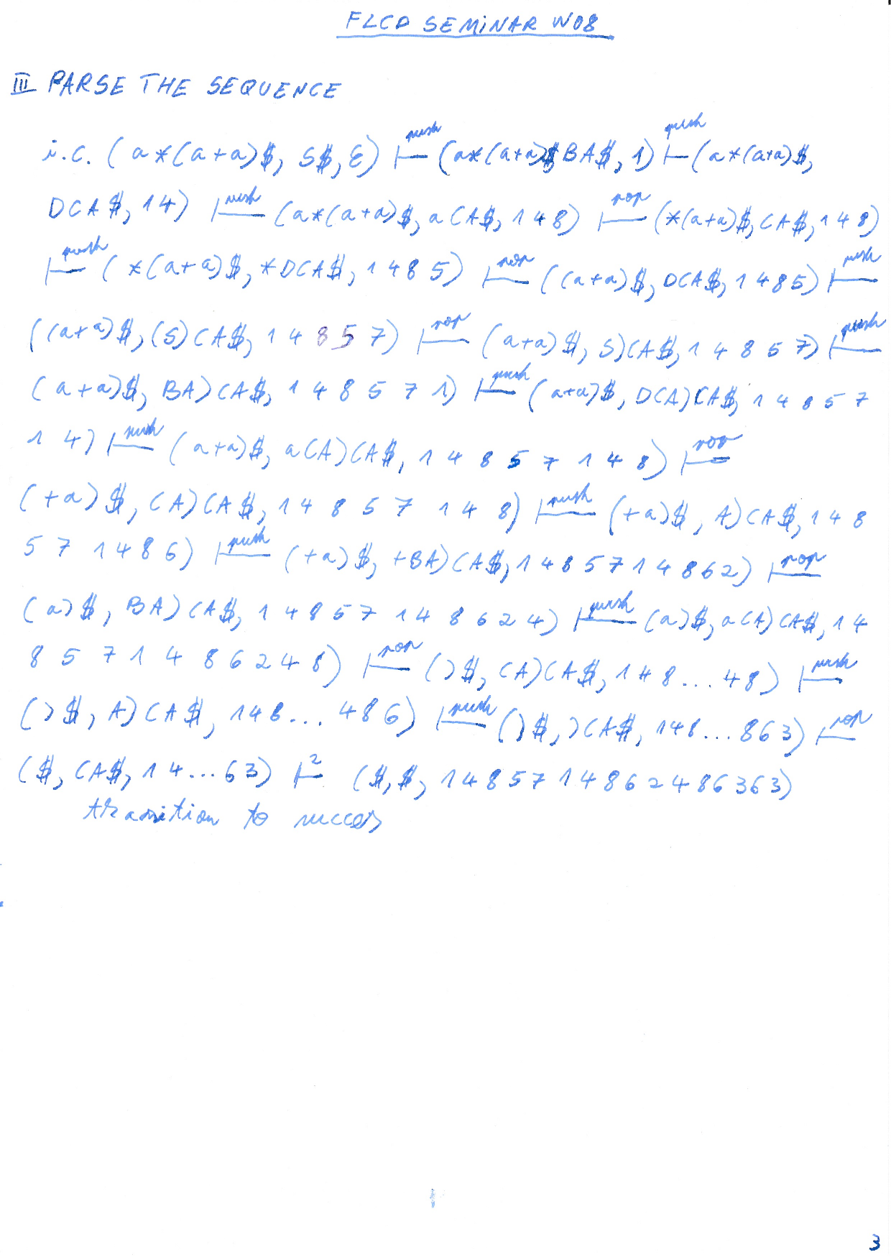

# LAB W8

FOLLOW = FIRST(what's next)

syntactic analysis - next 4 labs

[L5](https://moodle.cs.ubbcluj.ro/mod/assign/view.php?id=2841) noi: recursive descendant

production string = ??

derivation string = ??

CFG = in the left we have just 1 non-terminal

pt azi - clasa Grammer, care citeste din fisier, foloseste meniu,

g2.txt, alegeti una din cele 2 gramataci si faceti cfg-ul

rec desc:

ll1(1): first, follow, tabel

lr1(1): goto, closure

pe moodle: pdf cu link-ul catre git de la fiecare membru

in unul din exemplele din cartea profesoarei este o greseala

atentie la configuratie - in functiede configuratie, face o actiunue

peste 2 saptamani sa avem complet

# LECTURE W9

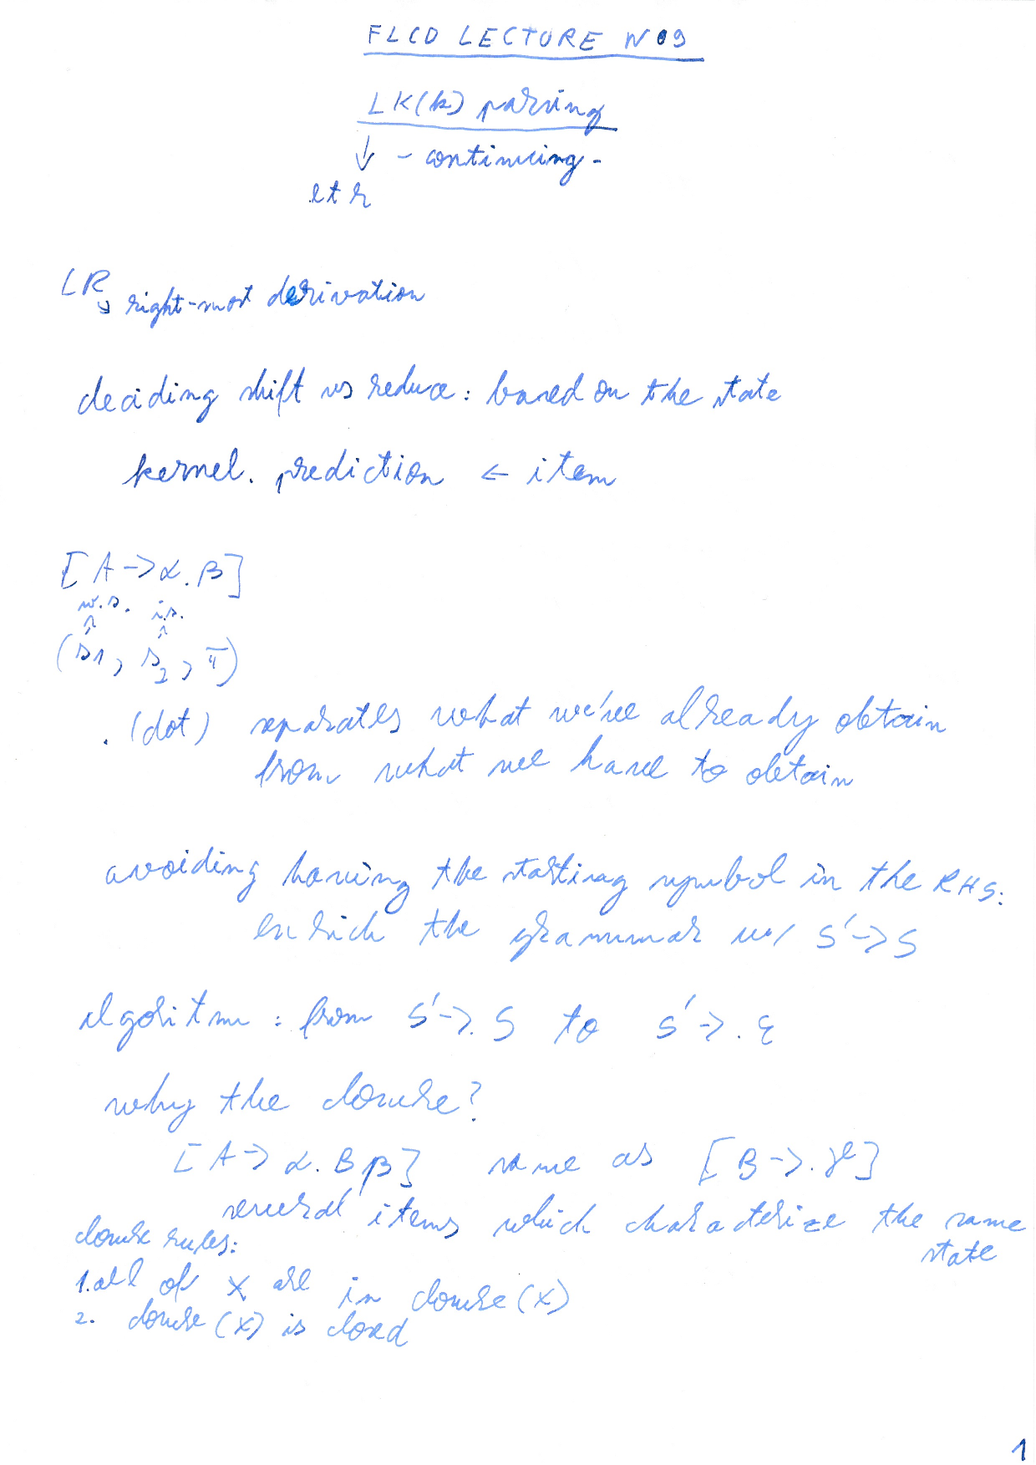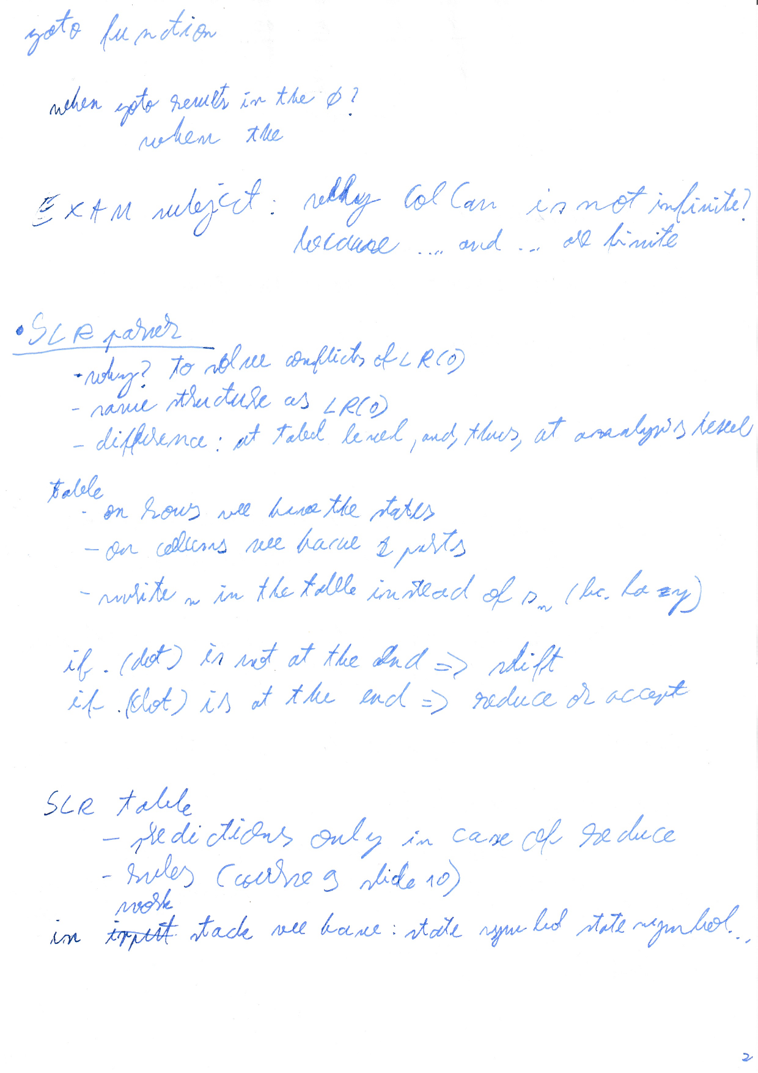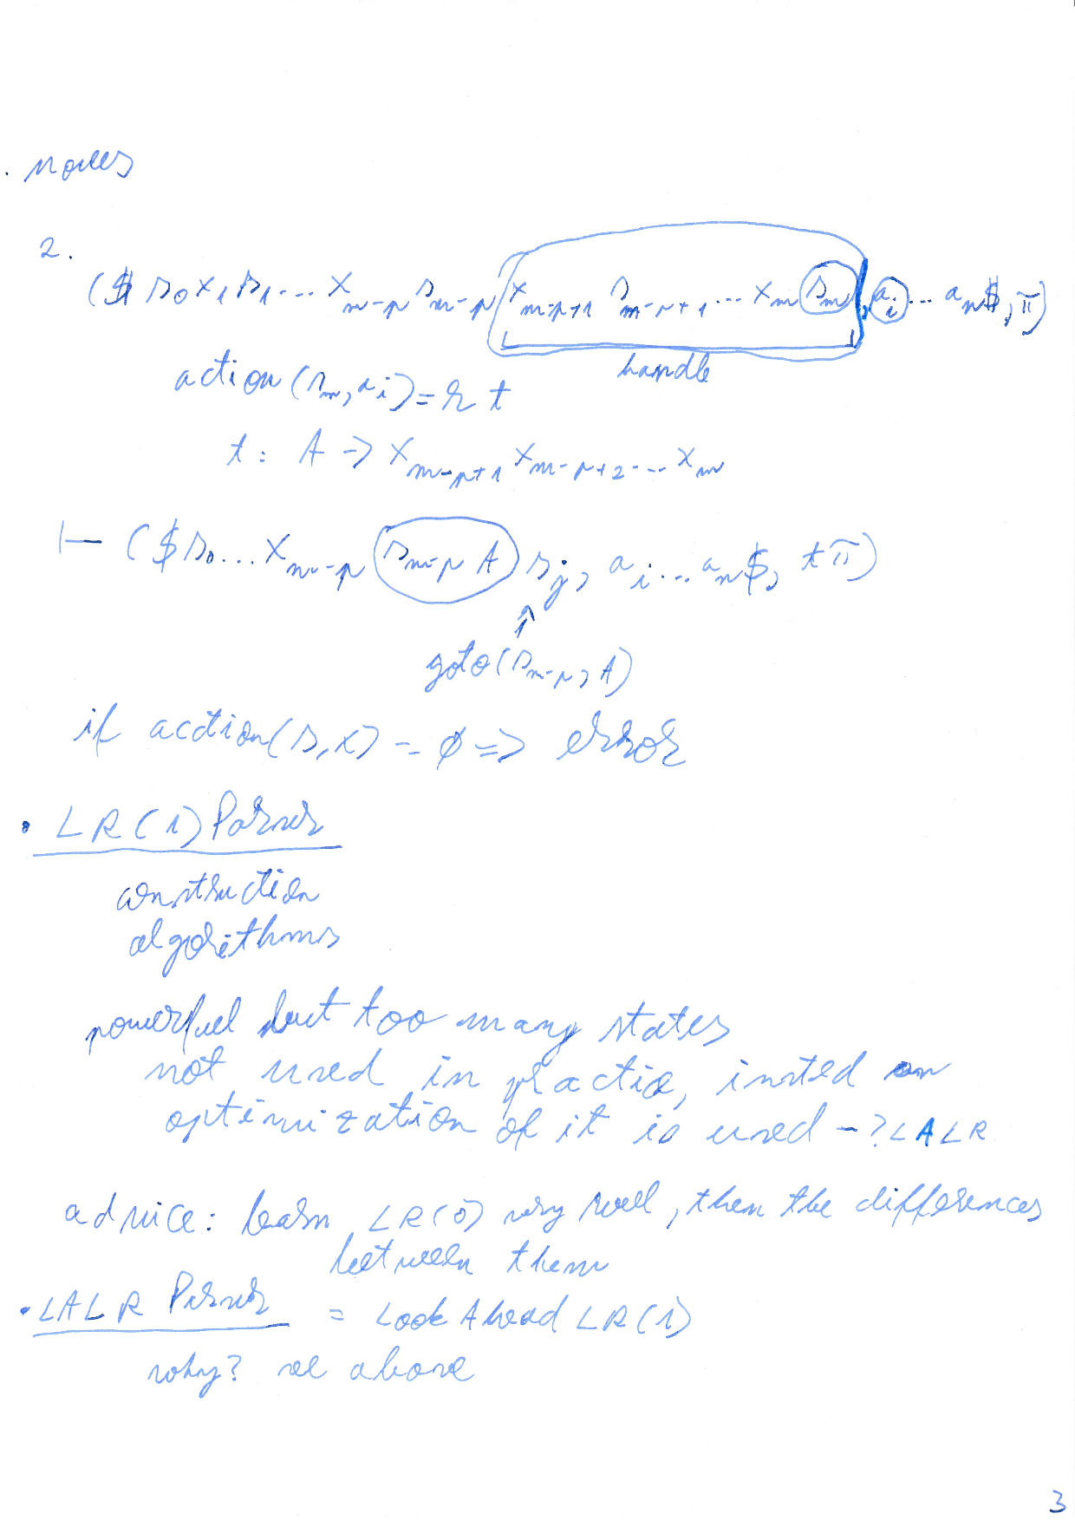

# LECTURE W10 - lex & yacc

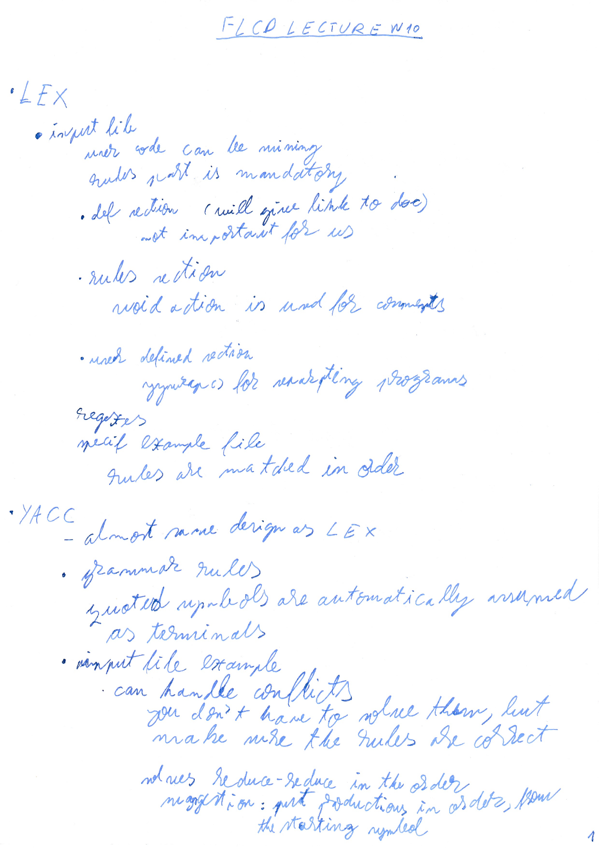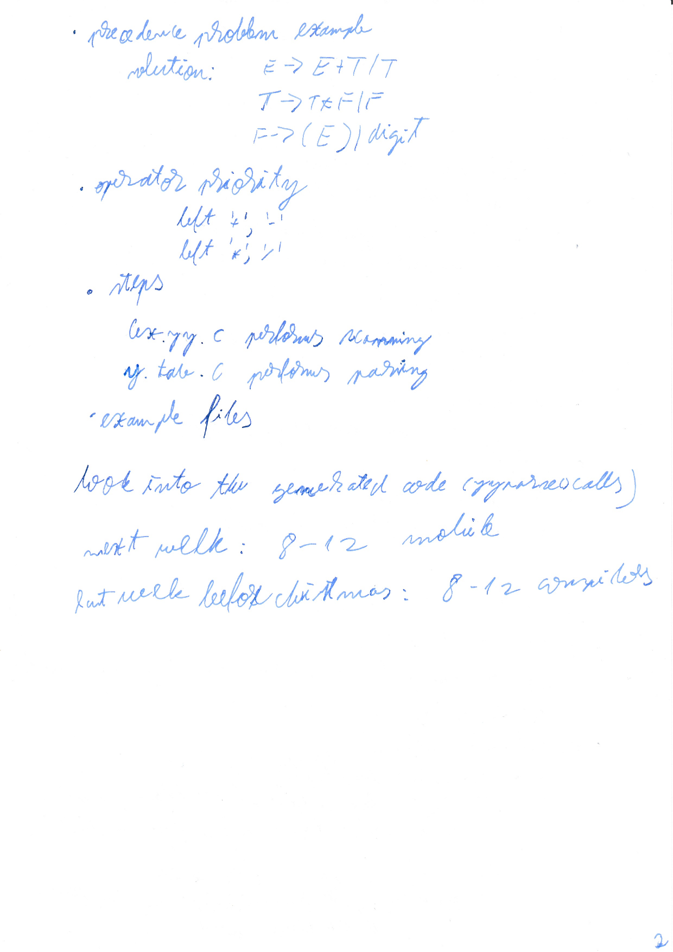

# SEMINAR W10 - LR(0), SLR

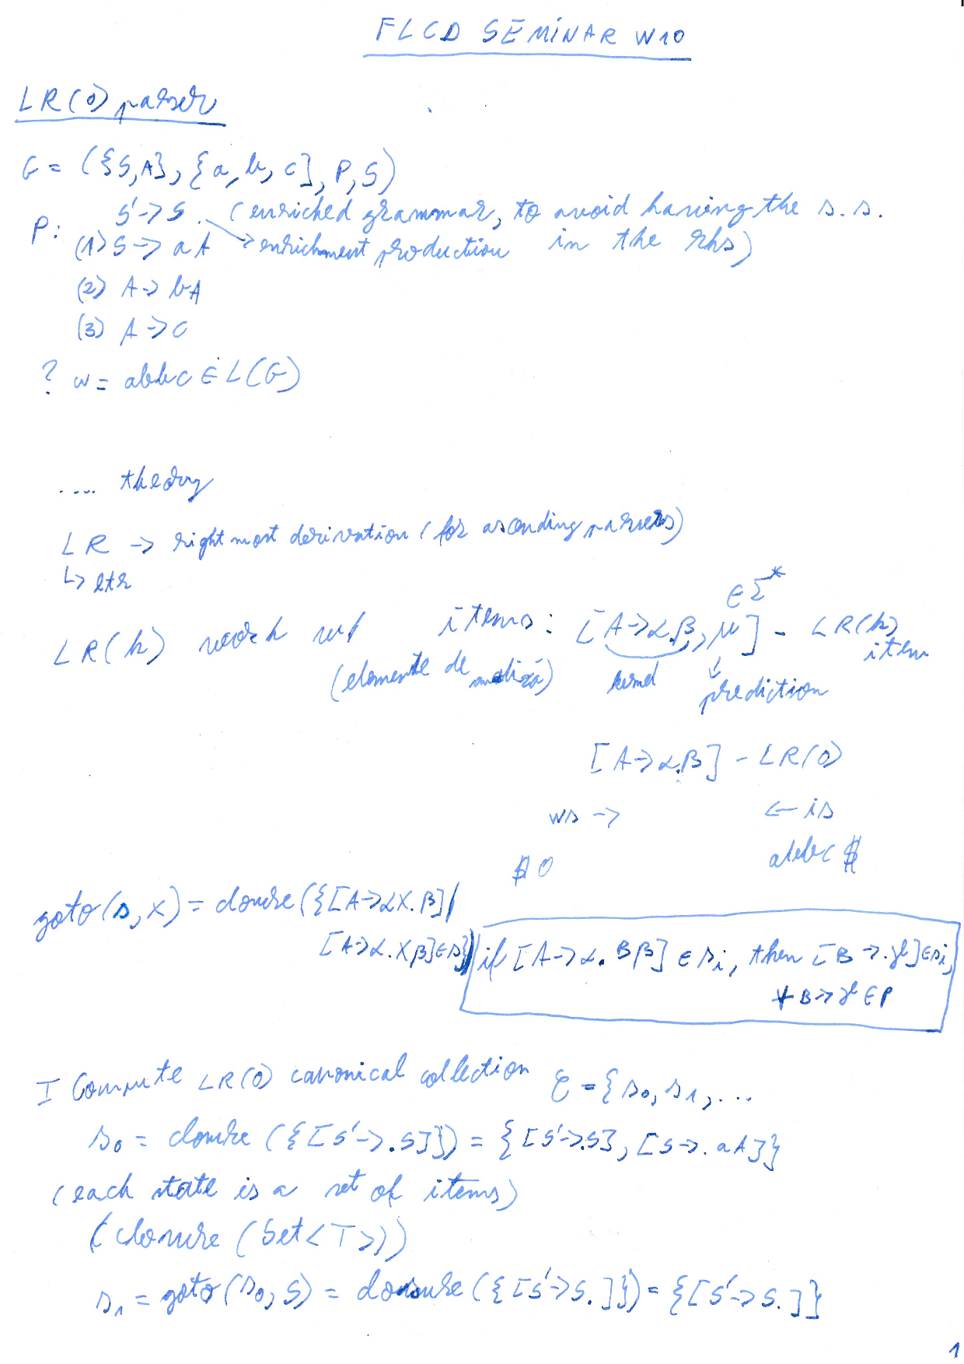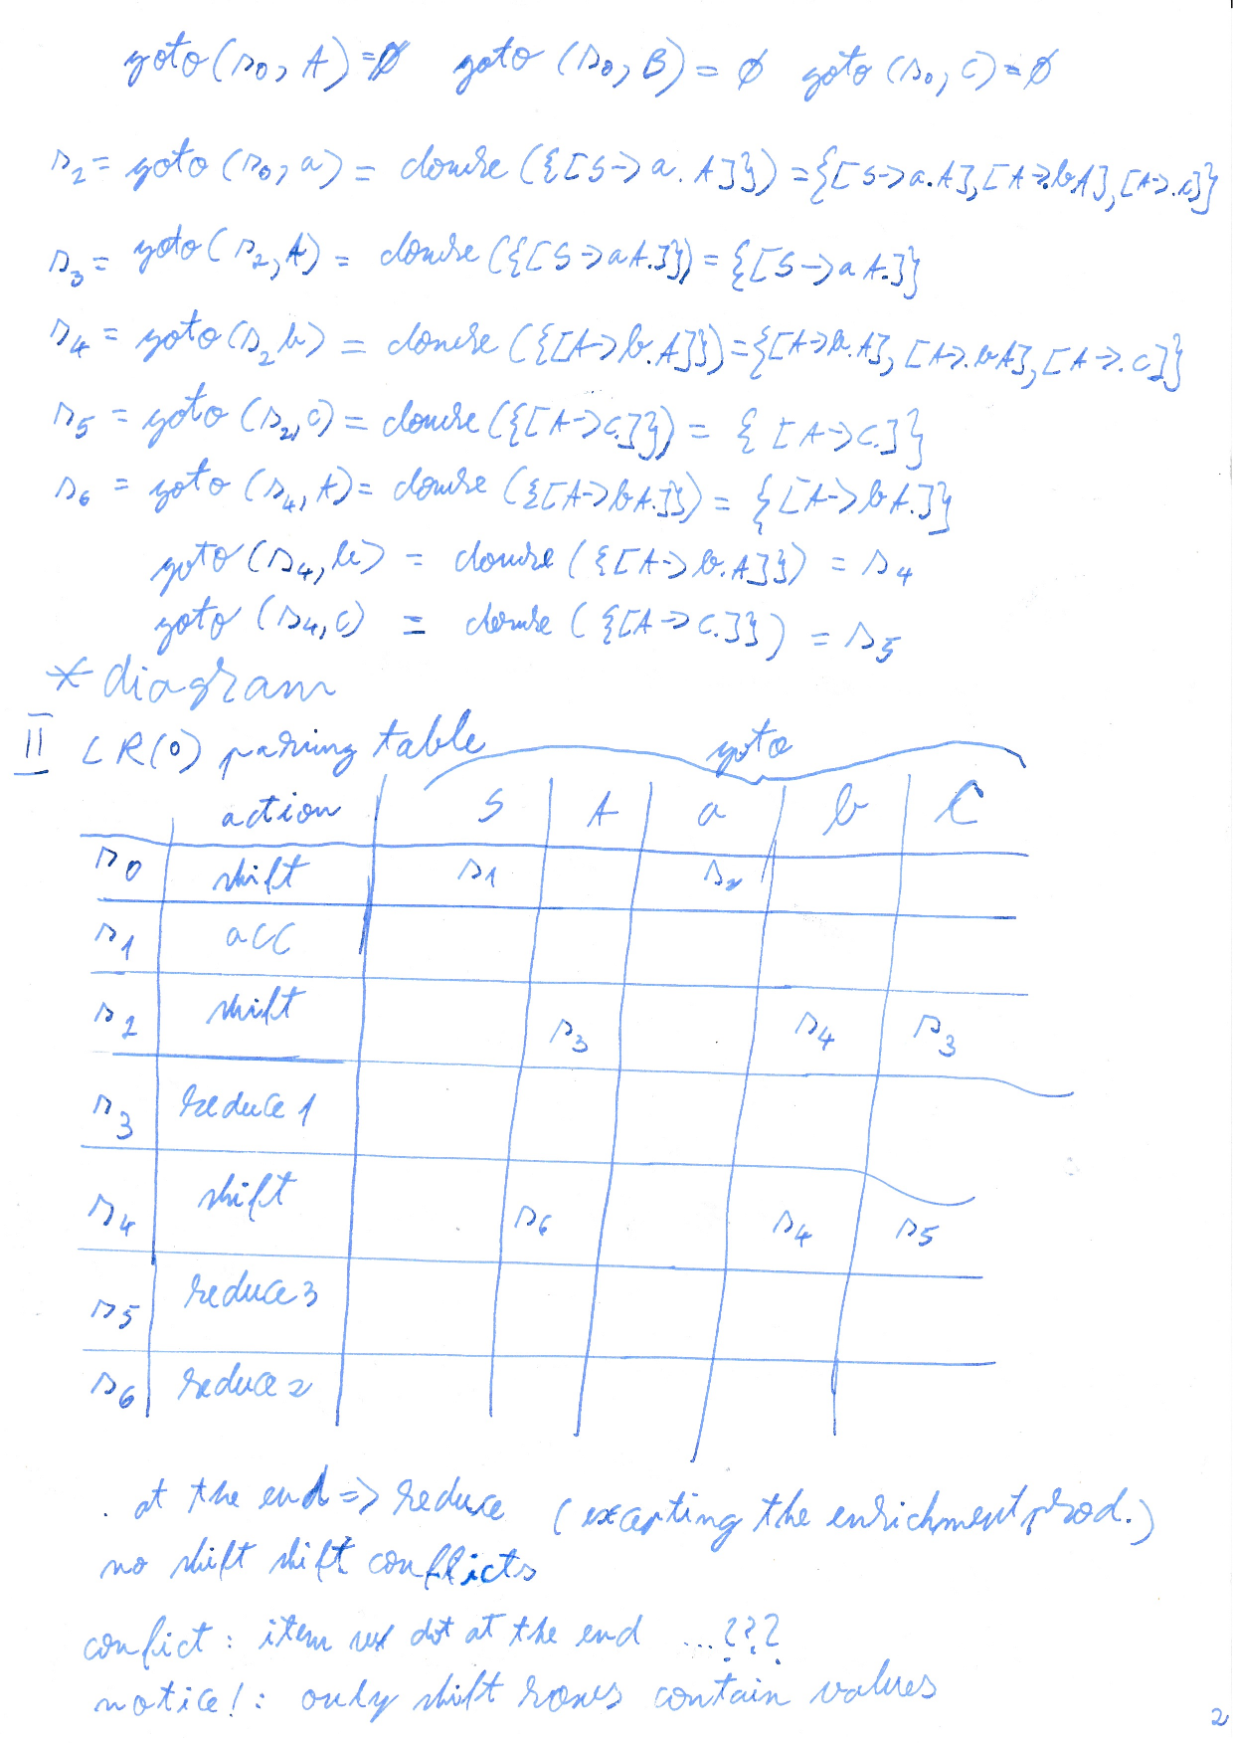

**diagram:**

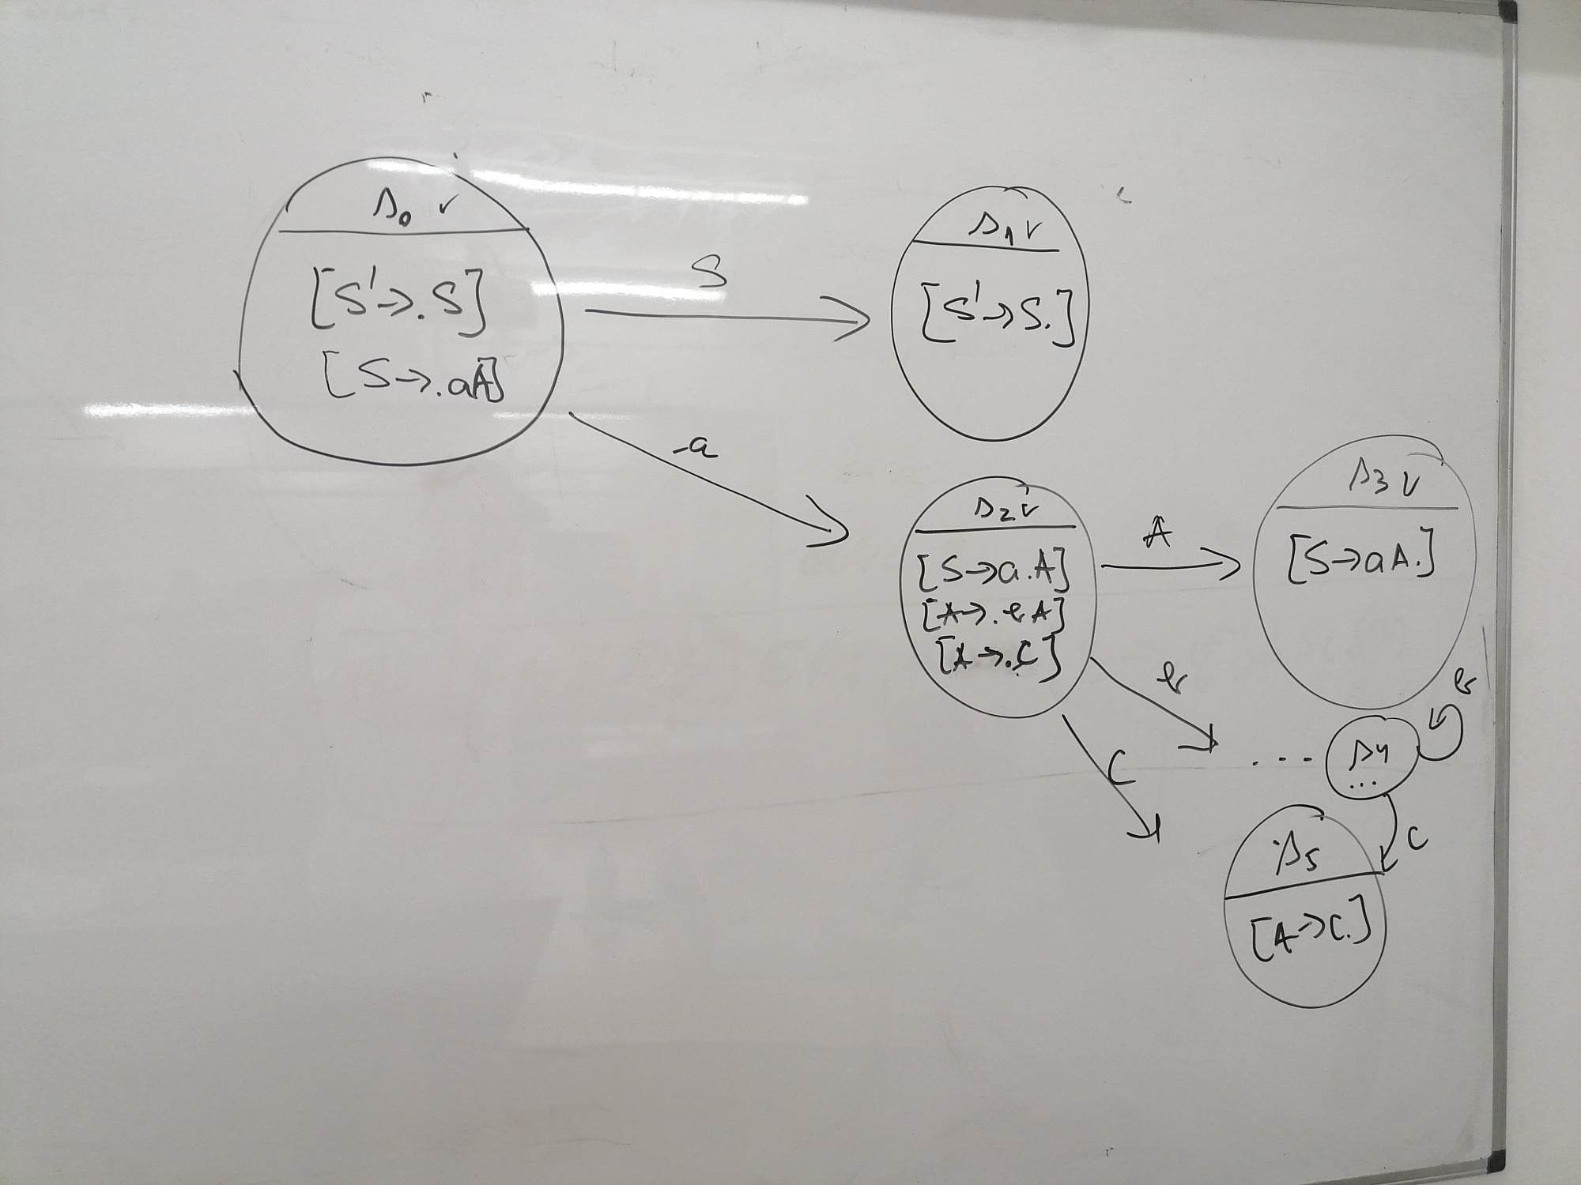

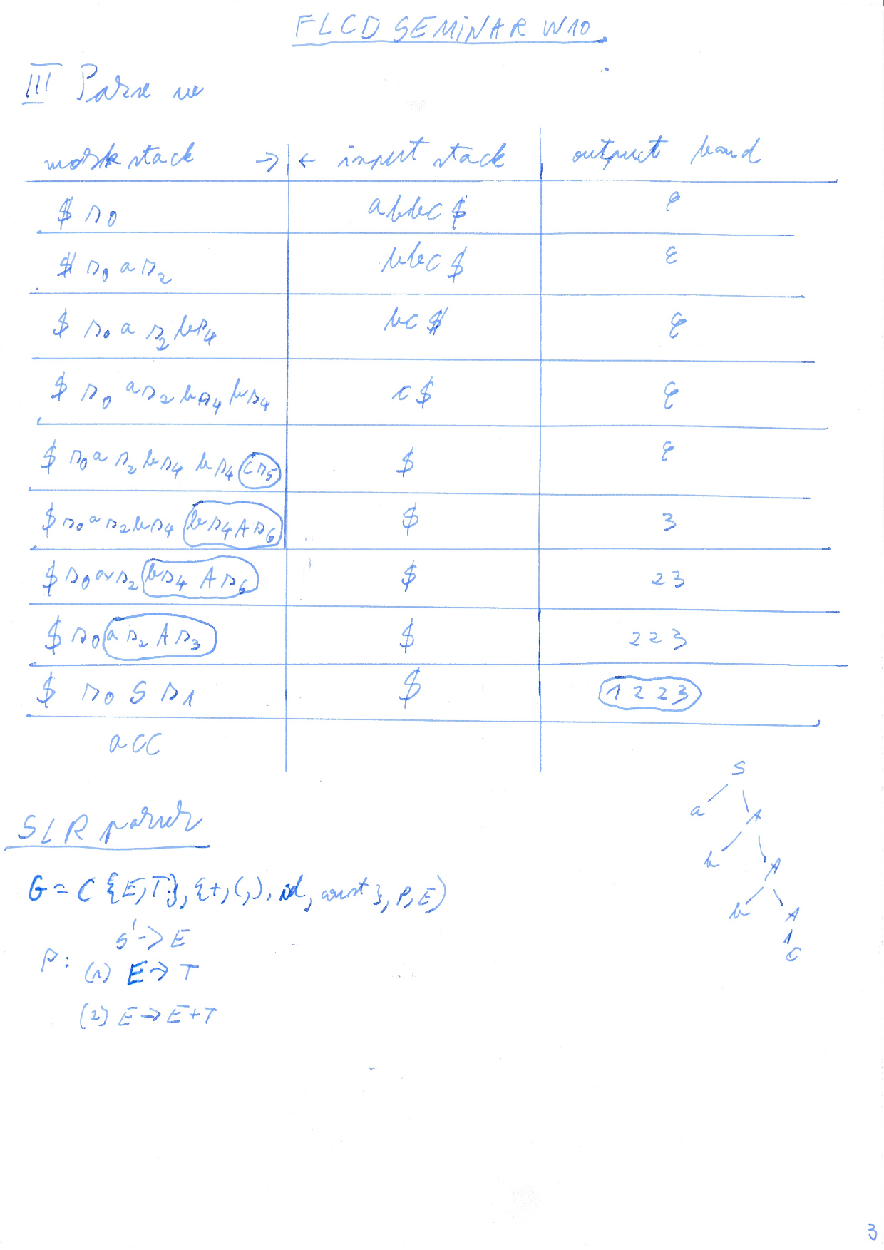

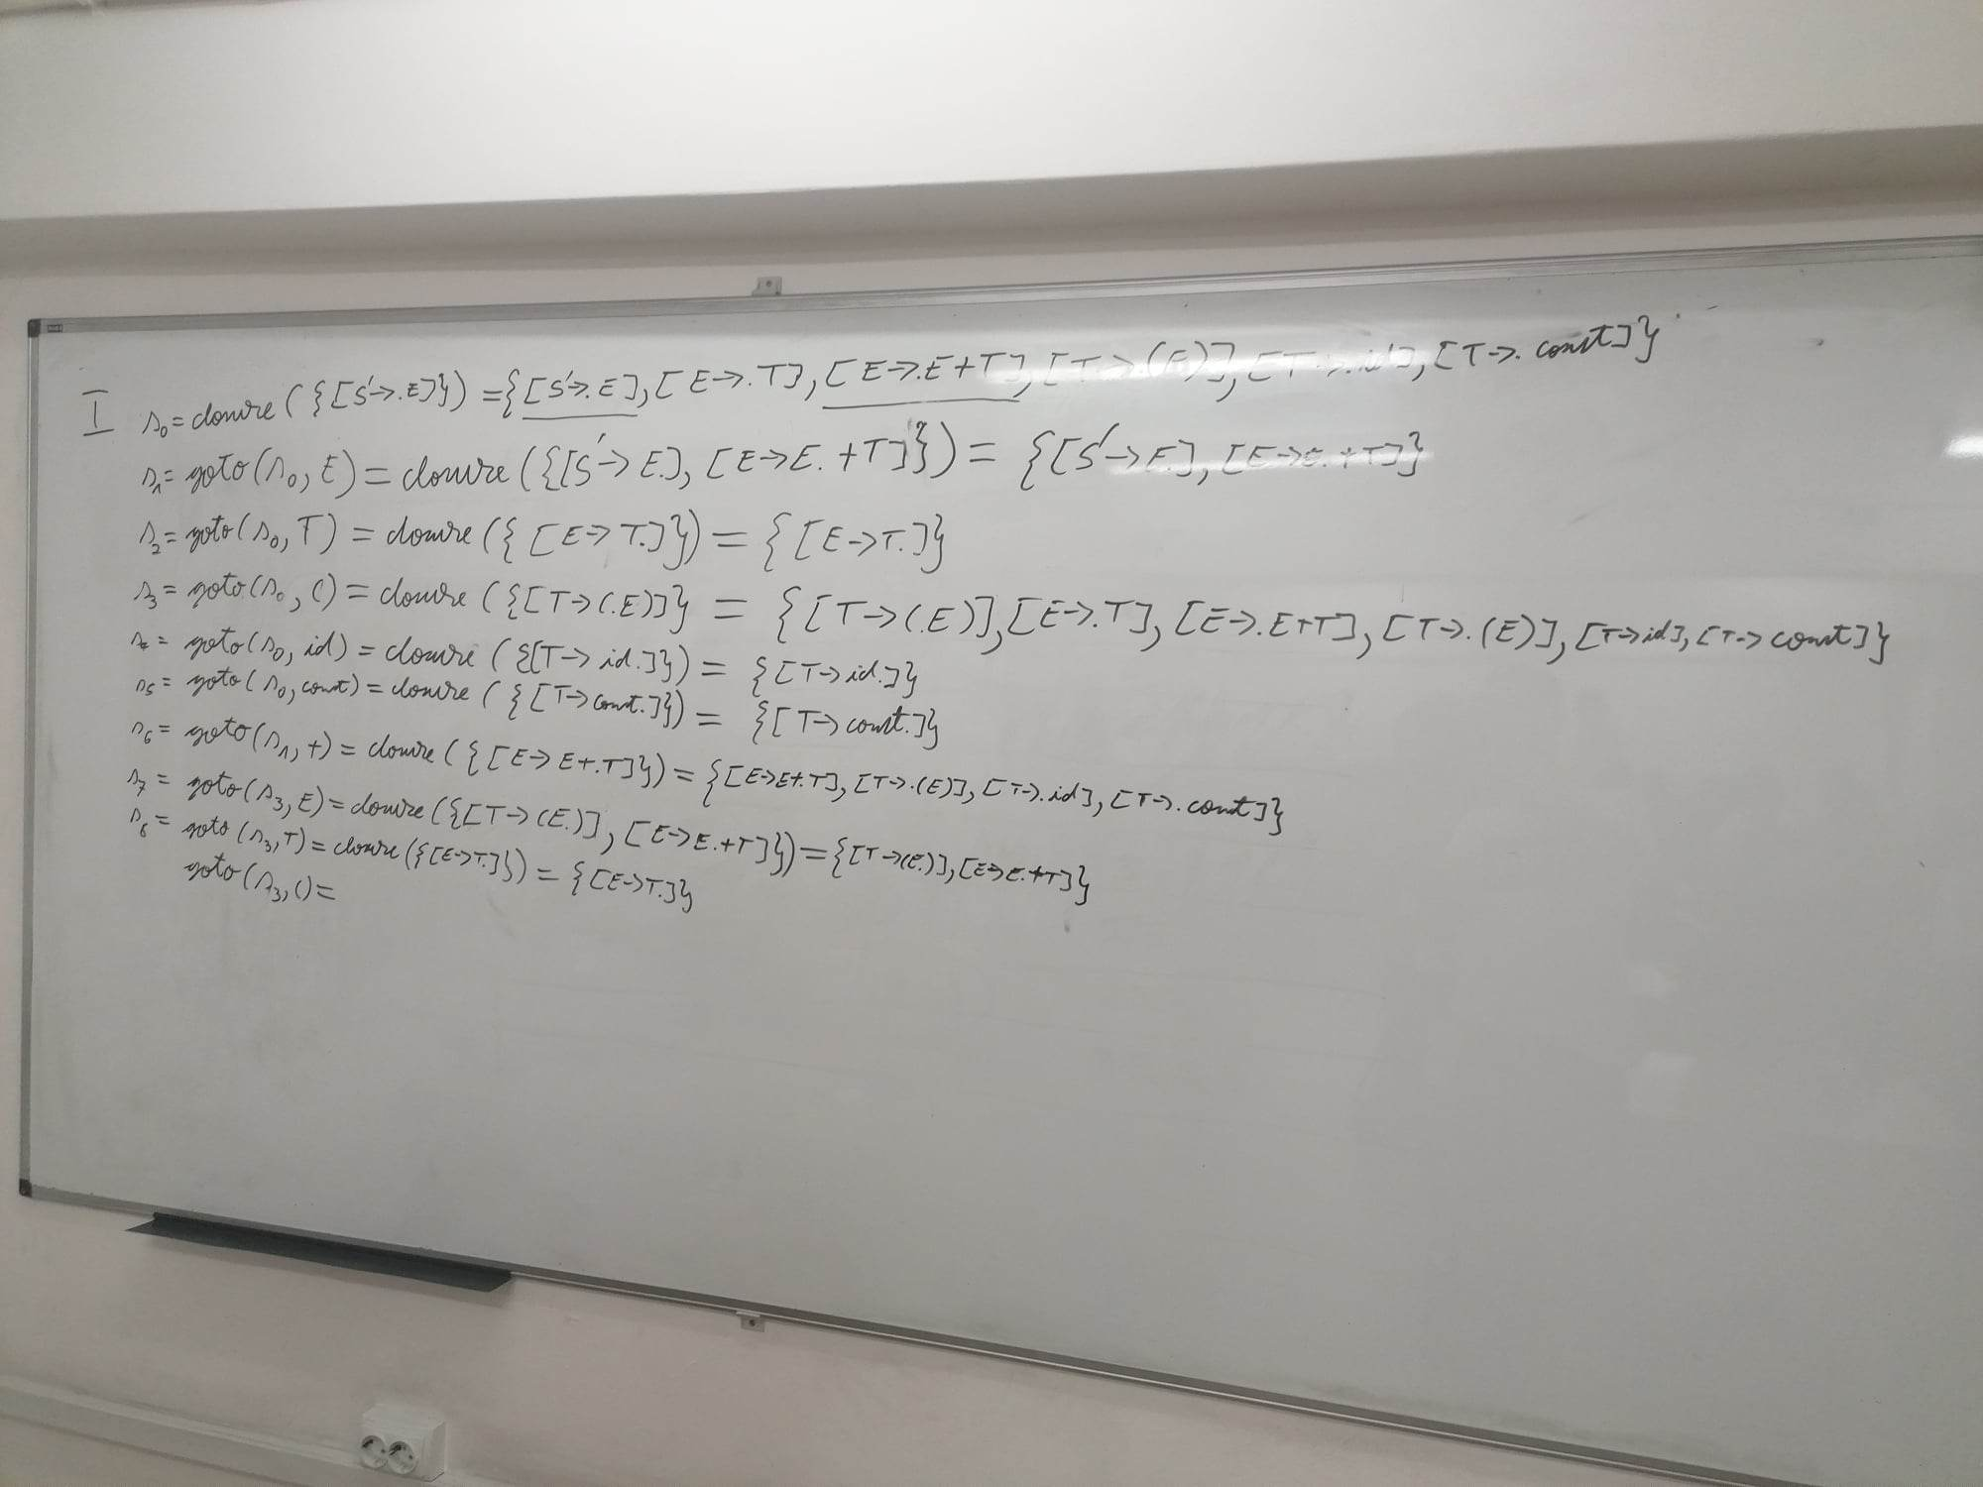

# LAB W10

examenele vor fi dimineata. corectarea dupa masa

# LECTURE W11 - see W12

# SEMINAR W11 - SLR, LR(1)

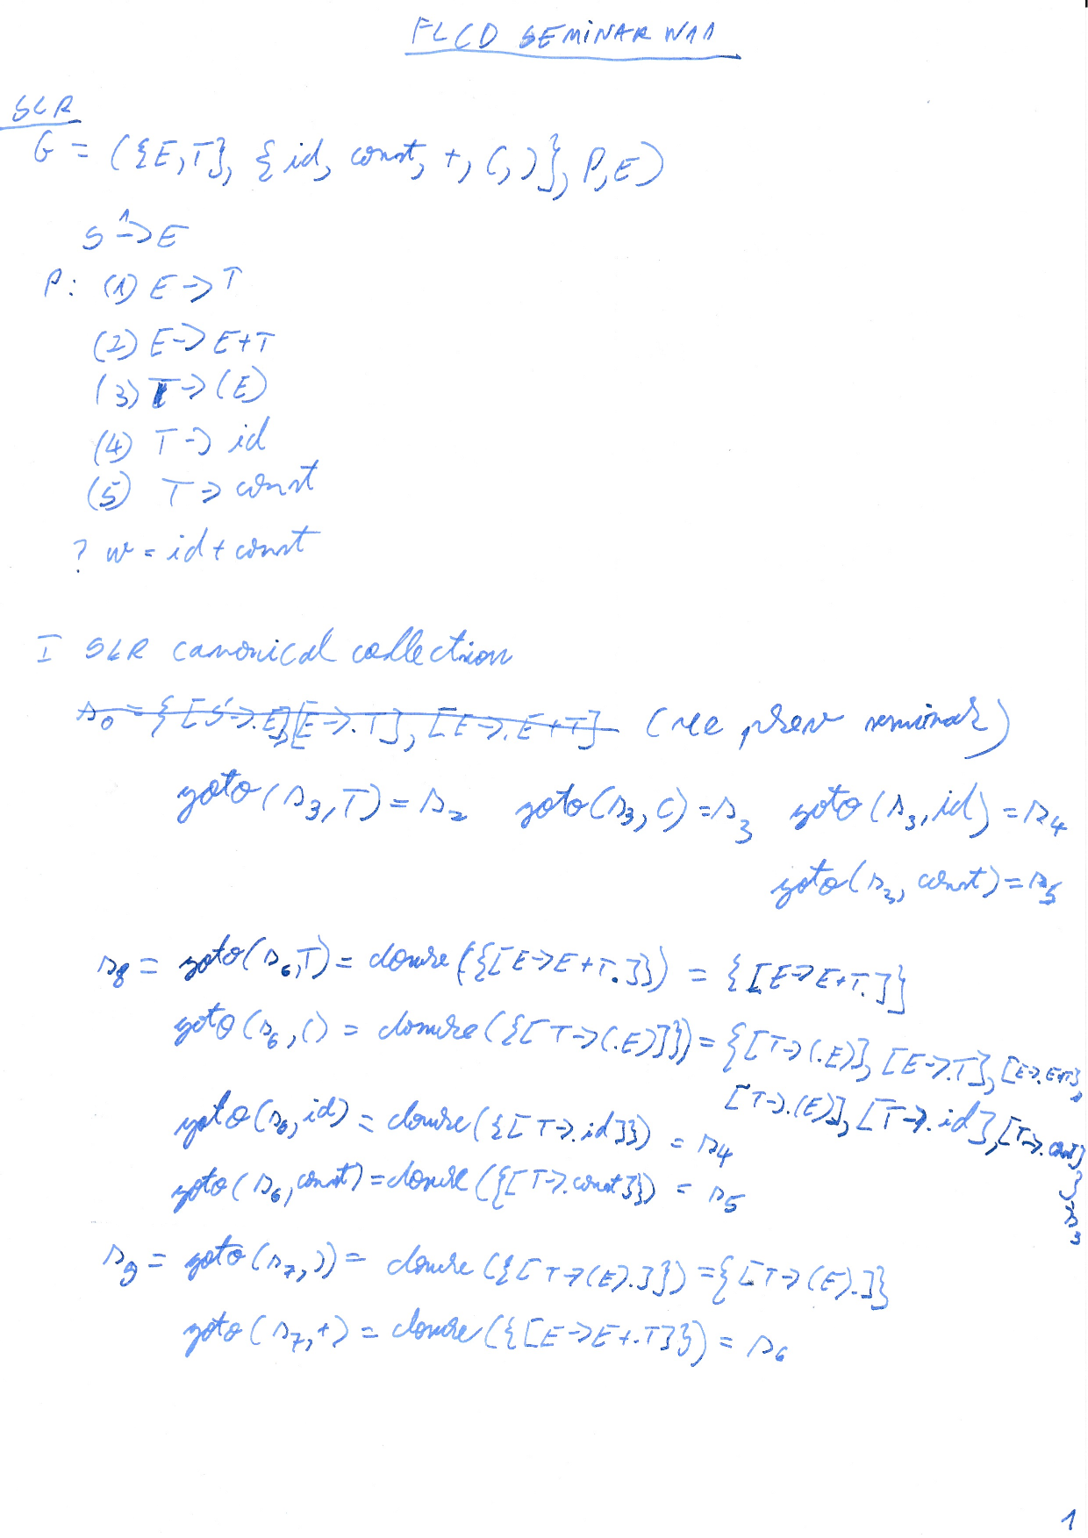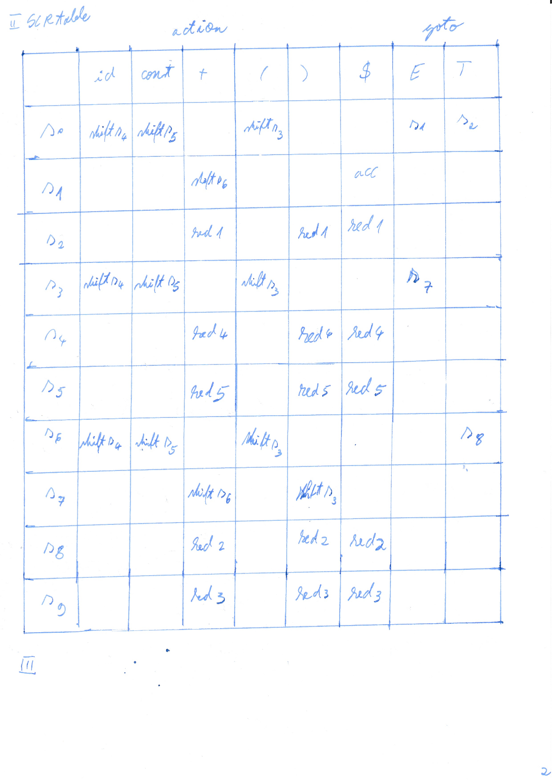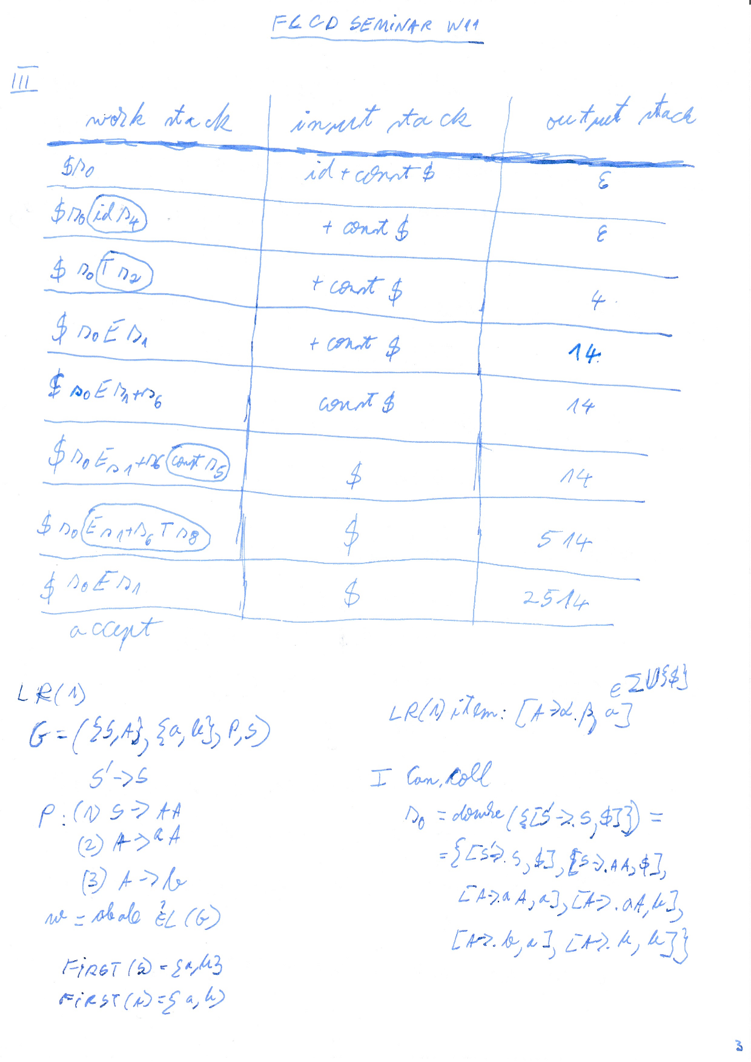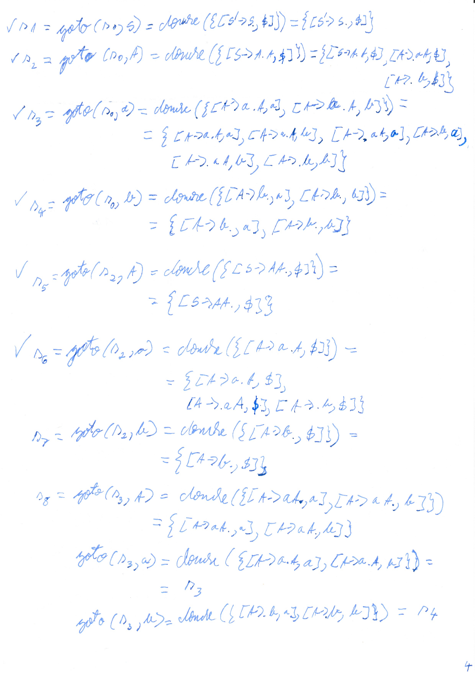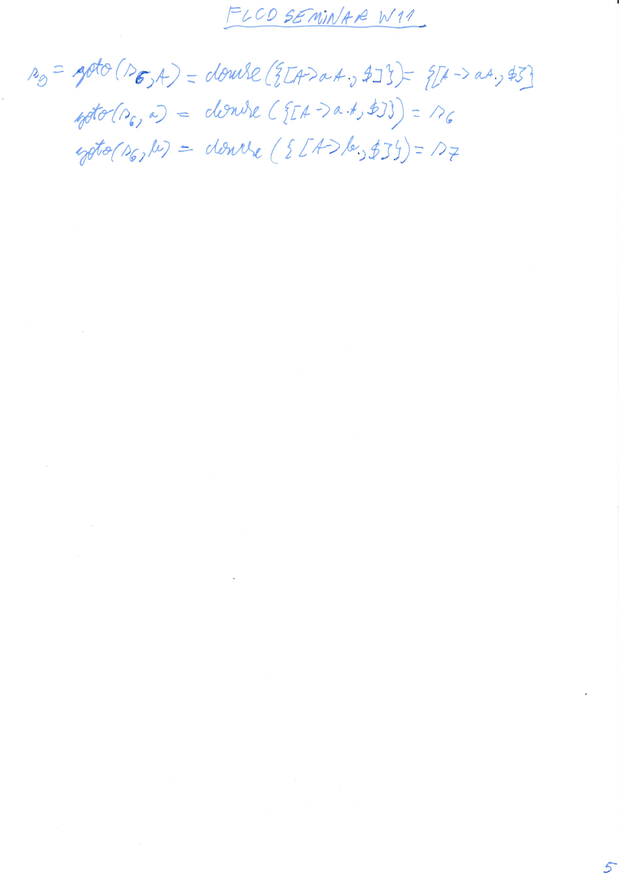

# LAB W11

LR0 < SLR <

LR0 si SLR sunt la fel la tabel

la SLR apare predictia

# LECTURE W12

# SEMINAR W12 - LR(1), LALR(1)

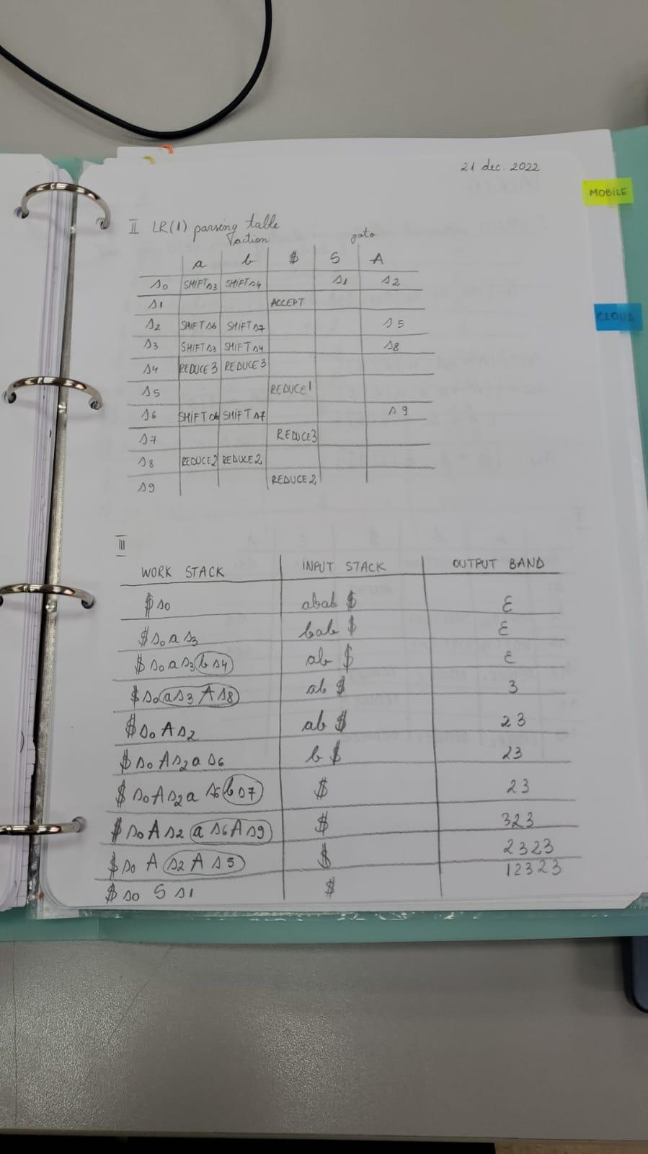

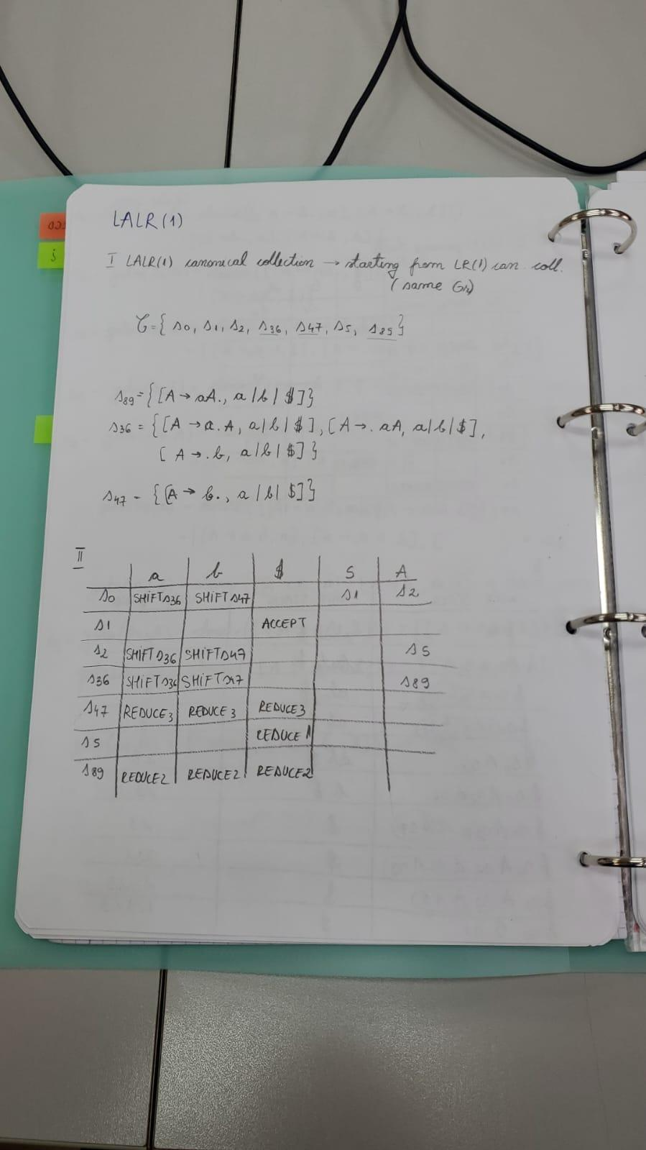

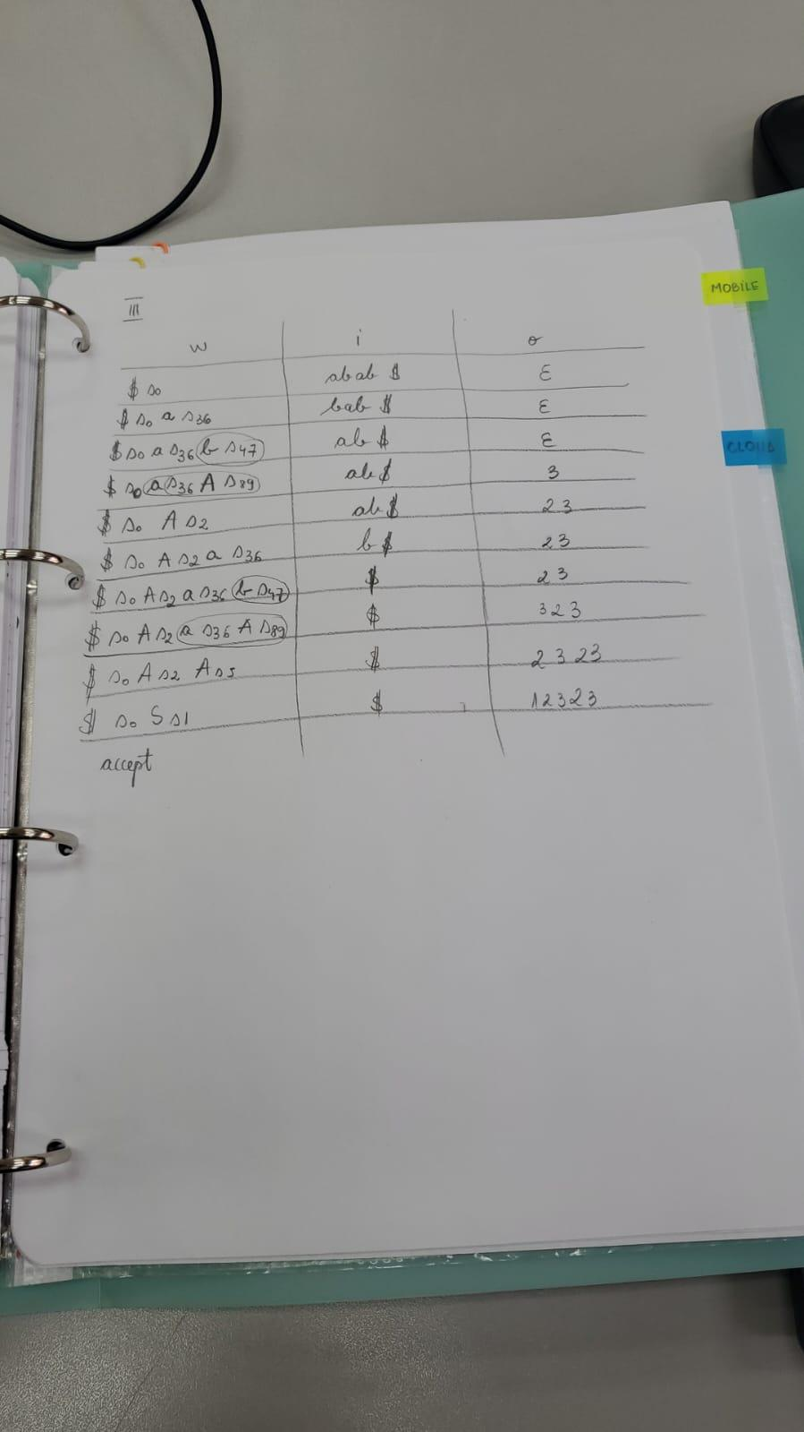

# SEMINAR W12 - PDA (cu alta grupa)

where are the notes???

# LAB W12

DEADLINE ANALIZATOR SINTACTIC: PRIMA SAPATAMAN DUPA VACANTA

TOT ATUNCI: NE EXPLICA lex-ul si facem si lex-ul

documentatie:

* explicate DSurile
* diagrama de clase

avem

* g1 in conosola

ne trebuie

* g1 in fisier
* g2 + g2 in fisier
* documentatie

# LECTURE W13

# SEMINAR W13 - PDA

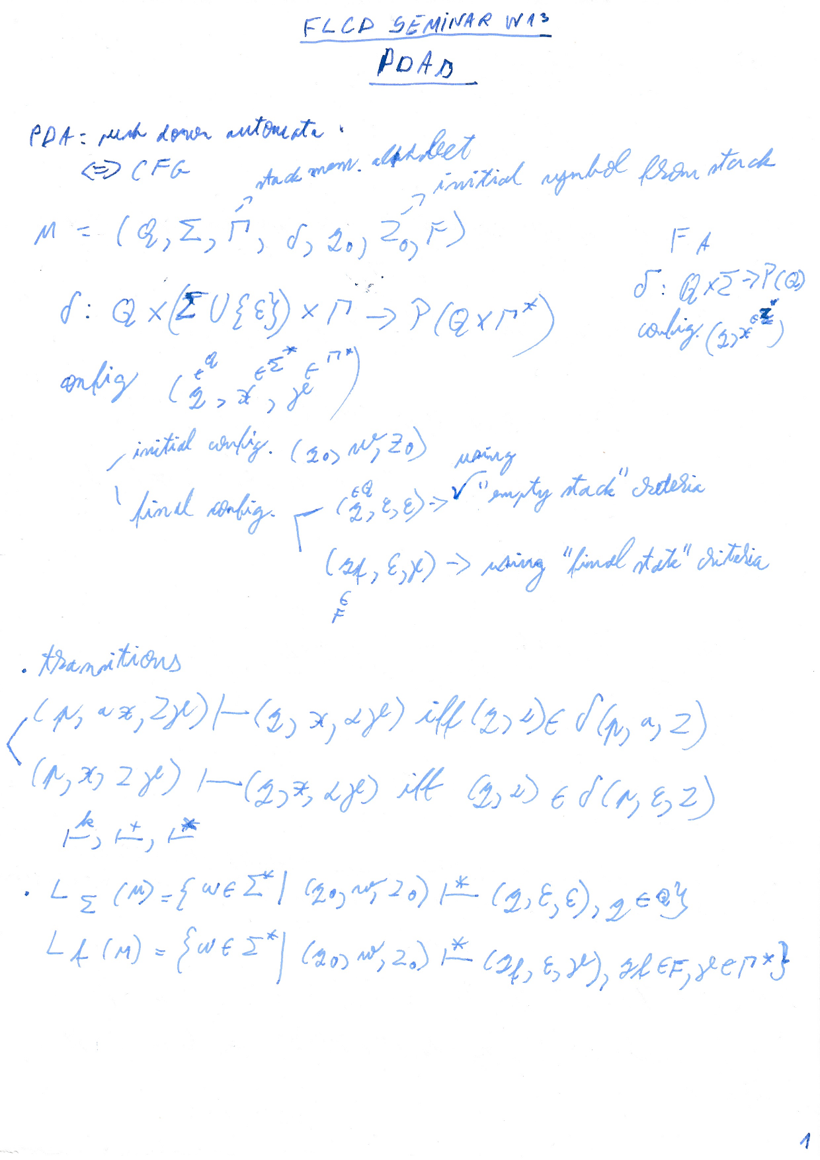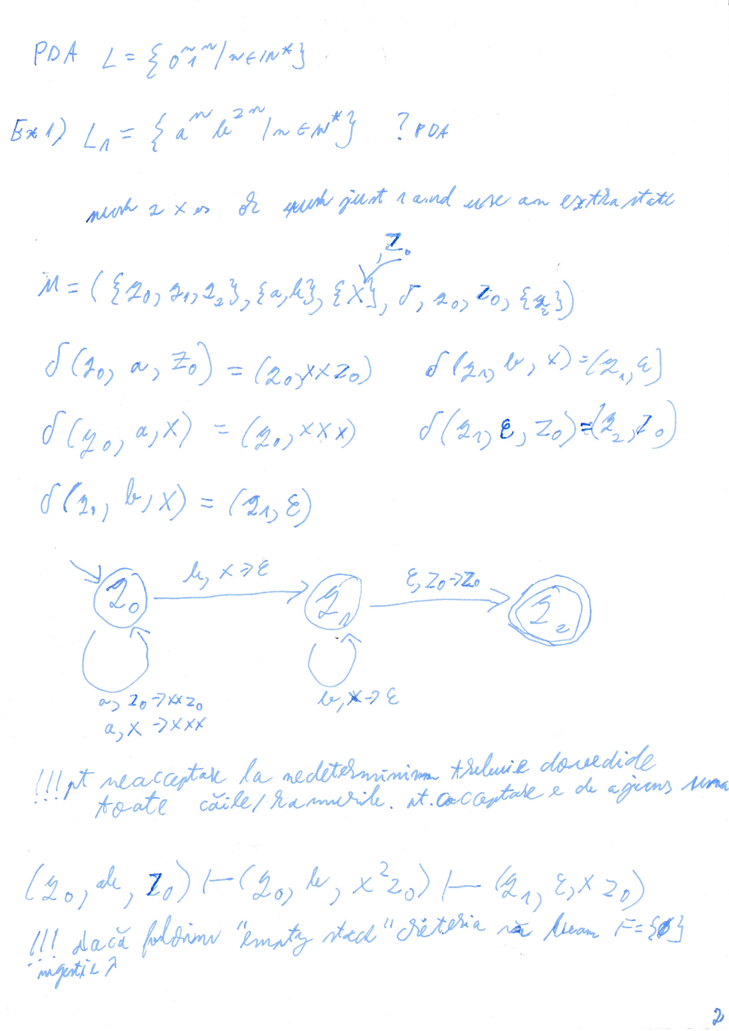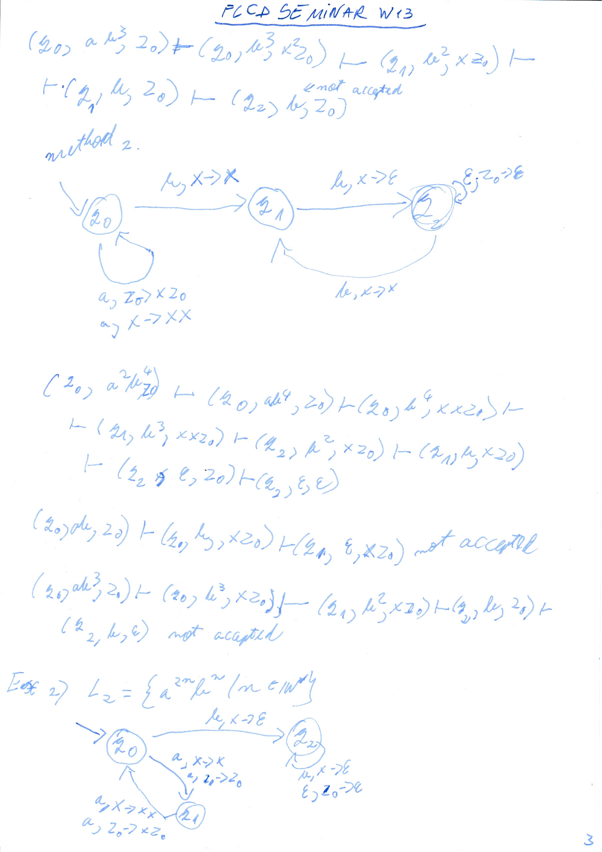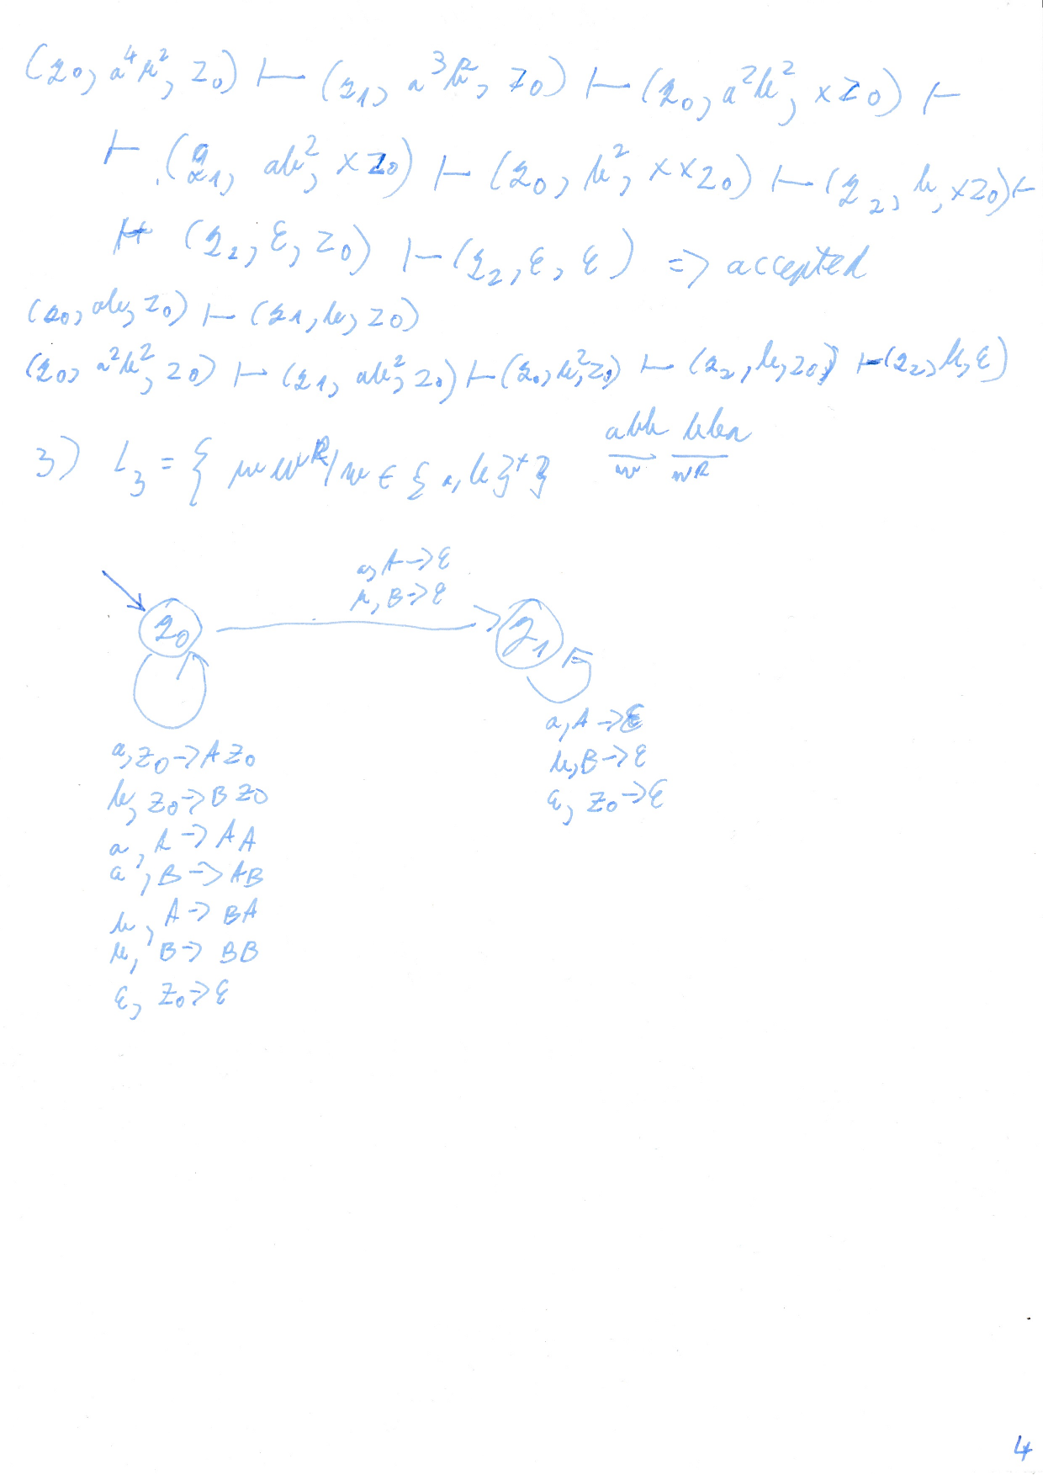

# LAB W13

!!! uitati-va pe moodle luni dimineata

!!! predam saptamana viitoare L8 si L9

!!! code review pt L7 integration pana maine, 12 ian, ora 16:00

analizatoare: lexical, ??

lex compiler -> <https://silcnitc.github.io/lex.html> -> <https://web.archive.org/web/20220511161030/http://dinosaur.compilertools.net/>

<https://www.google.com/search?q=flex+compiler+documentation> -> <http://web.mit.edu/gnu/doc/html/flex_1.html> ->

<https://silcnitc.github.io/roadmap.html>

<https://moodle.cs.ubbcluj.ro/pluginfile.php/31768/mod_folder/content/0/Course10.pdf>

descarca lab-urile la final si face diff

# LECTURE W14

4.5 for the exam. (UPDATE: 2023-01-26 19:21 but [Motogna's site](https://motogna.wordpress.com/courses/#:~:text=At%20least%20grade%205%20(from%20a%20scale%20of%201%20to%2010)%20at%20written%20exam) says >= 5)

something about bonus

exam: 1.5h; paper, pen; ID card

2ndary date - email 2 days before the exam day, w/ a strong reason

respect and cheating

during the exam:

use mask if necessary

not exit & re-eneter (ex: toilet)

no phones (you'll have to put it somewhere)

## subjects

several subjects for the exam

### subject 1 - 4 small questions, multiple choice 0.5p/question (all have at least 1 answer)

ex: consider the regular expression 0+1*. which regular expression ∈ to this?

00

01

101

001

reg ex/op on languages/accepted sequences by grammars or FA

ALL OR NOTHING

### subject 2 - RA - FA - RE transformations

don't put just the final result. you will get no intermediary points

they are trying to give as much points as possible, but you have to write something

### subject 3 - construct PDA

if you have time try 1 sequence that's accepted and 1 that's not accepted

### subject 4 - parsing (2 points)

descending recursive - apply the algorithm to see if the sequence is accepted.

ex: this is a grammar, construct first and follow

ex: this is first and follow, construct the table

### subject 5 - attribute grammars, intermediary code (2 points)

### after the exam

2nd cache - extra NON-TRIVIAL question

to ceil your grade. ex: for 9.2

exam grade is between 4 and 4.5

## questions

if u were just present to the seminar, you get ?5 for seminar grade

it's closed book

**sample problems -** [**ultima fisa a cursului**](https://www.cs.ubbcluj.ro/files/curricula/2022/syllabus/IE_sem5_MLE5023_en_motogna_2022_6765.pdf#page=5) **-> bibliography -> nr4 -** [**G. MOLDOVAN, V. CIOBAN, M. LUPEA - Limbaje formale si automate. Culegere de probleme, Univ. Babes-Bolyai, Cluj-Napoca, 1996**](https://drive.google.com/file/d/1zY35-e9RlPIZSu-L6E7IdsnLXAlLsGwe/view)

max seminar points - 10. if you have over, it is transformed into bonus

# SEMINAR W14 - attribute grammar, 3 address code

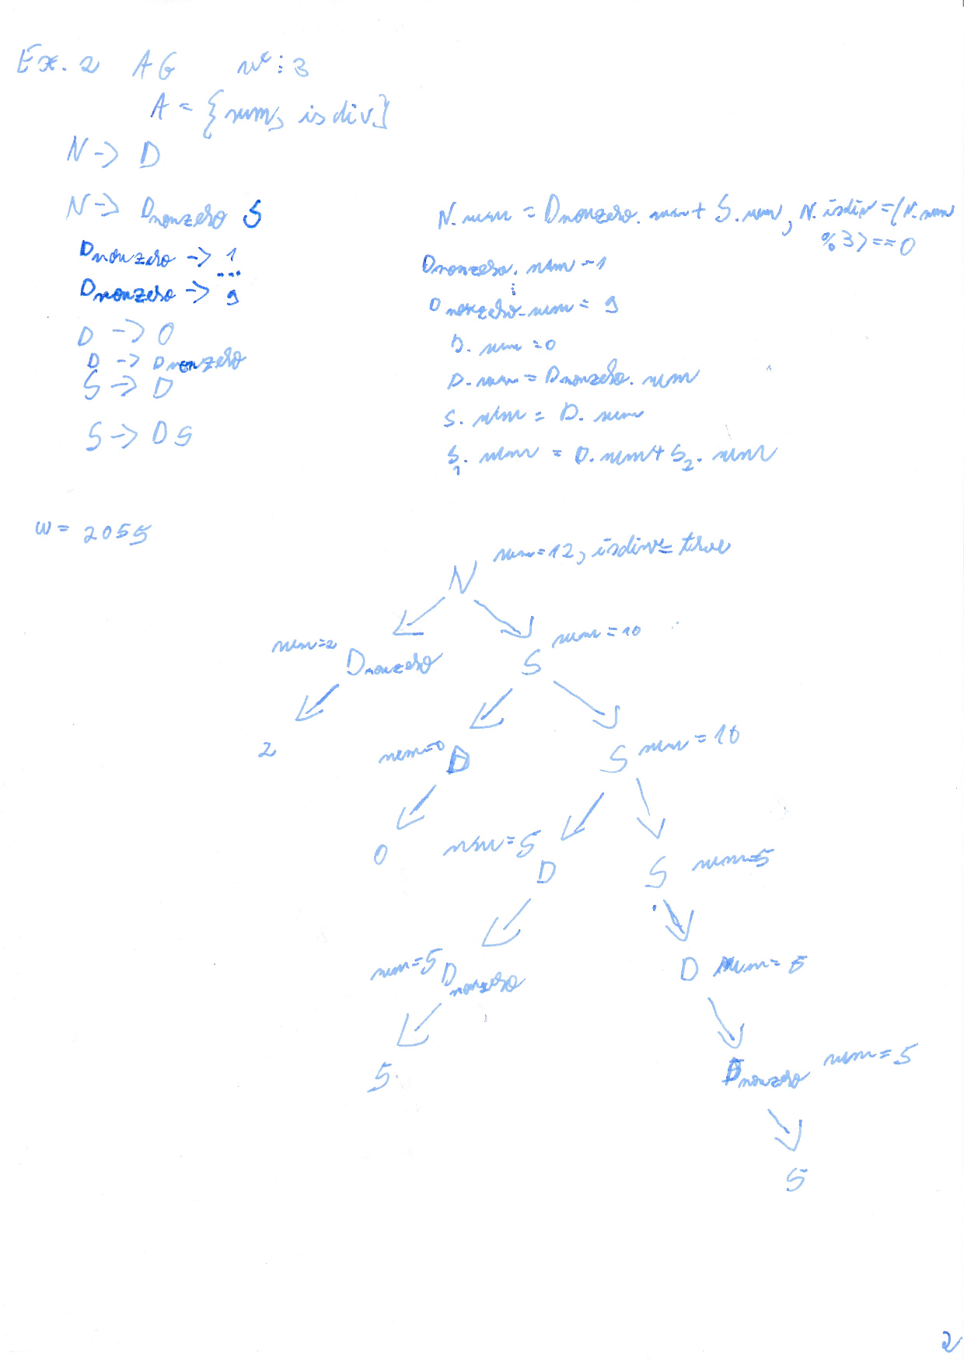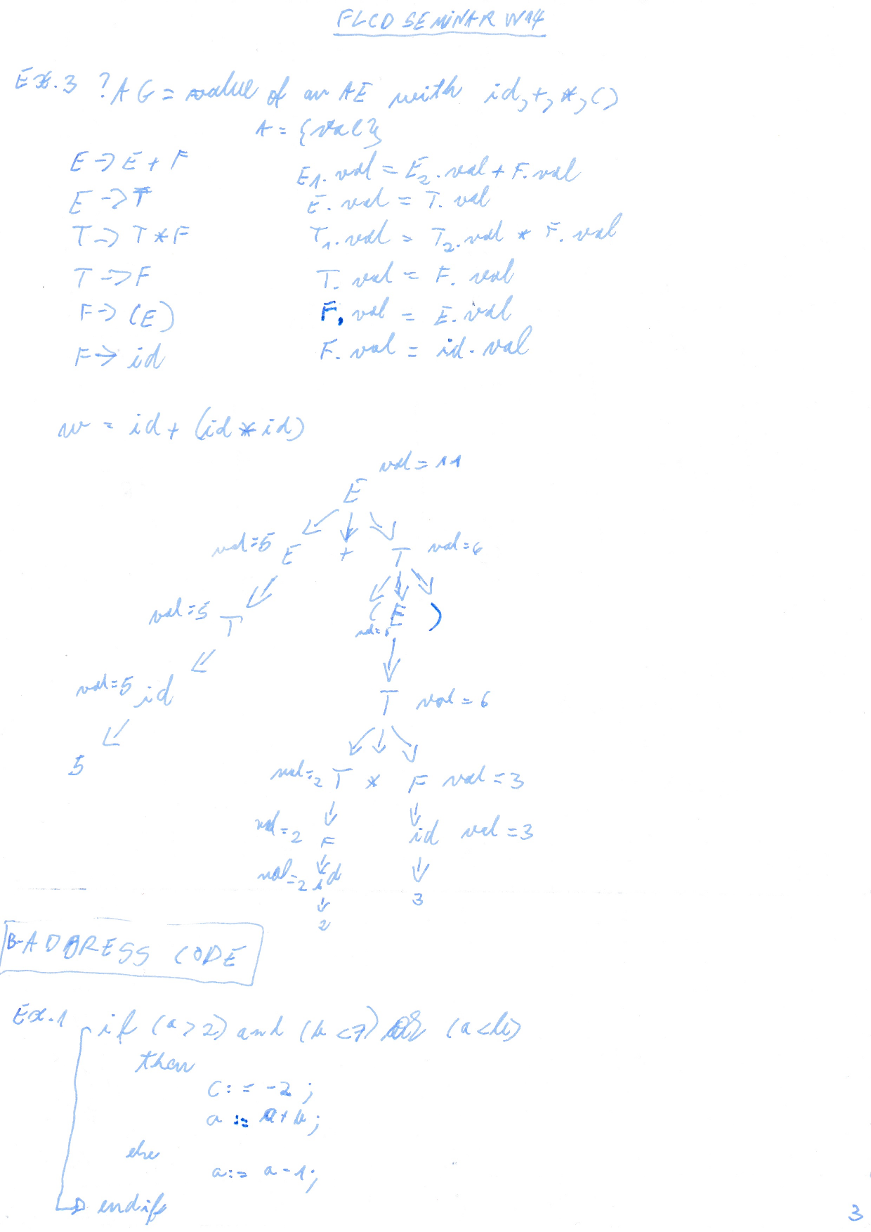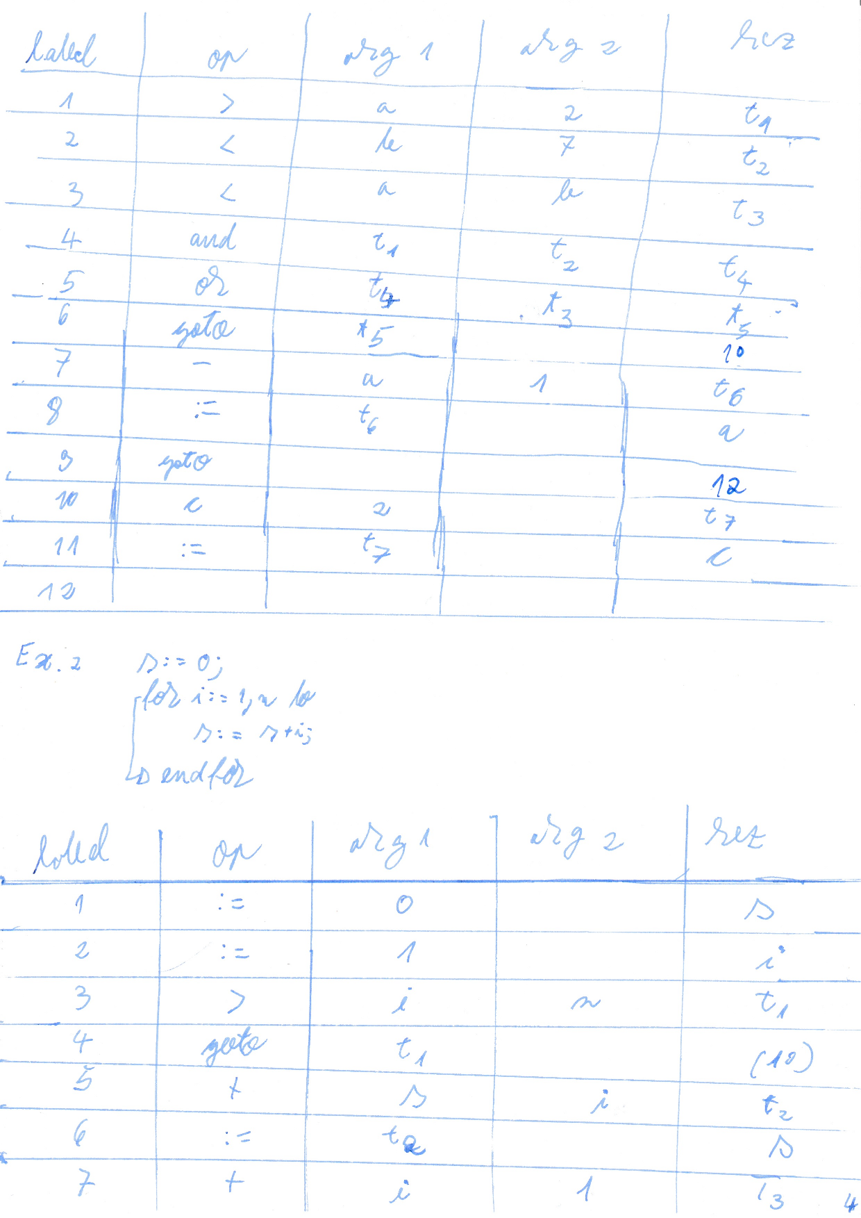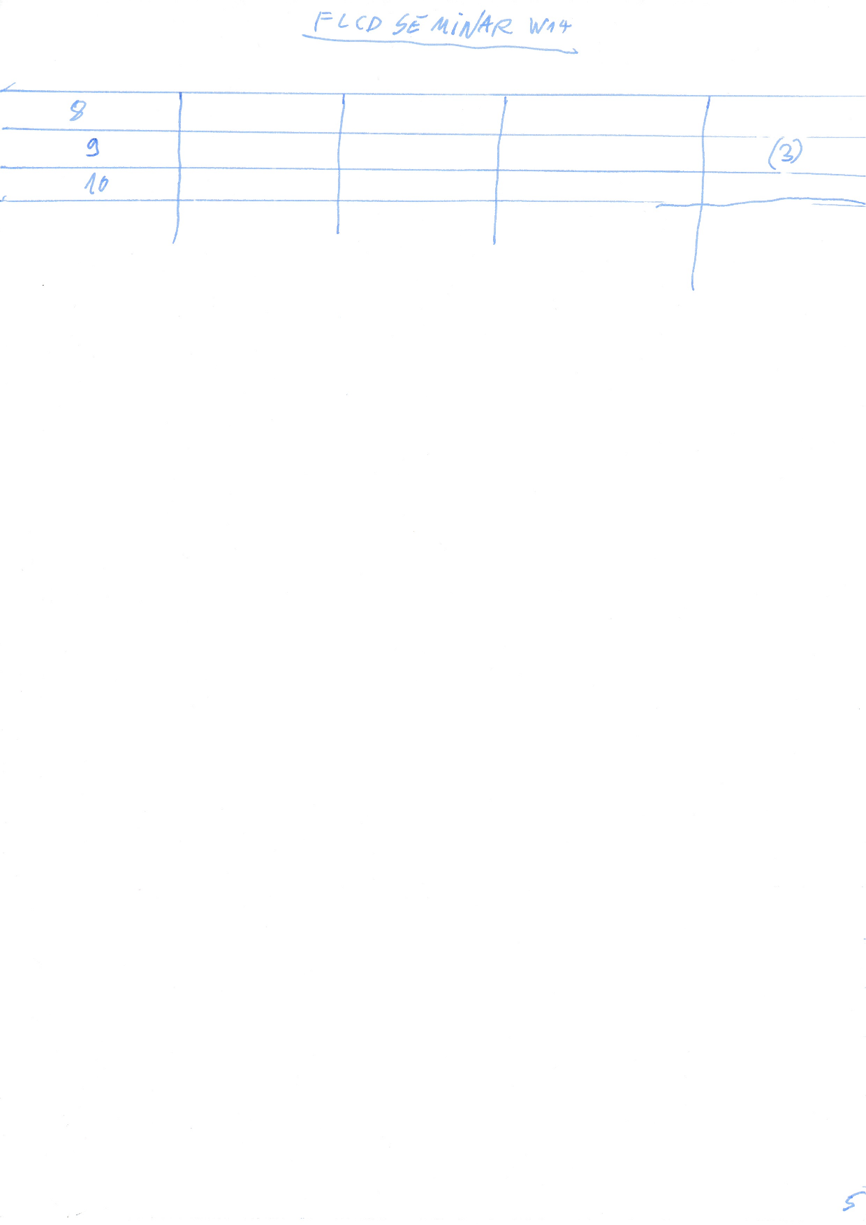

# LAB W14

tema [lab 8](https://moodle.cs.ubbcluj.ro/mod/assign/view.php?id=2977) todos

* lang.lxi
* ??demo

23 deadline pt note

sa incarcam pe moodle

verifcati daca e pdf

# exam preparation 27 Jan & 21 Feb

## plan

1. [read course pdfs](https://github.com/Patrulescu-Ronald-Sandrino/S5.FLCD/tree/main/lectures)
2. read old [FLCD Seminar notes](https://drive.google.com/drive/folders/116a96X5Y0VBU53cShA0vvXVJ6cE_7pUz) (at the same time?)
3. read [ponturi LFTC](https://docs.google.com/document/d/1KVtZvAv42sztRrNo2jZ0IDAs5kekbASf6Pv4uWRiHZQ/edit)
4. read [quizes LFTC](https://docs.google.com/document/d/1JoVQCFWeFIat5hn_4JsOOjGjuw8xBPEVVRsHGZowNrg/edit)
5. check, do & understand examples from WhatsApp/UBB IE 2020-2023 ✅
6. do subjects from Arhiva by Reziak Ezos [LFTC - Motogna Simona](https://drive.google.com/drive/u/0/folders/1lo4qLQP88Ishn_ci4kZeqz3YiFc9GMHw)
7. support, if needed
   1. [G. MOLDOVAN, V. CIOBAN, M. LUPEA - Limbaje formale si automate. Culegere de probleme, Univ. Babes-Bolyai, Cluj-Napoca, 2000.pdf](https://drive.google.com/file/d/1zY35-e9RlPIZSu-L6E7IdsnLXAlLsGwe/view) contains theory, exercises and solutions
8. study session jinga
   1. [exam_2023-01-27_ticket-7](https://docs.google.com/document/d/1ukuX8BTcK9C14VIKZI9uyZ7O7Cg0vqglXH26x2-1CjY/edit)
   2. <https://ubbcluj-my.sharepoint.com/personal/tudor_jinga_stud_ubbcluj_ro/_layouts/15/stream.aspx?id=%2Fpersonal%2Ftudor%5Fjinga%5Fstud%5Fubbcluj%5Fro%2FDocuments%2FStudy%20Sessions%2FFLCD%2Emkv&ga=1>
      1. 00:00 subject I
      2. 16:15 - 27:57 II FA -> RE
      3. 30:48 II FA -> RLG
      4. 40:42 III PDA
      5. 51:32 IV LL1 first + follow
      6. 1:17:03 - end IV LL1 parsing table
      7. [Copy of exam_2023-01-27_ticket-7](https://docs.google.com/document/d/1odfe8L7fgCPiIBMfxexD3GcyFHogwwsnfT8lBTV1CII/edit)
9. tabs
   1. [S5.FLCD](https://drive.google.com/drive/folders/1di58ItxOzCECMVzp4IxLaOBVPsLfO7Nr)
   2. [LFTC - Motogna Simona](https://drive.google.com/drive/u/0/folders/1lo4qLQP88Ishn_ci4kZeqz3YiFc9GMHw)
   3. [aMetode-de-Proiectare-a-Compilatoarelor-Simona-Motogna.mpdf](https://drive.google.com/file/d/1SCqvbryI90EPanJoqSRKT6tF2q-8Y_4H/view)
   4. [FLCD Notes](https://docs.google.com/document/d/1w5dVGgyhk2__FfmHxxjtNRsmQWbXAmhERrdbYBq3sm8/edit#heading=h.79g7j2b25m51)
   5. lectures-merged.pdf
   6. [FLCD Notes](https://docs.google.com/document/d/1w5dVGgyhk2__FfmHxxjtNRsmQWbXAmhERrdbYBq3sm8/edit#heading=h.79g7j2b25m51)
   7. teams seminar 6-7
   8. seminars-932.pdf
   9. M, LUPEA - Limbaje formale si automate
   10. [exam_2023-01-27_ticket-7](https://docs.google.com/document/d/1ukuX8BTcK9C14VIKZI9uyZ7O7Cg0vqglXH26x2-1CjY/edit#heading=h.ge1vn4xg2uhp)
   11. [Copy of exam_2023-01-27_ticket-7](https://docs.google.com/document/d/1odfe8L7fgCPiIBMfxexD3GcyFHogwwsnfT8lBTV1CII/edit#heading=h.sjf7ikxo2zhg)

## examples

[pdf with all seminars from 932](https://drive.google.com/file/d/1jB6Ig4El3QZQK-p3eiVnhAo7_OlRbr26/view)

### I (2p) quiz

grammar

1. SEMINAR W3 -> [FLCD Notes](https://docs.google.com/document/d/1w5dVGgyhk2__FfmHxxjtNRsmQWbXAmhERrdbYBq3sm8/edit#heading=h.9b4ylbowlzjr)
2. [teams seminar 3](https://github.com/Patrulescu-Ronald-Sandrino/S5.FLCD/blob/main/teams_class-materials/FLCD%20Seminar%20notes/FLCD%20Seminar%203.pdf)

finite automata

1. SEMINAR W4 -> [FLCD Notes](https://docs.google.com/document/d/1w5dVGgyhk2__FfmHxxjtNRsmQWbXAmhERrdbYBq3sm8/edit#heading=h.ua61vmps12oh)
2. [teams seminar 4-5](https://github.com/Patrulescu-Ronald-Sandrino/S5.FLCD/blob/main/teams_class-materials/FLCD%20Seminar%20notes/FLCD%20Seminar%204-5.pdf)

### II (2p) transformations

1. SEMINAR W5 -> [FLCD Notes](https://docs.google.com/document/d/1w5dVGgyhk2__FfmHxxjtNRsmQWbXAmhERrdbYBq3sm8/edit#heading=h.v36ei8tgr14v) + SEMINAR W6 -> [FLCD Notes](https://docs.google.com/document/d/1w5dVGgyhk2__FfmHxxjtNRsmQWbXAmhERrdbYBq3sm8/edit#heading=h.z2hjwxexb70r)
2. [teams seminar 6-7](https://github.com/Patrulescu-Ronald-Sandrino/S5.FLCD/blob/main/teams_class-materials/FLCD%20Seminar%20notes/FLCD%20Seminar%206-7.pdf) + [teams seminar 7 board](https://github.com/Patrulescu-Ronald-Sandrino/S5.FLCD/blob/main/teams_class-materials/FLCD%20Seminar%20notes/FLCD%20Seminar%207%20board.pdf) (contains FA drawings)
3. carte lupea 49 RG ⇔ FA

### III (1p) PDA

1. [Course1112.pdf](https://moodle.cs.ubbcluj.ro/pluginfile.php/49237/mod_resource/content/1/Course1112.pdf)
2. SEMINAR W13 -> [FLCD Notes](https://docs.google.com/document/d/1w5dVGgyhk2__FfmHxxjtNRsmQWbXAmhERrdbYBq3sm8/edit#heading=h.zfz7nqsktou8)
3. [seminars 932](https://drive.google.com/file/d/1jB6Ig4El3QZQK-p3eiVnhAo7_OlRbr26/view) 36-37
4. carte lupea 75-83

### IV (2p) parser

1. CFG, parser
   1. [Course5.pdf](https://moodle.cs.ubbcluj.ro/pluginfile.php/30051/mod_folder/content/0/Course5.pdf)
   2. SEMINAR W7 -> [FLCD Notes](https://docs.google.com/document/d/1w5dVGgyhk2__FfmHxxjtNRsmQWbXAmhERrdbYBq3sm8/edit#heading=h.pnpa92p3x1km)
   3. [teams seminar 8](https://github.com/Patrulescu-Ronald-Sandrino/S5.FLCD/blob/main/teams_class-materials/FLCD%20Seminar%20notes/FLCD%20Seminar%208.pdf)
2. descendant recursive
   1. [Course6.pdf](https://moodle.cs.ubbcluj.ro/pluginfile.php/30525/mod_folder/content/0/Course6.pdf)
   2. SEMINAR W7 -> [FLCD Notes](https://docs.google.com/document/d/1w5dVGgyhk2__FfmHxxjtNRsmQWbXAmhERrdbYBq3sm8/edit#heading=h.pnpa92p3x1km)
   3. [teams seminar 8](https://github.com/Patrulescu-Ronald-Sandrino/S5.FLCD/blob/main/teams_class-materials/FLCD%20Seminar%20notes/FLCD%20Seminar%208.pdf)
3. LL(1) - the one w/ FIRST, FOLLOW
   1. [Course7.pdf](https://moodle.cs.ubbcluj.ro/pluginfile.php/30801/mod_folder/content/0/Course7.pdf)
   2. SEMINAR W8 -> [FLCD Notes](https://docs.google.com/document/d/1w5dVGgyhk2__FfmHxxjtNRsmQWbXAmhERrdbYBq3sm8/edit#heading=h.pcskq5h7n0qg)
   3. [teams seminar 9](https://github.com/Patrulescu-Ronald-Sandrino/S5.FLCD/blob/main/teams_class-materials/FLCD%20Seminar%20notes/FLCD%20Seminar%209.pdf)
4. LR(0)
   1. [Course8.pdf](https://moodle.cs.ubbcluj.ro/pluginfile.php/38607/mod_folder/content/0/Course8.pdf)
   2. SEMINAR W10 -> [FLCD Notes](https://docs.google.com/document/d/1w5dVGgyhk2__FfmHxxjtNRsmQWbXAmhERrdbYBq3sm8/edit#heading=h.8dmn74hm6zgu)
   3. [teams seminar 10](https://github.com/Patrulescu-Ronald-Sandrino/S5.FLCD/blob/main/teams_class-materials/FLCD%20Seminar%20notes/FLCD%20Seminar%2010.pdf)
5. SLR
   1. [Course9.pdf](https://moodle.cs.ubbcluj.ro/pluginfile.php/31464/mod_resource/content/6/Course9.pdf)
   2. SEMINAR W10 -> [FLCD Notes](https://docs.google.com/document/d/1w5dVGgyhk2__FfmHxxjtNRsmQWbXAmhERrdbYBq3sm8/edit#heading=h.8dmn74hm6zgu)
   3. SEMINAR W11 -> [FLCD Notes](https://docs.google.com/document/d/1w5dVGgyhk2__FfmHxxjtNRsmQWbXAmhERrdbYBq3sm8/edit#heading=h.5s6j96y8ptkd)
   4. [teams seminar 11-12](https://github.com/Patrulescu-Ronald-Sandrino/S5.FLCD/blob/main/teams_class-materials/FLCD%20Seminar%20notes/FLCD%20Seminar%2011-12.pdf)
6. LR(1)
   1. [Course9.pdf](https://moodle.cs.ubbcluj.ro/pluginfile.php/31464/mod_resource/content/6/Course9.pdf)
   2. SEMINAR W11 -> [FLCD Notes](https://docs.google.com/document/d/1w5dVGgyhk2__FfmHxxjtNRsmQWbXAmhERrdbYBq3sm8/edit#heading=h.5s6j96y8ptkd)
   3. SEMINAR W12 -> [FLCD Notes](https://docs.google.com/document/d/1w5dVGgyhk2__FfmHxxjtNRsmQWbXAmhERrdbYBq3sm8/edit#heading=h.vne0bns2rby2)
   4. [teams seminar 11-12](https://github.com/Patrulescu-Ronald-Sandrino/S5.FLCD/blob/main/teams_class-materials/FLCD%20Seminar%20notes/FLCD%20Seminar%2011-12.pdf)
7. LALR(1)
   1. [Course9.pdf](https://moodle.cs.ubbcluj.ro/pluginfile.php/31464/mod_resource/content/6/Course9.pdf)
   2. SEMINAR W12 -> [FLCD Notes](https://docs.google.com/document/d/1w5dVGgyhk2__FfmHxxjtNRsmQWbXAmhERrdbYBq3sm8/edit#heading=h.vne0bns2rby2)
   3. [teams seminar 11-12](https://github.com/Patrulescu-Ronald-Sandrino/S5.FLCD/blob/main/teams_class-materials/FLCD%20Seminar%20notes/FLCD%20Seminar%2011-12.pdf)

### V (2p) attribute grammar & 3 address code

attribute grammars

1. lectures-merged.pdf 238-246
2. SEMINAR W14 -> [FLCD Notes](https://docs.google.com/document/d/1w5dVGgyhk2__FfmHxxjtNRsmQWbXAmhERrdbYBq3sm8/edit#heading=h.899yjyatcepv)
3. [seminars 932](https://drive.google.com/file/d/1jB6Ig4El3QZQK-p3eiVnhAo7_OlRbr26/view) 38-39

3 address code / intermediary code

1. lectures-merged.pdf 252-256
2. SEMINAR W14 -> [FLCD Notes](https://docs.google.com/document/d/1w5dVGgyhk2__FfmHxxjtNRsmQWbXAmhERrdbYBq3sm8/edit#heading=h.899yjyatcepv) pag 3-5
3. [seminars 932](https://drive.google.com/file/d/1jB6Ig4El3QZQK-p3eiVnhAo7_OlRbr26/view) 40-41
4. [attribute grammar for boolean expressions](https://www.google.com/search?q=attribute+grammar+for+boolean+expressions&tbm=isch#imgrc=AM7AsMHggAqAlM)

## cheatsheet

### chomsky hierarchy

lectures-merged.pdf#page=35

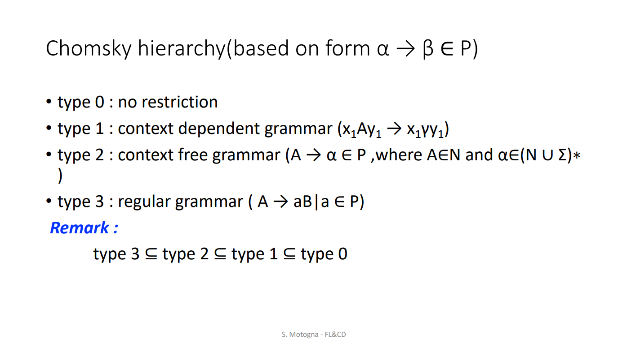

### RG & RLG defs

lectures-merged.pdf#page=51

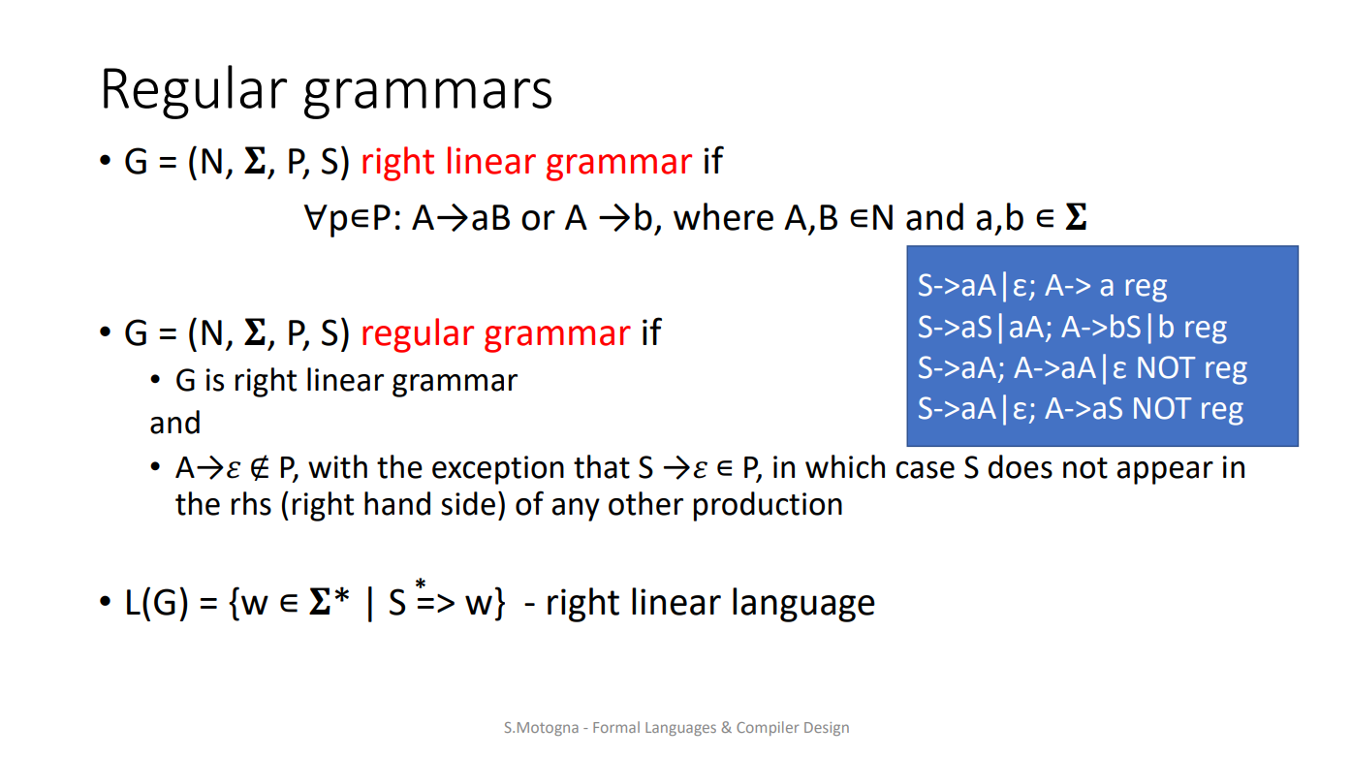

### transformations

#### RG -> RE

lectures-merged.pdf#page=58

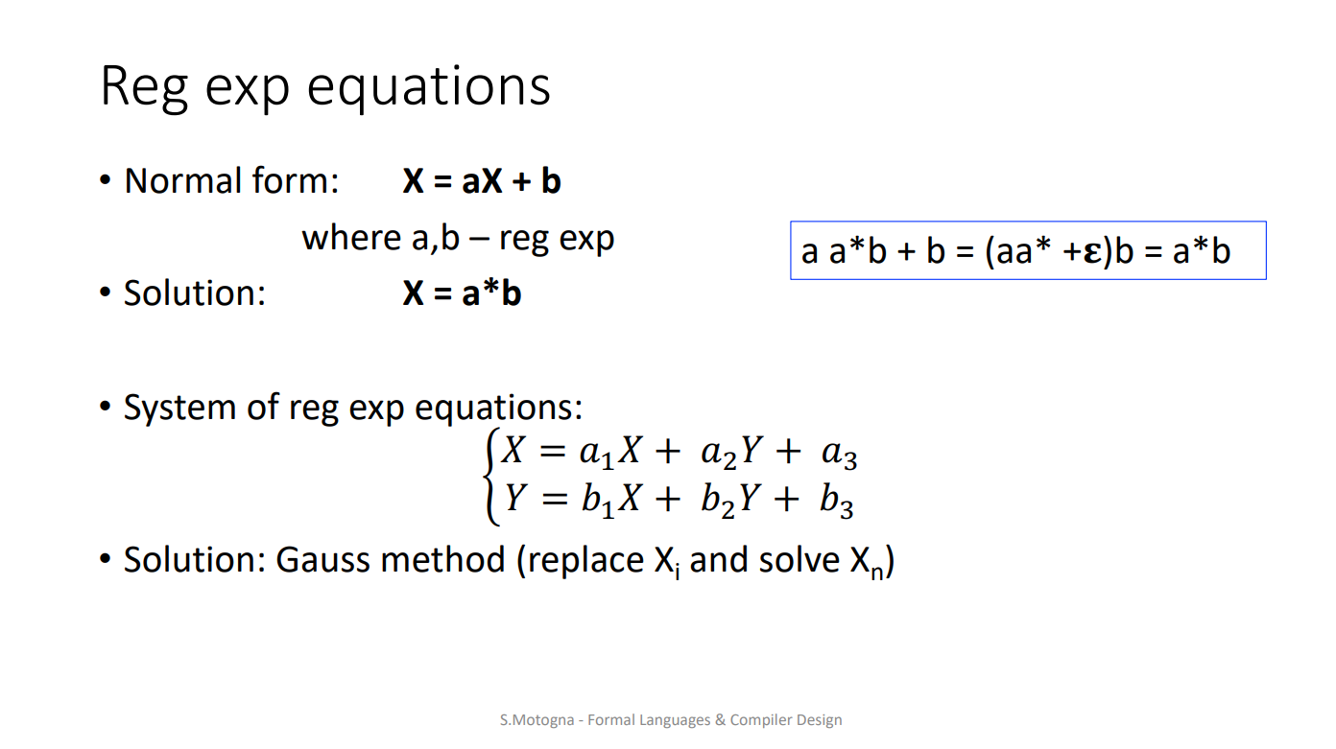

lectures-merged.pdf#page=65

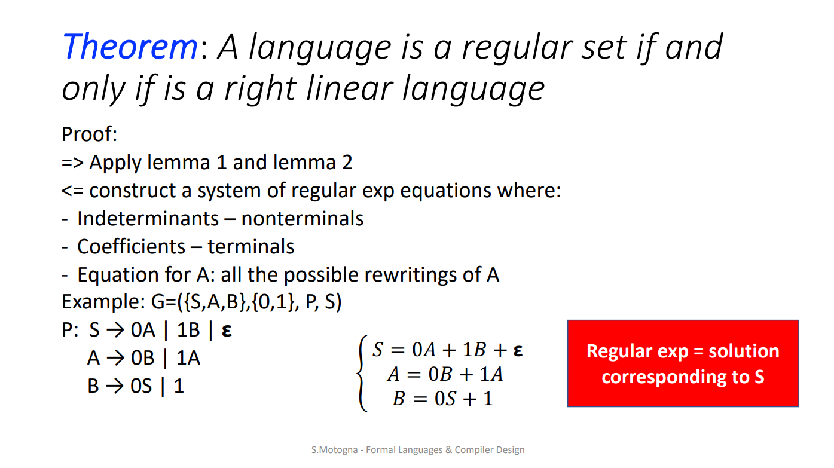

#### RE -> RLG

<https://stackoverflow.com/questions/13816439/left-linear-and-right-linear-grammars/13945932#13945932>

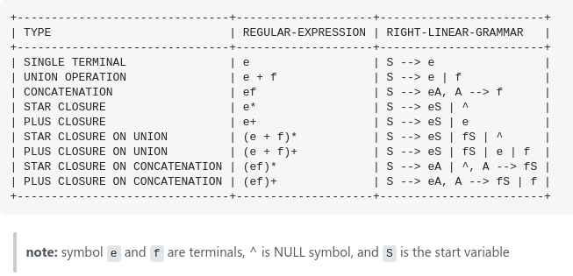

#### FA -> RE

lectures-merged.pdf#page=66

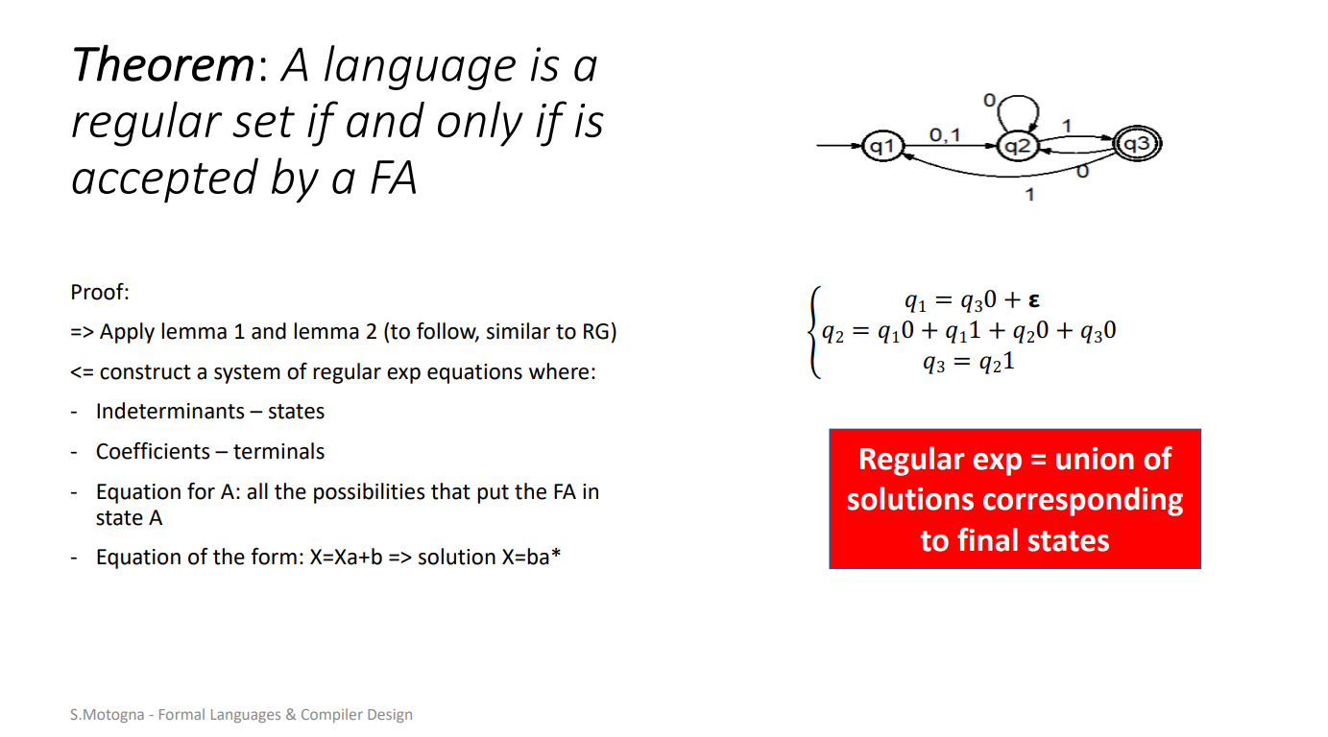

#### RE -> FA

manually

#### RG -> FA

carte lupea pag49

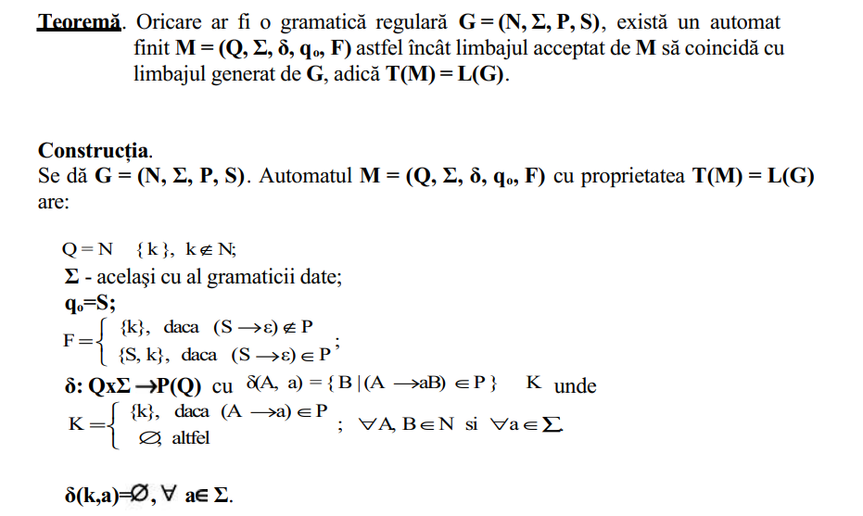

but 1st, if you have single productions (aka renaming rules) (aka A → B, where A, B ∈ N), you have to replace them with A → whatever B goes into (lectures-merged.pdf#page=92)

ex:

A → B | …

B → α1 | α2 | ... | αn

=> A -> α1 | α2 | ... | αn | …

?[Right Linear Grammar to DFA](https://youtu.be/WopIfcdR6K4)

#### FA -> RLG

finite automata to right linear grammar -> [DFA to Right Linear Grammar RLG](https://youtu.be/xmknBzUHLIc?t=16) 00:16

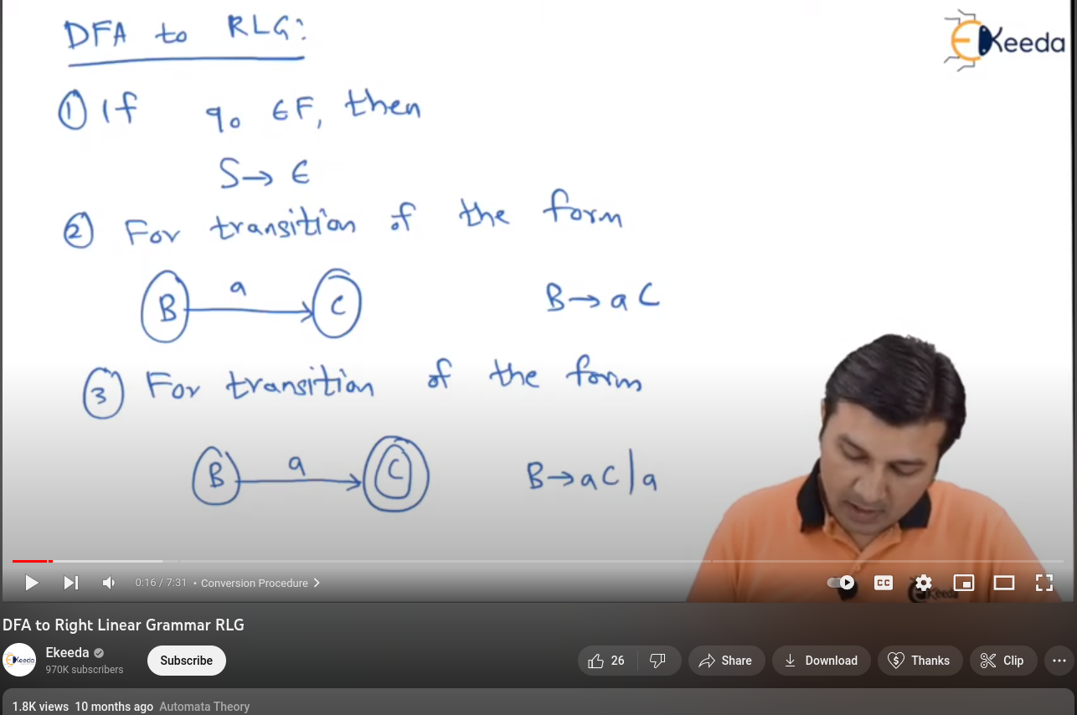

carte lupea pag49 - lipsește regula pentru S->ε (asta e pentru FA -> RG)

FLCD Seminar 6-7 pag2-5 (t3 and t4)

seminars 932 pag14 example3 (production p → ε is probably wrong)

### arithmetic expression grammar

E -> E * T | T

T -> T * F | F

F -> (E) | id

## arhiva

### [Exam_ian2021.pdf](https://drive.google.com/file/d/14-GWPe-Jb-8p1N3A9QkAIxXNDTl4aUTC/view)

intrebari

1. pag 14 Q1 which sequences belong to the grammar

<https://www.jflap.org/jflaptmp/> - java software tool to make transformations, PDA, pumping lemma and other stuff

## lectures index (written in the last page of lectures-merged)

course details 1-9

introduction 10-14

scanning 15-28

context for grammar 30-31

grammar 32-36

finite automata 42-50

regular grammars 51-53

regular sets & expressions 54-58

transformations (RG ⇔ FA ⇔ RE ⇔ RG) 59-70

pumping lemma 72-76

cfg 77-83

eq transformations of cfg 84-93

parsing 94-100

descendent recursive parser 101-112

LL(1) Parser 113-138

LR(k) parsing 141-150

LR(0) Parser 151-169

SLR Parser 170-178

LR(1) Parser 179-189

LALR Parser 189-192

parsing recap 193-196

lex & yacc 200-220

PDA 221-233

context for attribute grammar 235-237

attribute grammar 238-246

intermediary code 249-251

3 address code 252-256

Optimize intermediary code 257-262

Generate object code 264-280

Turing machines 281-290.

# EOF

Title (aka BOF) -> [FLCD Notes](https://docs.google.com/document/d/1w5dVGgyhk2__FfmHxxjtNRsmQWbXAmhERrdbYBq3sm8/edit#heading=h.4erucbtv44ov)